NARRATIVE STORYTELLING IN CHINESE AND VIETNAMESE IDOL SURVIVAL PROGRAM: THE COMPARISON BETWEEN PRODUCE CAMP 2021 (CHUANG 2021) AND VOTE FOR FIVE

NARRATIVE STORYTELLING IN CHINESE AND VIETNAMESE IDOL SURVIVAL PROGRAM: THE COMPARISON BETWEEN PRODUCE CAMP 2021 (CHUANG 2021) AND VOTE FOR FIVE

Le Ho My Uyen

This Independent Study Manuscript Presented to
The Graduate School of Bangkok University
in Partial Fulfillment
of the Requirements for the Degree
Master of Arts in Communication Arts
2023

This manuscript has been approved by
the Graduate School
Bangkok University

Title: Narrative Storytelling In Chinese And Vietnamese Idol Survival Program: The Comparison Between Produce Camp 2021 (CHUANG 2021) And Vote For Five

Author: Le Ho My Uyen

Independent Student Committee:

Advisor Suwannamas Lekngam Wongwilatnurak

Field Specialist -

Le, Ho My Uyen. Master of Communication Arts, 12, 2024 Graduate School, Bangkok University.
Narrative Storytelling In Chinese And Vietnamese Idol Survival Program: The Comparison Between Produce Camp 2021 (CHUANG 2021) And Vote For Five (131 pp.)
Advisor: Suwannamas Lekngam Wongwilatnurak , Ph.D.

Abstract
This study investigates the narrative storytelling elements in Chinese and Vietnamese idol survival shows through a comparative analysis of CHUANG 2021 from China and Vote For Five from Vietnam. Using Meir Sternberg's narrative dynamics and Saussure’s Semiotics Theory, the research examines how storytelling is constructed through semiotic and narrative techniques in each program. A qualitative content analysis was conducted, focusing on key components such as visual elements, contestant interactions, performance settings, and linguistic diversity.
Saussure’s Semiotics Theory provides a lens to analyze the use of semiotic elements, such as costumes, set designs, and visual consistency, in shaping audience perceptions. In CHUANG 2021, a high level of visual cohesion is evident across performances and behind-the-scenes footage, with contestants’ dormitory life and multilingual conversations adding depth to their portrayals. In contrast, Vote For Five demonstrates less visual consistency, with performance costumes and set designs varying significantly across episodes. Moreover, contestant interactions and behind-the-scenes content are minimally featured, focusing more on the performances themselves.
Meir Sternberg’s concept of narrative dynamics—prospection-suspense, retrospection-curiosity, and re-cognition-surprise—reveals differing approaches to storytelling. In CHUANG 2021, these narrative values are systematically embedded across the show’s semiotic and narrative elements, creating a cohesive and engaging story arc. Conversely, Vote For Five applies these dynamics inconsistently, leading to less structured storytelling.
This research highlights how cultural and production contexts influence the narrative strategies of idol survival shows. The findings provide insights into how storytelling techniques can enhance audience engagement, offering recommendations for producers to refine their approaches in emerging markets like Vietnam, where the idol industry is still developing.
Keywords: Idol, Chinese Survival Program, Vietnamese Survival Program, Semiotics, Narrative Dynamics

Acknowledgement

First and foremost, I would like to express my deepest gratitude to my advisor, Dr. Suwannamas Lekngam Wongwilatnurak, for her invaluable guidance, encouragement, and support throughout this research journey. Your expertise and insightful feedback have been instrumental in shaping the direction and quality of this thesis.
I would also like to extend my sincere thanks to the faculty members and staff at Communication Arts Department at Bangkok University, whose resources and expertise have provided a strong foundation for my academic growth.
To my fellow classmates and peers, thank you for the thought-provoking discussions, collaboration, and encouragement that have made this journey more enriching and enjoyable. Your camaraderie has been a constant source of motivation.
I am also deeply grateful to my family and friends for their unwavering support, patience, and understanding throughout this process. Your belief in me has been a source of strength during the most challenging moments.
This thesis is a culmination of the collective support and encouragement of all these individuals, and I am forever grateful for their contributions.

Table of contents
Page
ABSTRACT iii
ACKNOWLEDGEMENT v
LIST OF TABLES viii
LIST OF FIGURES ix
CHAPTER 1: INTRODUCTION 1
1.1 Rationale and Problem Statement 1
1.2 Objectives of Study 18
1.3 Scope of Study 18
1.4 Research Questions 18
1.5 Significance of the Study 19
1.6 Definition of Terms 19
CHAPTER 2: LITERATURE REVIEW 22
2.1 Related Literature and Previous Studies 22
2.2 Related Theories 31
2.3 Conceptual Framework 35
CHAPTER 3: METHODOLOGY 38
3.1 Research Design 38
3.2 Population and Sample Selection 40
3.3 Research Instrument 41
3.4 Data Collection Procedure and Data Analysis 42
3.5 Reliability and Validity of the Study 43
CHAPTER 4: FINDINGS 44
4.1 Textual analysis in Chinese and Vietnamese Idol
Survival Show 44
4.2 Conclusions 91
CHAPTER 5: DISCUSSION 94
5.1 Summary of Findings 94
5.2 Discussions 9

Table of contents (Continued)
Page
CHAPTER 5: DISCUSSION (Continued)
5.2.1 Discussions based on past research findings 97
5.2.2 Discussions based on relevant concepts and theories 98
5.2.3 Discussions based on your expectations 100
5.3 Recommendation for Further Application 101
5.3.1 Application for communication scholars/researchers 102
5.3.2 Application for governmental offices/policy makers 104
5.3.3 Application for communication practitioners 105
5.4 Recommendation for Further Research 107
BIBLIOGRAPHY 110
APPENDIX 117
BIODATA 119

List of Tables
Page
Table 3.1: The Coding Sheet: Catalouge of narrative elements 42
Table 4.1.1: The Coding Sheet: Semiotic elements in Lover Boys 88 performance
stage 45
Table 4.1.2: The Coding Sheet: Semiotic elements in You Better Not Think About Me
performance stage 51
Table 4.1.3: The Coding Sheet: Semiotic elements in Push No.5 for Cute in
Input Method performance stage 57
Table 4.1.4: The Coding Sheet: Semiotic elements in Thà Rằng Như Thế performance
stage 65
Table 4.1.5: The Coding Sheet: Semiotic elements in Như Là Mơ performance stage 71
Table 4.1.6: The Coding Sheet: Semiotic elements in Cùng Đi Khắp Tinh Cầu
performance stage 76
Table 4.1.7: The Coding Sheet: Semiotic elements in CHUANG 2021 - A Nice
Evening! Trainees Make a Call to Their Families behind the scenes clip 81
Table 4.1.8: The Coding Sheet: Semiotic elements in Vote For Five - Gửi người đặc
biệt và duy nhất.. behind the scenes clip 87
Table 4.1.9: The Coding Sheet: Catalouge of narrative elements in Vietnam and China
idol survival show 91

List of Figures
Page
Figure 1.1: Nominations in the category "Most Popular Programs on Digital and
Television Platforms (including YouTube, TikTok...)" 2
Figure1.2: The program "2 days 1 night" won the category "Most popular program on
digital and television platforms (including YouTube, TikTok...)" at the 29th
Mai Vang awards ceremony 2
Figure1.3: Vietnamese trainees participate in idol survival programs 3
Figure1.4: Korean idols of Vietnamese origin 4
Figure1.5: Highest Korean “Produce 101” viewership rating through 4 seasons 5
Figure1.6: Poster of “Produce 101 Japan Season 2” program 6
Figure1.7: Poster of CHUANG 2021 program 6
Figure1.8: Views of the theme song of the show "Produce 101 Japan Season 2" 7
Figure1.9: Views of the theme song of the show CHUANG 2021 7
Figure1.10: Views of the final night’s song of the show CHUANG 2021 7
Figure1.11: Views of the final night’s song of the show "Produce 101 Japan Season 2 7
Figure1.12: Promotion poster of CHUANG 2021 program 8
Figure1.13: Promotion poster “Are you a werewolf?” segment in CHUANG 2021
program 11
Figure1.14: Promotion poster “Dorm Diary” segment in CHUANG 2021
program 12
Figure1.15: Promotion poster “Behind The Scenes” segment in CHUANG 2021
program 12
Figure1.17: Mr. Nguyễn Quang Huy - The producer and director of Vote For Five at
the press conference launching the show. 14
Figure1.18: Promotion poster for Vote For Five program. 14
Figure1.19: Male idol groups from idol survival shows. 17

List of Figures (continued)
Page
Figure2.1: Korean soloist Gdragon’s costume in MV “One of a kind” (left) and
Vietnamese artist ZERO 9’s JBin’s costume in MV “WHY” (right). 23
Figure2.2: Members of research project “Unveil Vietnamese Fandom—Why this new
emerging culture matters to brands”. 26
Figure2.3: Definition of “planned unexpectancy”. 27
Figure2.4: Definition of “fandom cycle”. 27
Figure2.5: A scene from Sơn Tùng MTP’s “Lạc Trôi” music video with the
appearance of the Bitis Hunter shoe line. 28
Figure2.6: Poster with the appearance of Son Tung MTP for the Be The Sky
Collection bank card collection. 29
Figure2.7: Conceptual framework of the study 36
Figure4.1: Comments in Lover Boy 88’s video. 46
Figure4.2: Stage effect in Lover Boy 88 stage performance. 47
Figure4.3: Costume in Lover Boy 88 stage performance 49
Figure4.4: Comments in Lover Boy 88 video (2) 50
Figure4.5: Stage effect in You Better Not Think About Me stage performance 52
Figure4.6: Comments in You Better Not Think About Me video 53
Figure4.7: Costume in You Better Not Think About Me stage performance 55
Figure4.8: Comments in You Better Not Think About Me video (2) 56
Figure4.9: Stage effect in Push No.5 for Cute in Input Method stage performance 59
Figure4.10: Comments in Push No.5 for Cute in Input Method 60
Figure4.11: Costume in Push No.5 for Cute in Input Method stage performance 61
Figure4.12: Comments in Push No.5 for Cute in Input Method video (2) 62

List of Figures (continued)
Page
Figure4.13: Interaction in Push No.5 for Cute in Input Method stage performance 64
Figure4.14: Comments in Push No.5 for Cute in Input Method video (3) 65
Figure4.15: Stage effect in Thà Rằng Như Thế stage performance 67
Figure4.16: Costume in Thà Rằng Như Thế stage performance 69
Figure4.17: Comments in Thà Rằng Như Thế video 70
Figure4.18: Stage effect in Như Là Mơ stage performance 72
Figure4.19: Costume in Như Là Mơ stage performance 74
Figure4.20: Comments in Như Là Mơ video 75
Figure4.21: Stage effect in Cùng Đi Khắp Tinh Cầu stage performance 77
Figure4.22: Costume in Cùng Đi Khắp Tinh Cầu stage performance 78
Figure4.23: Comments in Cùng Đi Khắp Tinh Cầu video 79
Figure4.24: Setting in CHUANG 2021 behind the scene video 82
Figure4.25: Interaction between the contestants and their families 84
Figure4.26: Comments in CHUANG 2021 behind the scene video 85
Figure4.27: Interaction between contestants and other families 86
Figure4.28: Setting in VOTE FOR FIVE behind the scene video 88
Figure4.29: Comments in VOTE FOR FIVE behind the scene video 89
Figure4.30: Costume in Vote For Five behind the scene video 90

Introduction

The introduction of this master’s thesis sets the stage for exploring the key aspects of idol survival shows, specifically focusing on the Chinese and Vietnamese markets. This section provides an overview of the research problem, explaining the growing popularity of idol survival programs and their influence on the entertainment industry, particularly in shaping public perceptions of contestants. The introduction outlines the objectives of the study, which aim to compare how these two countries portray contestants' personal stories and musical talents, and how these portrayals impact audience engagement. It also highlights the significance of the research by addressing the gap in existing literature, specifically the limited academic exploration of the portrayal of contestants' personalities and talents in these programs. By delving into both the production aspects and audience reception, the introduction frames the broader context for the research questions and lays the groundwork for the detailed analysis presented in the thesis.

Rationale and Problem Statement
In 2023, domestically produced reality-format TV shows have been very positively received not only by Vietnamese audiences, but also been nominated in award ceremonies (VOV, 2023). The evidence is at the award ceremony of the Mai Vang award - an awards have been held annually by the daily newspaper of the Ho Chi Minh City Party Committee: Nguoi Lao Dong newspaper; since 1995 to honor individuals and groups of artists who have made significant contributions to culture and the arts - In the category "Most Popular Programs on Digital and Television Platforms (including YouTube, TikTok...)", 3 out of 5 nominees are reality TV shows, which are 2 Days 1 Night, Rap Viet and The Masked Singer Vietnam (Nld.com.vn, 2023), as in figure 1.1. Figure 1.2 shows the result of reality TV show 2 Days 1 Night won Mai Vang award as the most favorite TV program (SGGP, 2024). Therefore, to achieve a deeper understanding of content that aligns with the audience's interests and preferences, researcher make the decision to concentrate on analyzing reality-format programs.
Figure 1. 1: Nominations in the category "Most Popular Programs on Digital and Television Platforms (including YouTube, TikTok...)".( maivang.nld.com.vn, 2024)
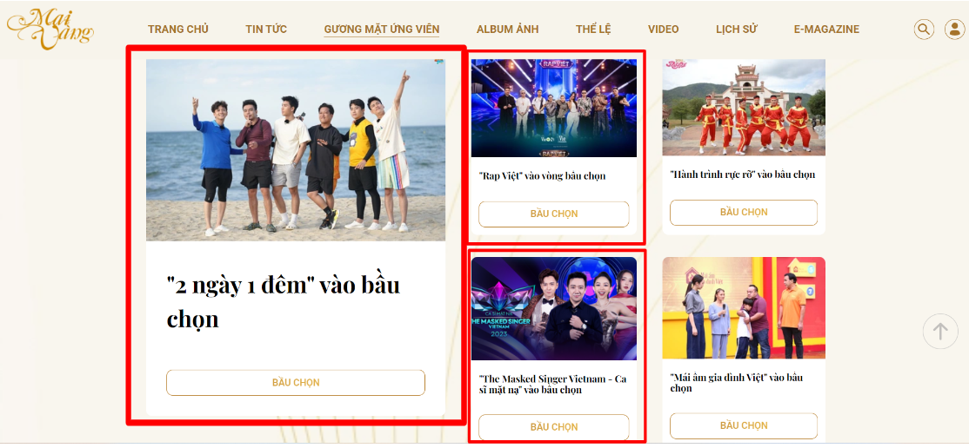

Figure 1. 2: The program "2 days 1 night" won the category "Most popular program on digital and television platforms (including YouTube, TikTok...)" at the 29th Mai Vang awards ceremony (VieShows Youtube Channel, 2024)
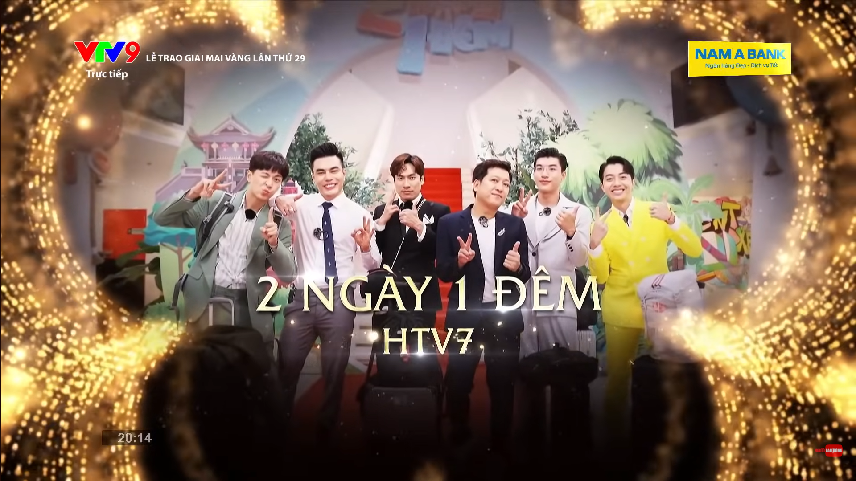

Despite the fact reality-format shows has become new entertainment trend among Vietnamese audiences, it appears that there is a shortage of music competition reality shows featuring participants who are trainees aspiring to debut as an idol group, as the first idol survival program in Vietnam is Vote For Five released in 2021. This situation is clearly shown through the reality that K-pop industry witnesses an increasing presence of international idols (Istad, Gibson, & Curran, 2022). Vietnamese trainees are constantly looking for opportunities to debut music groups in national idol survival competitions, such as: Nguyễn Thành Công (Boys Planet), Đặng Hồng Hải (Boys Planet), Huỳnh Hoàng Hùng (Asia Super Young), Huỳnh Phan (Asia Super Young), Vũ Linh Đan (Universe Ticket), and Ánh Sáng (CHUANG Asia). Furthermore, successful debuts of individuals like Hanbin Ngô Ngọc Hưng (Tempest), Hanni Phạm Ngọc Hân (New Jeans) in the competitive Korean entertainment market underscore the talent pool in Vietnam. With Vietnamese trainees aiming for international idol survival programs, investing in idol nurturing programs becomes essential. Hence, the Vietnamese entertainment industry should consider establishing more comprehensive idol nurturing shows. Figure 2.1 lists contestants of Vietnamese origin who have participated in international idol survival programs. Figure 2.2 lists the names of Vietnamese trainees who have debuted as idols in Korea. It must be mentioned that Hanbin Ngo Ngoc Hung (left) was also a contestant on a music competition reality show selecting members for a Korean music group called I-LAND.
Figure 1. 3: Vietnamese trainees participate in idol survival programs. From the left and up to down: Nguyễn Thành Công, Đặng Hồng Hải, Hoàng Huỳnh Hùng. Hoàng Phan, Vũ Linh Đan, Ánh Sáng. (Internet, 2024)


Figure 1. 4: Korean idols of Vietnamese origin. From the left: Hanbin Ngô Ngọc Hưng (TEMPEST), Hanni Phạm Ngọc Hân (NewJeans) (Internet, 2024)
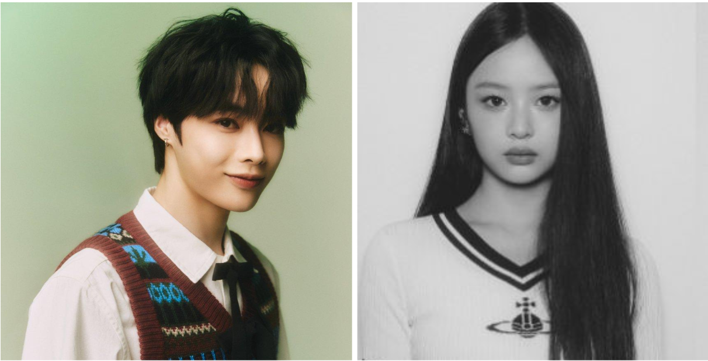

The starting point of the idol survival show genre started from Korea. Back in the time, South Korea's cultural phenomenon, known as Hallyu or the Korean Wave, propelled by K-pop and dramas, has significantly elevated the country's soft power globally (Choi & Maliangkay, 2014). Stakeholders in South Korea, spanning the government, businesses, media, and academics, have actively pursued strategies to shape the future of Hallyu, aligning it with their objectives (Kim, 2015). One of the key aspects of this wave is the music competition reality competition format, particularly popularized by "Produce 101 Season 1" in 2016.
"Produce 101" has become a global success story, with its unique format—absence of judges and reliance on audience decisions—leading to emotional connections between contestants and audience, those who are exposed to this new type of entertainment for the first time, as well as meeting more than 100 contestants at the same time. Beyond showcasing talent, the show delves into contestants' personal lives, behind-the-scenes stories, and down-to-earth aspect (Zhang, 2021). Its success has expanded both nationwide and internationally. According to rating agency Nielsen Korea, “Produce 101 season 1” had the highest viewers reaching 4.4 percent, while “Produce 101 season 2” had the highest ratings, peaking at 5.2 percent. Season three of “Produce 101” named “Produce 48” has the highest viewership at 3.1 percent, and season four, which can be called “Produce X 101” reached its highest ratings with 2.5 percent (Yoon, 2019), as illustrated in figured 1.3.
Figure 1. 5: Highest Korean “Produce 101” viewership rating through 4 seasons. (Korea JoongAn Daily, 2019)
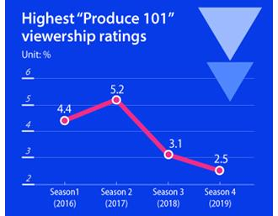

Furthermore, the show’s popularity has acrossed East Asia and beyond, spawning multiple franchises and localized versions, including in China and Japan, with a massive global following. The first season of "Produce 101 China" attracted more than 4.3 billion views on Tencent Video (Caijing, 2018). The hashtag for the fourth season of “Produce 101 China”, which is #ProduceCamp2021 has been viewed more than 2.89 billion times and has received around 4.75 million comments on both Chinese, and global social platforms (Dao, 2021), such as Weibo, Xiaohongshu, Twitter, Instagram, ...
Among franchise programs from "Produce 101" series, there are shows like CHUANG 2021 and "Produce 101 Japan Season 2," whose release dates are relatively close with the first study variable of this research – Vietnamese idol survival program Vote For Five. CHUANG 2021 was released on February 17, 2021, "Produce 101 Japan Season 2" on April 8, 2021, and Vote For Five on June 28, 2022. Moreover, these three shows can ensure the consistency since having male contestants, as some other "Produce 101" series feature female competitors.
Figure 1. 6: Poster of “Produce 101 Japan Season 2” program (LAPONE Entertainment, 2021)
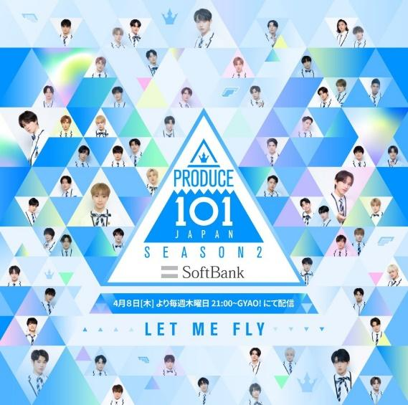

Figure 1. 7: Poster of CHUANG 2021 program (We TV, 2021)


In order to assess popularity of the two mentioned programs in the "Produce 101" series, researcher base on views of the shows’ theme song videos in the first and last episodes on each program’s official YouTube channel. This choice is to ensure uniformity for the two subjects of comparison. The video announcing the theme song of CHUANG 2021 recorded 6.1 million views. Meanwhile, "Produce 101 Japan Season 2" reached 4.8 million views for the release of its theme song. CHUANG 2021 recorded an achievement of 5.4 million views for its theme song in the final night of the competition. On the other hand, the video of the final theme song "Produce 101 Japan Season 2" reached 3.6 million views (see Figure 5.1 - 5.4). Therefore, this research project chooses CHUANG 2021 as the frame of reference for content and popularity for Vote For Five.
Figure 1. 8: Views of the theme song of the show CHUANG 2021, accessed on March 18, 2024: 6.1 million views (CHUANG ASIA Channel, 2021)
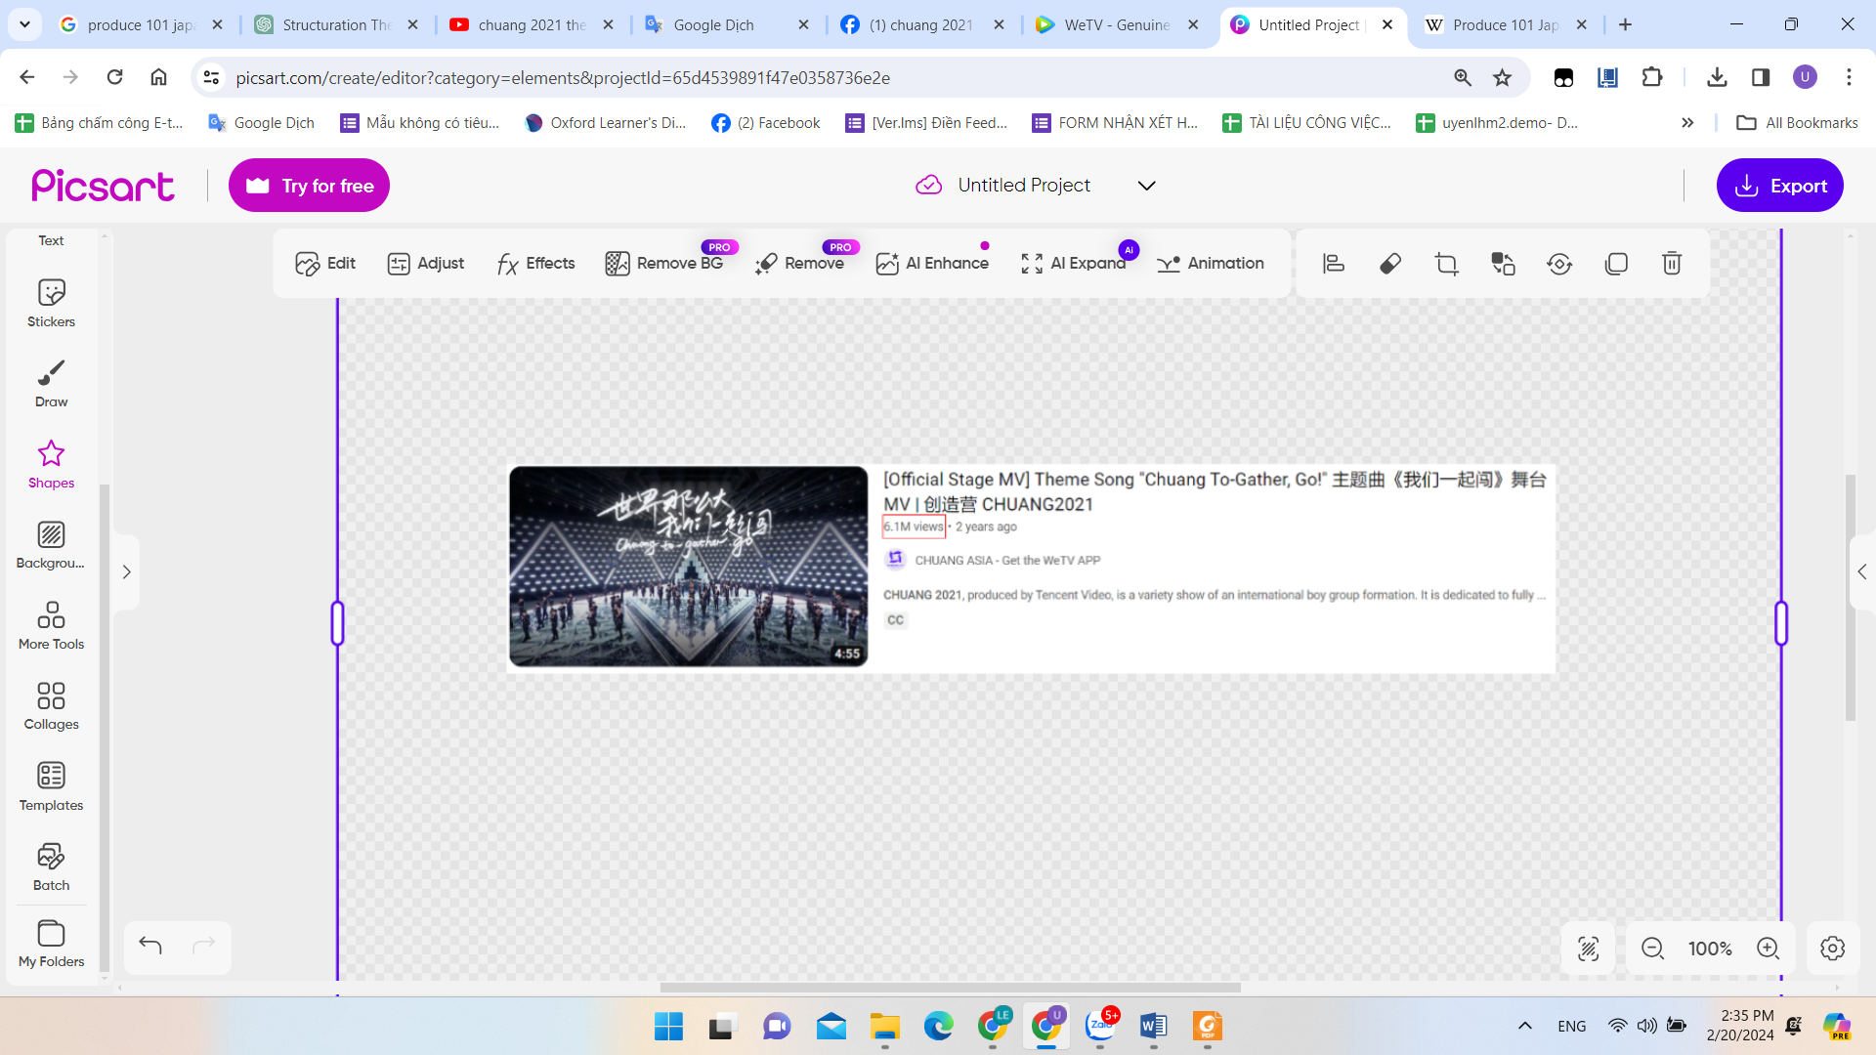
Figure 1. 9: Views of the theme song of the show "Produce 101 Japan Season 2", accessed on March 18, 2024: 4.8 million views (PRODUCE 101 JAPAN Channel, 2021)
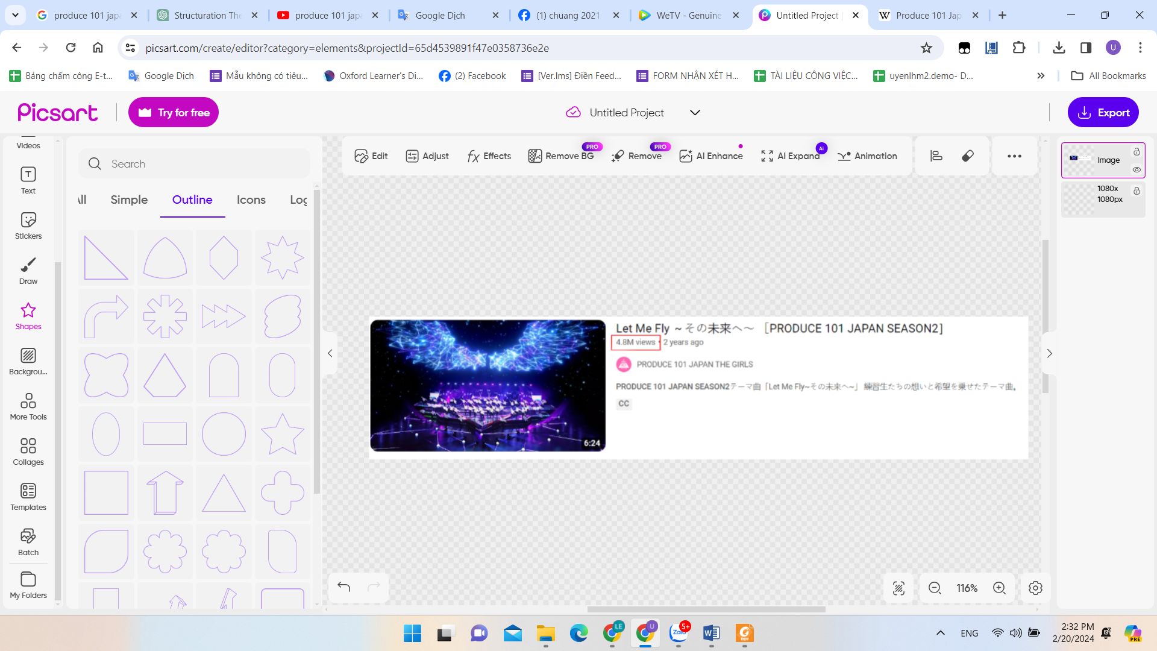
Figure 1. 10: Views of the final night’s song of the show CHUANG 2021, accessed on March 18, 2024: 5.4 million views (CHUANG ASIA Channel, 2021)
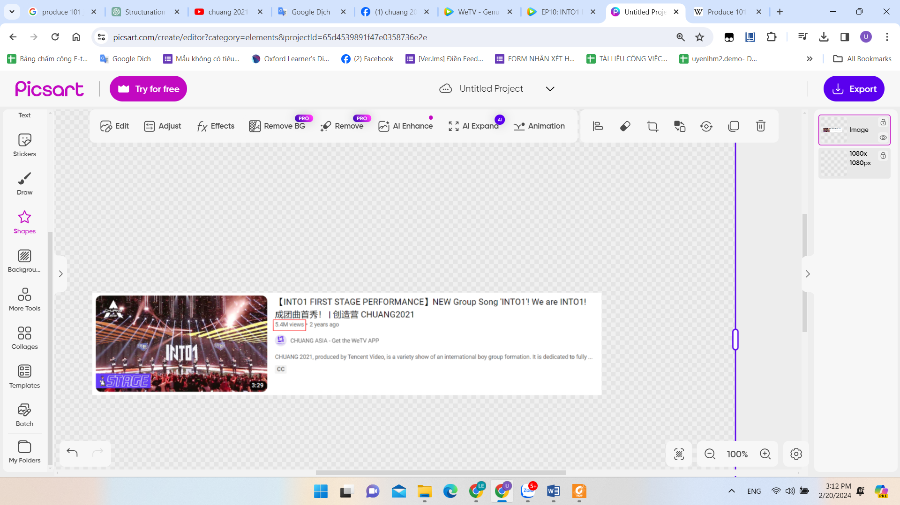
Figure 1. 11: Views of the final night’s song of the show "Produce 101 Japan Season 2", accessed on March 18, 2024: 3.6 million views (PRODUCE 101 JAPAN Channel, 2021)
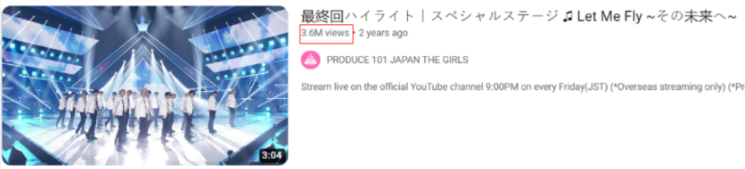

CHUANG 2021, is a Chinese music competition reality television show that aired in 2021. It is part of the "Produce 101" series franchise, which originated in South Korea and has been adapted in various countries. The show was developed by a Chinese multimedia company Tencent, and was broadcast on two video streaming platform Tencent Video and WeTV. The show aims to discover and debut a new boy group by selecting trainees from a pool of contestants through audience voting.
Throughout the competition, 90 male contestants undergo rigorous training in singing, dancing, and other performance skills under the guidance of mentors. They participate in challenges and missions required performing live in front of viewers and mentors. The contestants are evaluated based on their performances, stage presence, teamwork, and popularity among the audience. At the end, 11 finalist qualified contestants form into a boy band called INTO1.
Figure 1. 12: Promotion poster of CHUANG 2021 program. (We TV, 2021)


CHUANG 2021 follows a multi-round format to determine the final lineup of the boy band. The following is an explanation for each round of the program:
- Auditions Round: Contestants perform alongside their label mates or in pre-made groups in front of mentors and other competitors. After each performance, the trainees and mentors both decide on the contestant's ranking through voting devices installed in their seats. The ranking is called "Class" in the show and can be divided into four classes, following the descending order: A, B, C, and F. This ranking is not permanent, as it can change after the 1st public evaluation stage and theme song challenge.

- 1st Public Evaluation Stage: Contestants are required to perform live in front of the audience for the first time. By having a voting device prepared inside the studio, audience can vote for their favorite performance and favorite trainee after each performance. There are 14 songs available for the upcoming 1st evaluations, and trainees can choose the song they want based on their rank. The higher their rank, the earlier they can choose the song. Each song has a limit on how many team members can join. A draw was held to determine which groups will compete against each other. This battle on the 1st public evaluation stage is crucial as it decides the trainees' new class status. The team with the highest votes in this performance will become the new Class A students automatically.

- Theme Song Challenge: The theme song "我们一起闯" is performed in both Chinese and English versions, titled "Chuang, To-Gather, Go!" All trainees are required to memorize the choreography and learn both the Chinese and English lyrics of the song within a short period of time. After this designated time, all 90 trainees are re-evaluated by the mentors, resulting in changes within the trainees' new class rankings, as they may either rise or fall.

- 1st elimination: 60 trainees from 1st to 60th ranking can enter the 2nd public evaluation stage. Contestants placed from 56th to 90th are eliminated from the competition.

- 2nd Public Evaluation Stage: Contestants are required to perform live in front of the audience. By having a voting device prepared inside the studio, audience can vote for their favorite performance and favorite trainee after each performance. This evaluation stage is divided into three professional directions is Dance, Vocal and Composition. Trainees watch all professional direction assessment performance track demo video and fill in their professional direction assessment of the first, second and third volunteer, forming 5 dance teams; 3 vocal teams; and 3 composition teams of 11 teams. Each group is limited to five places, and if the excess is excluded according to the ranking, the lower ranked participants will be transferred to the second or third volunteer. The team and individual with the highest audience votes are awarded Best Performance Team and MVP, respectively, and earn the opportunity to perform in the next stage.

- 2nd Elimination: 33 trainees from 1st to 33rd ranking can enter the 3rd public evaluation stage. Contestants placed from 34th to 60th are eliminated from the competition.

- 3rd Public Evaluation Stage: Contestants are required to perform live in front of the audience. By having a voting device prepared inside the studio, audience can vote for their favorite performance and favorite trainee after each performance. During the evaluation phase, trainees participate in concept evaluation by listening to six original songs and watching professionally-directed assessment performance videos. Viewers select one trainee as the center for each song through an online poll lasting a week. Other trainees choose songs based on their rankings. The team and individual with the highest audience votes receive awards for Best Performance Team and MVP receiving facility benefits in their dormitory.

- 3rd Elimination: 25 trainees from 1st to 25th ranking can enter the finale. Contestants placed from 26th to 33rd are eliminated from the competition.

- The Finale: The final episode took place on April 24, 2021, and was shown live to reveal the 11 contestants chosen to debut as members of the new boy band, INTO1. The outcome was determined by votes cast online from both nation and global audience.
"CHUANG 2021: Are You a Werewolf?": This is a segment within the Chinese music competition reality show CHUANG 2021, where contestants participate in a game inspired by the party game "Werewolf." This show broadcasted on Tencent and WeTV. In this segment, contestants take on roles such as werewolves, villagers, or other characters, and they must use strategy and deduction to identify and eliminate the werewolves among them.
Figure 1. 13: Promotion poster “Are you a werewolf?” segment in CHUANG 2021 program. (We TV, 2021)
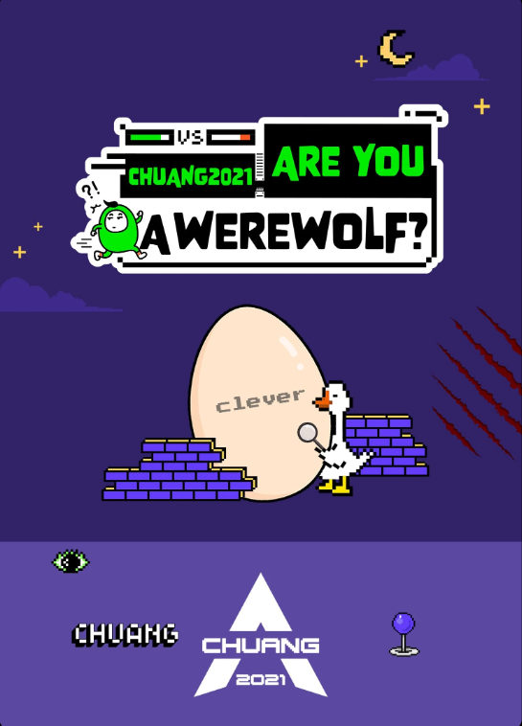

“CHUANG 2021: Dorm Dairy”: This is a derivative show of CHUANG 2021 that offers a glimpse into the daily lives and experiences of contestants competing in the CHUANG 2021 competition. The show broadcasted on Tencent and WeTV. It captures the journey of aspiring artists as they navigate challenges, form friendships, and pursue their dreams of debuting in the entertainment industry. Through candid moments and behind-the-scenes footage, viewers get to know the contestants on a personal level, witnessing their growth, struggles, and interactions with one another.
Figure 1. 14: Promotion poster “Dorm Diary” segment in CHUANG 2021 program. (We TV, 2021)
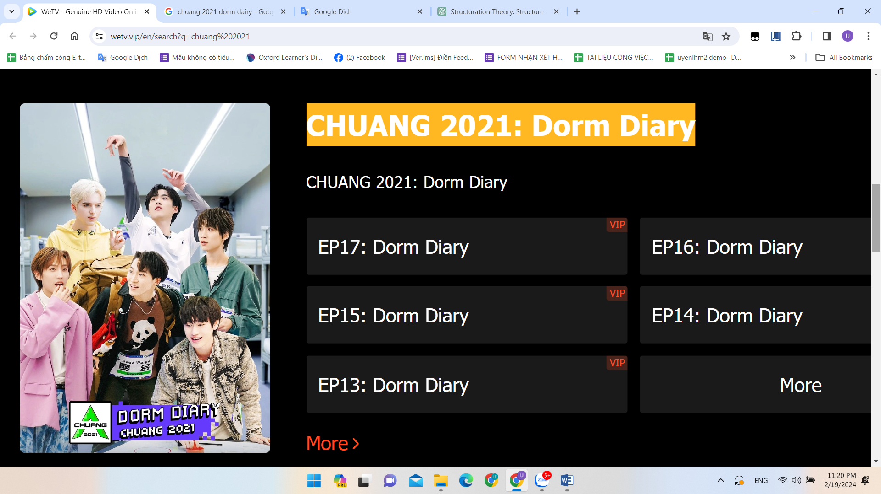

“CHUANG 2021: Behind The Scenes”: "CHUANG 2021: Behind the Scenes" provides a captivating glimpse into the production and dynamics of the show. This derivative show broadcasted on Tencent and WeTV. It offers viewers an exclusive look at the intricate workings of the program, from the audition process to the intense training sessions and the contestants' emotional journeys. Viewers gain insight into the personal stories and aspirations of the contestants as they strive to achieve their dreams of becoming idols. Additionally, the show delves into the mentorship provided by industry professionals and the camaraderie among contestants.
Figure 1. 15: Promotion poster “Behind The Scenes” segment in CHUANG 2021 program. (We TV, 2021)
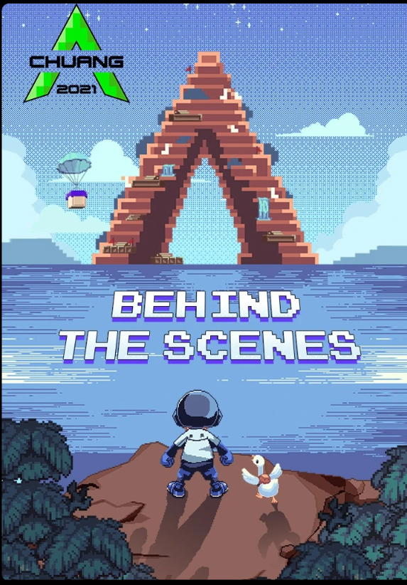

“CHUANG 2021: Practice Room”: "CHUANG 2021: Practice Room" is a spin-off of CHUANG 2021. The show broadcasted on Tencent and WeTV. In this spin-off, viewers are given a behind-the-scenes look into the intense training and rehearsal process undergone by the contestants as they prepare for their performances on the main show. The series offers a glimpse into the rigorous training regimen, personal struggles, and camaraderie among the participants as they strive to improve their skills and showcase their talents.

Figure 1. 16: Promotion poster “Practice Room” segment in CHUANG 2021 program. (We TV, 2021)
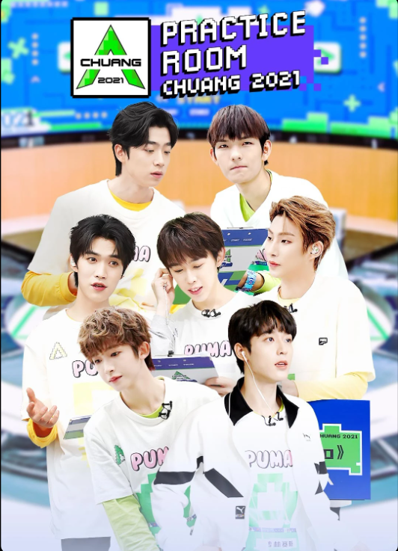

Focusing on Vietnamese context as mentioned, Vietnamese trainees are constantly looking for opportunities to debut as artists through Korean survival competitions. This touched music producers in Vietnam and led to the formation of Vote For Five. Mr. Nguyễn Quang Huy - The producer and director of Vote For Five spoke at the press conference launching the show, stating: " Vote For Five is not a remake of Produce 101. What we aim to do is create more opportunities so that young people can stand on stage and assert their talents.", as reported in (Trần, 2022).
Figure 1. 17: Mr. Nguyễn Quang Huy - The producer and director of Vote For Five at the press conference launching the show. (duyendangvietnam.net, 2022)

Vote For Five is the first Vietnamese music competition reality show that aired in 2021, providing a platform for aspiring musicians to showcase their talents and compete for a spot in a newly-formed boy band. The show was developed by a Vietnamese entertainment company WEPRO, and was broadcasted on YouTube. Despite not being part of the "Produce 101" series franchise, the show follows a similar format, with contestants performing in teams and being eliminated through audience voting to select a specific number of trainees to form a boy band.
Figure 1. 18: Promotion poster for Vote For Five program. (Facebook fan page Vote For Five, 2022)
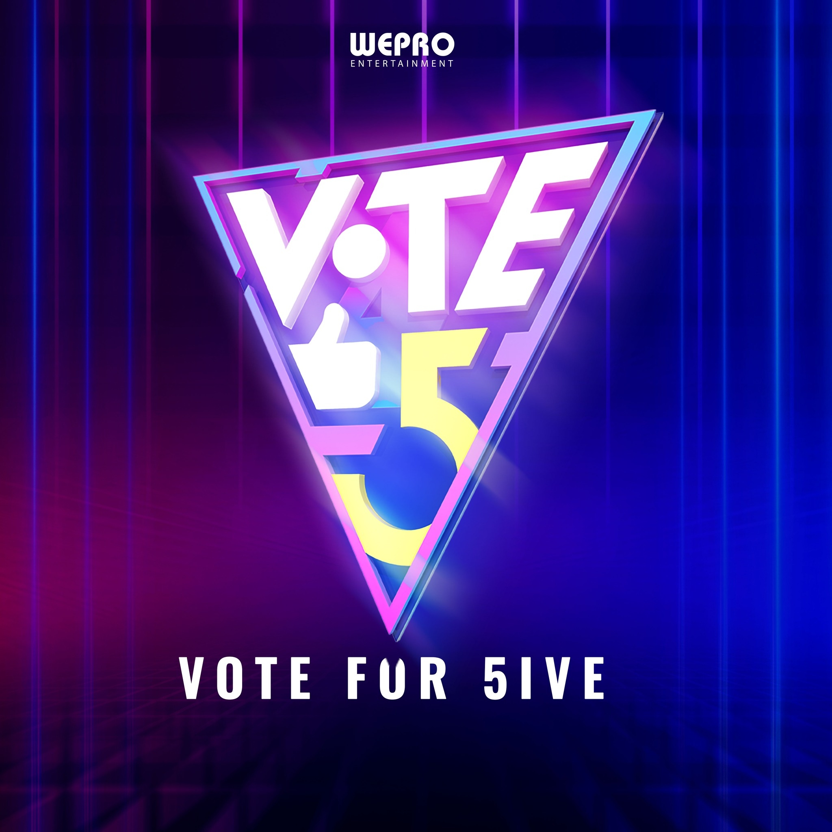

During the contest, 100 young male trainees receive intense training in singing, dancing, and other performance abilities with mentors' support. They face challenges and tasks, performing live for audiences and mentors. Their performances, stage skills, teamwork, and audience appeal are assessed. Finally, the top 5 contestants come together to form a boy band. The competition rounds are held as following:
- Auditions Round & 1st Elimination: The Vote For Five's Top 100 is split into three age groups: A, B, and C, based on birth years. Group A includes individuals born between 1992 and 1997, divided into six subgroups. Group B comprises those born between 1998 and 1999, organized into three subgroups. Group C consists of individuals born between 2000 and 2004, also with three subgroups. Each subgroup is required to rehearse together and present a specific song during the competition. As the rehearsal proceeds, the mentors secretly observe contestants through a screen inside a closed room. As a result, 50 trainees are eliminated even before the official stage.
- 1st Public Evaluation Stage & 2nd Elimination: The 50 contestants are tasked with reallocating personnel for each song and are required to perform live in front of the audience. With a voting device readily available inside the studio, viewers can cast their votes for their preferred trainee following each performance. 40 trainees from 1st to 40th ranking can enter the 2nd public evaluation stage. Contestants placed from 41st to 50th are eliminated from the competition.
- 2nd Public Evaluation Stage & 3rd Elimination: During the second evaluation phase, participants engage in concept evaluation through performances of 8 designated songs. Their song selection is based on their ranking, with higher-ranked participants having priority in choosing. Each song has a maximum number of team members allowed to join. Contestants are obligated to perform live in front of the audience, who can then vote for their preferred participant using a provided voting device after each performance. 30 trainees from 1st to 30th ranking can enter the 3rd public evaluation stage. Contestants placed from 31st to 40th are eliminated from the competition.
- 3rd Public Evaluation Stage & 4th Elimination: In the third evaluation stage, contestants engage in a soundtrack-themed assessment where they perform six designated songs selected by mentors. Trainees are expected to showcase their performances live in front of the audience, who are provided with voting devices to vote for their preferred contestant following each performance. 25 trainees from 1st to 25th ranking can enter the 4th public evaluation stage. Contestants placed from 26th to 30th are eliminated from the competition.
- 4th Public Evaluation Stage & 5th Elimination: In this assessment stage, trainees engage in a group battle evaluation where they perform five pre-assigned songs. The group's ranking from the previous mission determines their priority in selecting songs. Contestants must deliver live performances before the audience, who can then vote for their preferred group using provided voting devices after each rendition. Audiences watching the live broadcast on the video on demand (VOD) application FPTPlay can also participate in real-time voting for their favorite group. Each member in the winning team gets 200 votes. 20 trainees from 1st to 20th ranking can enter the 5th public evaluation stage. Contestants placed from 21st to 25th are eliminated from the competition.
- 5th Public Evaluation & 6th Elimination: In the stage, trainees remain engaged in group battle evaluations, where they perform five designated songs. New groups are formed through a draw, and leaders select the order of song choices through a game. Contestants perform live in front of an audience, who can use voting devices to choose their preferred group after each performance. Additionally, viewers watching the live broadcast on the VOD application FPTPlay have the opportunity to participate in real-time voting for their favorite group. Each individual in winning team gets 1 million votes. 10 trainees from 1st to 10th ranking can enter the finale. Contestants placed from 11st to 20th are eliminated from the competition.
- The Finale: The final episode took place on October 13, 2022, and was shown live to reveal the 5 contestants chosen to debut as members of the new boy band. The outcome was determined by votes cast on-site and online.
However, Vote For Five faced challenges in gaining comparable recognition. Even though the content of the show was uploaded on video-on-demand (VOD) platform like YouTube, it struggled with low social media engagement, indicating a lack of resonance with the audience (Nguyên, 2022) among Vietnamese viewers compared with programs from “Produce 101” series. The researcher decides to choose Vote For Five due to being the first idol survival program follows the format of giving 100% decision-making power to the audience’s vote in Vietnam. Besides, the outcome of this program is unusual as it is the only idol survival show whose finalist boy band has no sight of debut with no further explanation (Linh, 2023), which is completely opposite to the debut of 9 boybands debut from Korea, China, and Japan idol survival show demonstrated in figure 13. The official program introduction of Vote For Five on official social networking sites such as Facebook and YouTube always include the phrase "Looking for a new generation boy band". So, the fact that the final contestants were not introduced means that the program has not yet achieved the program's stated goal.
Figure 1. 19: Male idol groups from idol survival shows. From the left, up to down: WANNA ONE, X1, JO1, INI, R1SE, INTO1, ZEROBASEONE, UNINE, IXFORM (Internet, 2024)
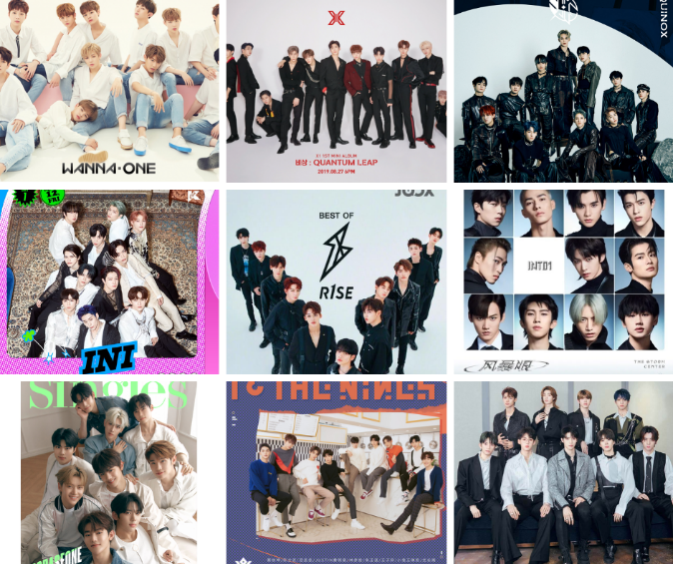

According to Hill (2014), intricately weaves real-life narratives with dramatization, impacting the emotional connection of the audience. The conclusion of an idol survival program marks a fresh start, influencing not only the winners but also the audience. Supporters become part of the success and responsibilities of the new group, actively participating in their journey (Kweon, 2018). The study aims to explore the narrative strategies of CHUANG 2021 and Vote For Five, seeking insights into the storytelling techniques and level of audience engagement contributing to one program's global success. Meanwhile, the research project also aims to understand why the other program struggles with audience connection.
When a story is shared through media, it's usually packaged in a set way, and the chance for interaction is left out (Garber-Barron & Si, 2021). In traditional media channels like television, radio, or newspapers, stories are typically presented in a one-way communication format, where the audience passively receives information without the opportunity to actively participate or provide feedback (Apuke, 2017). This leads to the decrease of audience engagement, which has gained significantly importance in the media and advertising business (Broersma, 2019). This research recognizes the significance of skilled storytelling in adjusting narratives based on audience reactions, aiming to provide insights into the ability of narrative storytelling in reality TV and its influence on audience. Through the exploration of these narrative strategies, the study seeks to unravel one of possible aspects that contribute to the global success of one program and the challenges faced by another in connecting with its audience.

Objectives of Study
1.2.1 To examine and compare the effective representation of the portrayal of contestants’ personal stories in the Chinese and Vietnamese idol survival programs.
1.2.2 To examine and compare the effective representation of the portrayal of contestants’ musical talents in the Chinese and Vietnamese idol survival programs.

Scope of Study
This study encompasses an examination of narrative storytelling in idol survival programs, focusing on a comparative analysis between the two Chinese and Vietnamese specific shows, respectively: CHUANG 2021 and Vote For Five. The study aims to explore how narrative elements, such as contestants' personal stories, are utilized in these programs. By analyzing the narrative techniques employed in each show, including the presentation of contestants' backgrounds, struggles, and aspirations, the study seeks to uncover similarities and differences in narrative construction. Through this comparative analysis, the study aims to provide insights into the role of narrative storytelling in idol survival programs.

Research Questions
1.3.1 How do the Chinese and Vietnamese idol survival programs portray the contestants’ personal stories?
1.3.2 How do the Chinese and Vietnamese idol survival programs portray the contestants’ musical talents?

Significance of the Study
Research on narrative techniques in idol survival shows, specifically Vietnamese one is currently limited, with scholarly attention traditionally focused on established formats like films and drama series. In academia, this topic offers valuable insights into the role of narrative construction in reality television and its impact on audience engagement in Vietnam market. This study contributes to academic analysis concerning media, cultural, and audience-related studies, as well as narrative-related theories. It sheds light on the dynamic relationship between storytelling, identity formation, and audience interaction.
From a media industry perspective, understanding the nuances of narrative storytelling in idol survival programs is crucial for Vietnamese producers, networks, and content creators. By analyzing the differences between CHUANG 2021 and Vote For Five, Vietnamese media professionals can glean insights into effective narrative strategies for engaging audiences and enhancing viewer retention. This research can inform programming decisions, content development, and marketing strategies, ultimately leading to more compelling and successful reality television productions.

Definition of Terms
1.6.1 Hallyu (한류): "Hallyu," or the "Korean Wave" (Oxford University, 2023), is the term used to describe the phenomenon of Korean popular culture that gained popularity in Southeast Asia and mainland China in the late 1990s (Kim, 2015). In this research, "Hallyu" specifically refers to the K-pop industry and, more specifically, Korean idol survival programs.
1.6.2 Idol survival program: An "idol survival program" is a reality TV competition dedicated to discovering and nurturing new pop music idols. Aspiring artists vie for spots in idol groups or solo debuts through challenges, performances, audience voting, and mentorship. Viewers witness contestants' journeys toward their dreams of stardom.
1.6.3 Idol survival show: The term referred to a television program where contestants, often singers or trainee artists, compete against each other in various musical performances. Participants are judged by a panel of experts and/or the audience, with eliminations occurring each round until a winner is chosen. The format aims to discover new talent and entertain viewers through performances and behind-the-scenes footage. Specifically, this definition indicated to this research’s samples - two selected TV shows.
1.6.4 Produce 101: A South Korean TV program, aired since 2016, showcases idol trainees—singers and dancers—facing challenges and eliminations, aiming to form a temporary group.
1.6.5 CHUANG 2021: This is a franchised Chinese idol survival show that united 90 male trainees from various backgrounds to create an 11-member international boy group through global viewer votes. It was exclusively broadcasted on Tencent Video and WeTV, holding the copyright for the program.
1.6.6 Vote For Five: In 2022, Vote For Five, which is a non-franchised but flavored with features of original Korean idol survival program, marked Vietnam's debut survival show, aiming to form a 5-member boy group from 100 male trainees through viewer voting. It's copyrighted by WePro Entertainment and aired on the official YouTube channel "VOTE FOR FIVE OFFICIAL."
1.6.7 Narrative storytelling: Storytelling is the process of turning content, including facts and information into a narrative or 'story' (Fischer, Selm, Sundermann, & Storksdieck, 2020). In this study, storytelling techniques encompass narrative structure, scenes, depiction of competitors, conflicts among contestants and judges, and dispute resolution showcasing participants' improvement.
1.6.8 Visual elements: Focusing on the performance aspect of mentioned idol survival shows, visual elements “contains an in-depth discussion of design elements and principles for costume, set, lighting, sound, projection, properties, and makeup designs” (MALLOY, 2022).

Literature Review

This chapter provides an explanation of reviewing related literature and previous studies, the knowledge gap found from the review of past studies, the main theories and concepts which will be employed to set a theoretical framework for this study, and a visualization of the theoretical framework.

Related Literature and Previous Studies
2.1.1 The emergence of Hallyu and “Produce 101” series
In the book "K-Pop Idols: Popular Culture and the Emergence of the Korean Music Industry", Jin & Lee (2019) discussed the establishment of the first girl and boy groups through audience voting. They emphasized the significant role of “Produce 101”, a large-scale project where the public, called “national producers” - means Korean fans who help to produce the final group, chose members for the debut group. This selection involved elimination rounds from a pool of trainees, and national producers influenced aspects such as the group's concept, debut song, and name. They highlighted that the core of this reality competition show genre lies in revealing a concealed and rigorous training process, showcasing the development and progress of the participants.
Since the birth of the South Korean girl group IOI and the South Korean boy band Wanna One from “Produce 101 Season 1” and “Produce 101 Season 2” became K-pop’s biggest breakout stars in the 2010s (Jin & Lee, 2019), and gradually became bright sample of the adaptation and production of the show in different countries, blending global entertainment formats with local cultural elements to appeal to local audiences. Companies in South Korea are collaborating to establish joint ventures that handle the casting, training, and promotion of Vietnamese artists according to the standards set by the Hallyu wave (Khachaturyan, 2021). However, since the South Korean girl group S.E.S's debut in 1997, Korean beauty standards in the entertainment industry context progressively became more stringent, to the point that the focus shifted away from talent and natural attractiveness to prioritizing artificially enhanced beauty achieved through plastic surgery (Obaya, 2022). Hence, Hallyu has been perceived as having controversial impact on Vietnamese consumers. One of the adverse effects of the influence of the Korean wave in Vietnam among young genaration includes the neglect of traditional arts in favor of Hallyu products and the uncritical adoption of Korean standards, ranging from beauty ideals to preferences in fine arts (Khachaturyan, 2021), for instance, following Korean’s stars’ weight loss diet, which reviewed as non-science-based and contradictory guidelines (Rd, 2019). Or we can mention the case of Vietnamese boy group ZERO 9, who plagiarized the costumes in the MV "One of a kind" by Korean artist Dgragon and used them in the group's MV "WHY". Therefore, the release of "Vote For Five" as the first Korean-alike-format competition show organized in Vietnamese entertainment market (Anh, 2022) seen as an underdog, compares to survival music competitions in the Korean or Chinese market (Sam, 2022). Given the existing gaps in production skills and the controversy surrounding media products following Korean format, it is evident that more academic research is needed to thoroughly explore the impact and evolution of Vietnamese music survival programs, especially to understand how they adapt Korean models while addressing unique cultural dynamics.
Figure 2. 1: Korean soloist Gdragon’s costume in MV “One of a kind” (left) and Vietnamese artist ZERO 9’s JBin’s costume in MV “WHY” (right) (Trần, 2018)

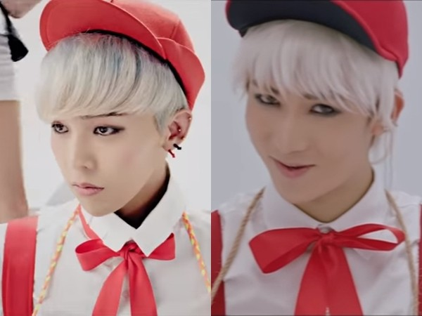
2.1.2 The aftereffects of Idol survival programs
In the work “School of K-pop: Teaching a Nation Through Idol Survival Programs” (Kweon, 2018), the researcher emphasizes the enduring impact of “Produce 101 season 1” - the first ever season of Produce 101 program series - is evident on national, international, and transnational levels. An example is the theme song from “Produce 101 Season 1”, which transformed into a campaign song during the 2016 Korean general elections. Moreover, I.O.I, a group from “Produce 101”, was selected to perform at an event marking the 130th anniversary of diplomatic ties between Korea and France. Besides, in 2017, Wanna One, a boy group from the second season of “Produce 101”, achieved the prestigious "Best Male Group Award" at the Mnet Asian Music Awards, the largest Hallyu music award show. The global appeal of “Produce 101” has garnered interest from international media distributors and content producers, particularly in other East Asian pop industries. As a result, various adaptations of the show have emerged in countries like Japan, China, Thai and Vietnam.
Korea has long been at the forefront of idol culture, with its roots tracing back to the late 1990s (Ding & Zhuang, 2021). The country's influence in this realm reached even greater heights with the emergence of the Hallyu phenomenon in the early 2000s (Jin & Yoon, 2014), solidifying its position as one of the global leaders in entertainment industry. In contrast, Vietnam's journey with K-pop has been more recent, experiencing a surge in interest since the early 2000s, particularly gaining momentum in the 2010s by Korean music and Korean TV drama (Pham, 2022). This relatively recent exposure means that the Vietnamese entertainment market has had less time to develop and integrate shows heavily influenced by the K-pop idol competition format. Additionally, Vietnamese youth who engage in K-pop fandom often face strong resistance from the Vietnamese public, which tends to hold traditional nationalistic views and community-focused values (Duong, 2016). This delay in familiarization is further compounded by the challenges of adapting new formats like music survival competition genre, as well as the necessity of establishing the necessary infrastructure and expertise to produce such complex and resource-intensive shows. As a result, while the Vietnamese audience is increasingly enthusiastic about K-pop, the entertainment industry is still in the early stages of fully incorporating and localizing the competitive elements popularized by K-pop idol competitions. Vietnamese idol survival programs encounter challenges in term of production processes due to their novelty, including a lack of comprehensive information about production processes. As the genre continues to evolve and garner traction among Vietnamese audiences, efforts to document and understand the production processes of these programs become increasingly essential. This holds true for both industry stakeholders and enthusiasts seeking deeper insights into Vietnamese entertainment industry, underscoring the significance of examining the intersection of cultural regulations of performing arts, audience’s preference, and production practices in shaping the country's entertainment landscape.
2.1.3 The evolution of idol admiration orientation in China and Vietnam
The study titled "Consumption-oriented Idol Worship in China" (Chen, 2021) offers a comprehensive exploration of the evolving dynamics between idols and fans in the post-2018 era of idol talent shows. It highlights a notable shift of fandom from passive consumption as being an output of media products managed by TV networks and investors, to active participation involved in creating and managing idols, to the extend that fandom culture turns into “Economic of fandom”, where investors see idol stars and their related merchandise as products, use modern media to communicate, and view "fans" as active consumers and creators. They make money and gain social advantages by running large-scale market operations.This fan-centric approach to the industry places emphasis not only on the idols themselves but also on the value they provide to consumers. Investors now view idols as commodities, utilizing mass media channels for communication and recognizing fans as dynamic participants in the idol ecosystem.
In Vietnam ranked 3rd after Indonesia and Thailand in terms of K-pop consumption, there is a burgeoning market for entertainment investors, as noted by (Huyền, 2023). A more structured study on fandom culture, specifically Vietnamese fandom, has been published by the Hakuhodo Institute of Life and Living ASEAN (HILL ASEAN). Its most recent research endeavor, titled “Unveil Vietnamese Fandom—Why this emerging cultural phenomenon is significant for brands” (Nguyen & Inada, 2023) offers profound insights into the increasing fascination of Vietnam with fandoms. Fandoms flourish through what scholars refer to as “planned unexpectancy”, which Kanto Inada - Communication Designer of mentioned research project - explained: “People join fandoms with a passion for their interest and to enrich their lives. They then gain unexpected experiences and knowledge inside their fandom, and have opportunities for personal growth. Fandoms eventually help people establish themselves through such ongoing self-improvement. Those who have had these experiences, whether consciously or not, become more deeply engaged with their fandom and help to expand its community.” Individuals join fandoms driven by their fervor for a particular interest, seeking to enhance their lives through personal growth achieved by gaining experience and knowledge within their fan community. Over time, participation in fandoms aids individuals in self-establishment through continual self-improvement endeavors. Those who undergo such experiences, whether intentionally or not, become more deeply immersed in their fandom (Nguyen & Inada, 2023), contributing to its expansion, and this process creates a loop, called “fandom cycle”. It is believed that brands can draw lessons from this dynamic and craft analogous opportunities for unexpected growth among their fans and users.
Figure 2. 2: Members of research project “Unveil Vietnamese Fandom—Why this new emerging culture matters to brands” (Nguyen & Inada, 2023)
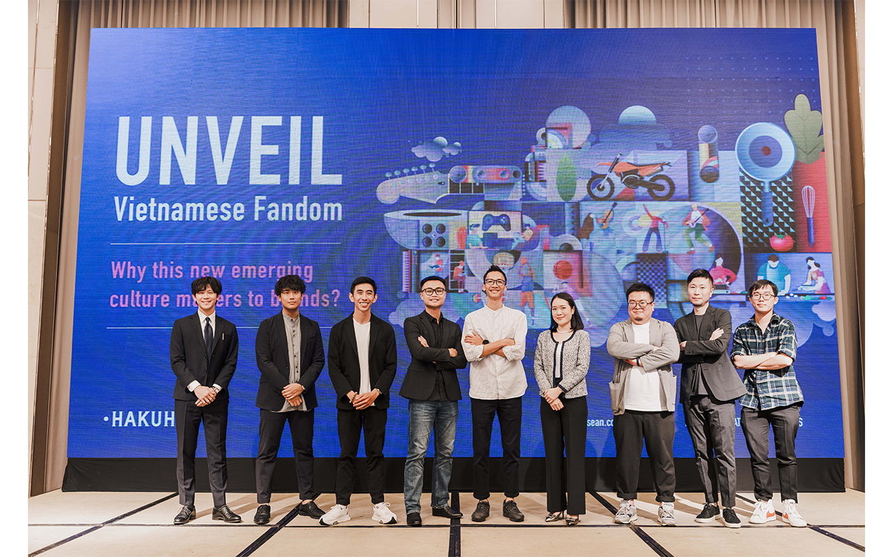

Figure 2. 3: Definition of “planned unexpectancy” (Nguyen & Inada, 2023)
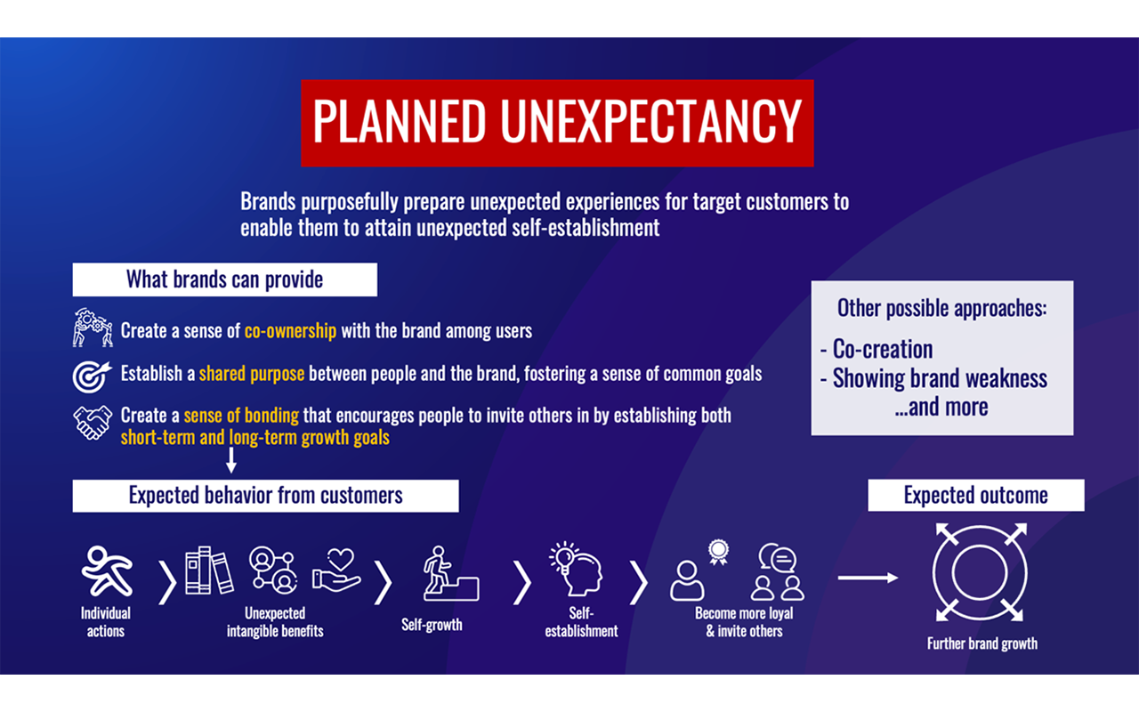
Figure 2. 4: Definition of “fandom cycle” (Nguyen & Inada, 2023)
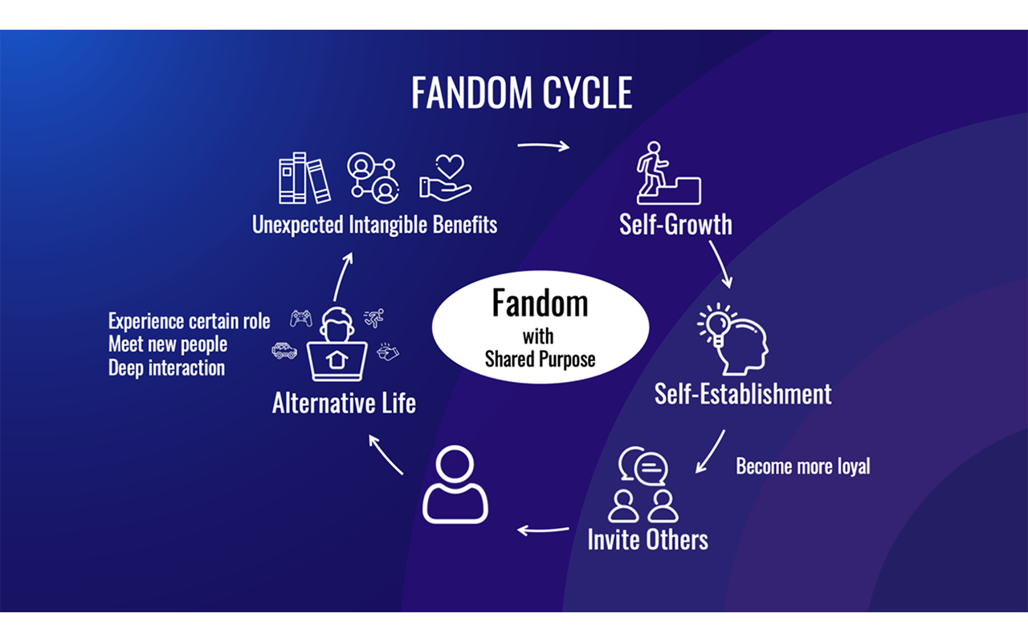
A specific data demonstrated through the case study of Sơn Tùng MTP – A Vietnamese male singer and songwriter - became the representative of Biti's Hunter sneaker line for a Vietnamese footwear brand – BITI. Biti's rejuvenated its brand through the music video "Lạc Trôi" on YouTube, where the singer showcases the new Hunter shoes amidst picturesque Vietnamese landscapes in a fantasy backdrop. Within the initial 48 hours, the video garnered seven million views, leading to a complete sell-out of Biti's products in just seven days (Nguyen & Nguyen, 2020). In this period of time Biti's Hunter's sales also increased by 300% (Nguyễn, Võ, & Nguyễn, 2021).

Figure 2. 5: A scene from Sơn Tùng MTP’s “Lạc Trôi” music video with the appearance of the Bitis Hunter shoe line (Vũ, 2023)

There is also a recent positive move by businesses that have begun to pay attention to the potential purchasing power of a fandom. Military Commercial Joint Stock Bank (MB) with the contribution of international card organization JCB has introduced the first unique collaboration with male singer Sơn Tùng MTP in the project "Be The Sky", in order to create The first bank card integrated with fandom card in Vietnam - Sky Card. Designed specifically for the Sơn Tùng MTP fandom community, which named SKY, the “Be The Sky” product is not simply a financial product but also crystallizes elements of music, art and technology, connecting fans with their idols. More important, “Be The Sky” is the first bank card in Vietnam to integrate a fandom membership card. Customers will have the opportunity to receive gifts as well as enjoy many exclusive incentives at events related to Sơn Tùng MTP (Dương, 2024)

Figure 2. 6: Poster with the appearance of Son Tung MTP for the Be The Sky Collection bank card collection (MB Bank, 2024)
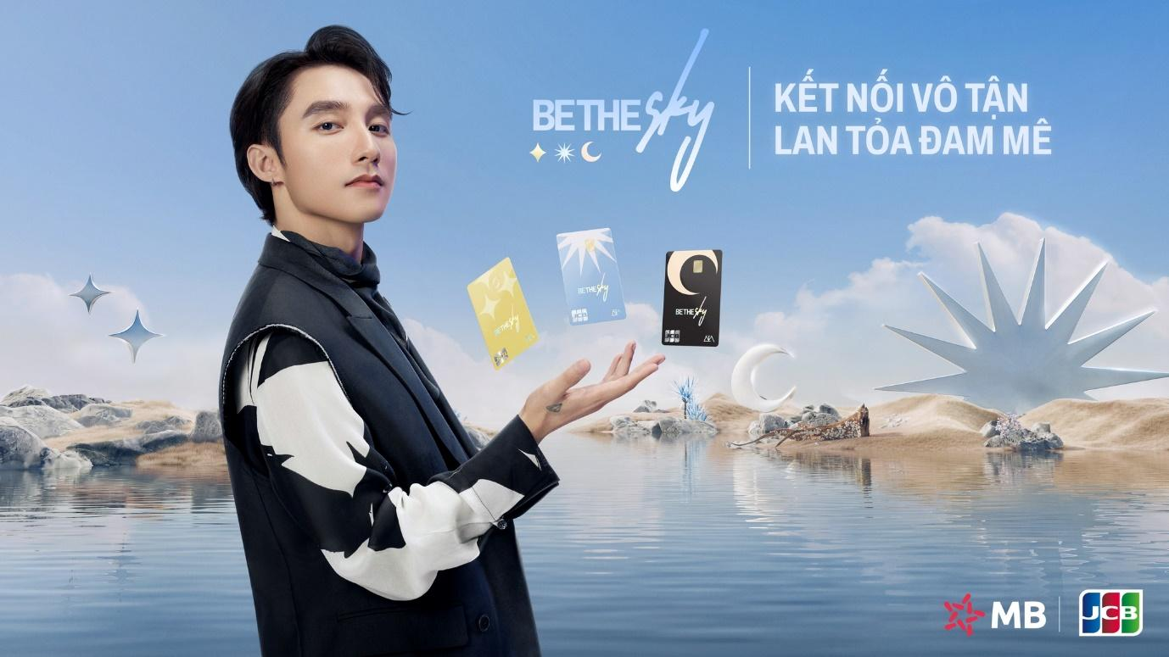

Vietnam boasts a fervent and dedicated fandom across various entertainment sectors, ranging from music and film to pop culture phenomena. However, the local management companies frequently fall short in leveraging this enthusiastic fan base due to a lack of published, free and easily- accesed study or research about fandom’s purchasing ability, on both domestic and internation academic websites. Strategic planning, crucial for capitalizing on the potential of the Vietnamese fandom and potentially expanding its reach globally, remains an overlooked aspect. Without a deep understanding of fan preferences, behaviors, and trends, management companies struggle to tailor their offerings effectively or engage with audiences in meaningful ways. As a result, opportunities to cultivate and harness the full potential of the Vietnamese fandom remain untapped, hindering the country's ability to make significant strides in the global entertainment landscape.
2.1.4 The transformation of idol survival program
Zhang's (2019) research highlights the distinctive features of network talent shows, particularly in the narrative mode of "idol cultivation" in China. Shows like <Chuang 2018> or <Idol Producer> focus on actively shaping star idols in alignment with mainstream values, moving away from the concept of "overnight fame" to "being worth teaching." The study underscores how online talent shows overcome the limitations of traditional formats by expanding channels through extended content related to contestants. Unlike traditional shows where personal attributes may be overshadowed, cultivation talent shows allow contestants' potential to persist, providing more opportunities for personalized audience choices. Moreover, the integration of social media in the new generation of talent shows enables fan interaction, turning it into a means for fans to actively participate in idol cultivation. Finally, the shift from a mere "show" to a focus on the "reality" of contestants' daily lives brings a more authentic connection between the fandom and idols.
The article “From "Overnight Fame" to "Being Worth Teaching" "Idol Cultivation": a New Narrative Mode of Talent Show” (Zhang, 2019) provides a close examination of the shifting narrative patterns observed in traditional and contemporary idol talent shows. However, these are general arguments, lacking a detailed textual analysis to determine the extent of these changes and how they occur. It is crucial to conduct an academic research to fill this void, not only to comprehend global idol survival programs, but also to establish a qualified standard for the content of Vietnamese idol talent shows. This endeavor aims to increase audience engagement.
In conclusion, the influence of the Korean wave, or Hallyu, on Vietnamese consumers has sparked both enthusiasm and controversy, particularly among the younger generation. While there is a growing interest in K-pop and its associated culture, this fascination has led to the neglect of the uncritical adoption of Korean standards, especially to entertainment practices. The emergence of Vietnamese idol survival programs, modeled after Korean formats, faces significant challenges due to gaps in production skills and a lack of comprehensive research on these programs. As the genre evolves, it is crucial to conduct more academic research to understand the adaptation of Korean models to the Vietnamese context and to address the unique cultural dynamics at play. Moreover, the Vietnamese entertainment industry has yet to fully capitalize on the potential of its dedicated fanbase, largely due to the absence of accessible research on fandom behavior and purchasing power. To make meaningful progress in the global entertainment landscape, it is essential to bridge these knowledge gaps and develop a deeper understanding of the production processes and audience engagement strategies that can drive the success of Vietnamese idol talent shows and the broader entertainment industry. Previous research on idol survival programs has mainly concentrated on the original "Produce 101" series in Korea or its Chinese adaptations. Even when it comes to research about Vietnamese fandom culture, this type of TV show still hasn't been included. This paper aims to explore Vietnam's locally produced idol survival programs and their target audience, which includes fans of the "Produce 101" series and the fandoms of Vietnamese contestants. These fans possess the cultural knowledge and ability to potentially influence the development of Vietnamese idol survival programs. By examining storytelling techniques and audience engagement, this study investigates how audiences perceive reality shows and interact with them.

Related Theories
2.2.1 The Competition Reality Television Show and Its Narrative Dynamics
According to Chandler & Munday (2011, p.355), “Reality Television is a hybrid genre combining fly-on-the-wall documentary, quiz show, and popularity contest…in which selected members of the public spend time together in the same location.
Since the early 2000s, reality television has become a major genre, attracting large audiences with its often controversial and sensational content. These shows typically focus on dramatic storylines, personal conflicts, and emotional moments (Olley et al., n.d.). What makes reality TV both fascinating and, at times, unsettling is the way these shows blur the line between staged events and real-life experiences (King, 2005). The genre’s popularity is driven by the use of video and other technology that lets the audience not only watch but also engage and even create content themselves. This gives reality TV a unique feeling of immediacy and spontaneity, as it captures unexpected moments in real time (Jagodzinski, J., 2003 cited in Papacharissi, Z. & Mendelson, A. L., 2007). Besides being a major source of revenue for television networks, reality shows offer participants a platform to showcase their talents and gain recognition. Many contestants go on to achieve fame, and viewers appreciate seeing real people performing tasks or challenges in a way that feels genuine and relatable. Reality TV gives individuals a chance to demonstrate their skills, start careers, and explore their own potential, making it both entertaining and impactful for the participants and the audience (Malur et al., 2014).
As Keating (2013) discussed, as a form of non-fiction entertainment, reality shows adhere to some of the conventions found in documentary filmmaking, for instance, producers and editors sift through extensive unscripted footage to construct a cohesive narrative. However, as a television genre, reality shows face the task of keeping viewers engaged not only during commercial breaks but also throughout a lengthy season comprising multiple episodes. Besides, as Newman (2006) explained in "From beats to arcs: Toward a poetics of television narrative”, a TV show that contains many episodes in particular season tackle the task of sustaining viewer interest, spanning not only the intervals between commercials but also throughout the entirety of a season or series. This combination of challenges establishes reality television as a unique storytelling format, blending elements from both documentary filmmaking and fictional episodic series.
In the essay “Telling in Time (II)” (Sternberg, 1992, p.529), Meir Sternberg has formulated a method for “narrativity as the play of suspense/curiosity/surprise between represented and communicative time (in whatever combination, whatever medium, whatever manifest or latent form). Along the same functional lines, I define narrative as a discourse where such play dominates.” Put simply, this assertion suggests that narratives aren't randomly occurring entities but rather intentionally crafted constructions. It implies that we interpret narratives based on their intended purposes, considering the functions they fulfill. The three primary functions mentioned—suspense, curiosity, and surprise—all revolve around controlling the flow of communication over time to influence how audience mentally reconstruct the sequence of events depicted in the story's world as we engage with it through reading or viewing.
Each of the three functions has a temporal nature, and Sternberg as in “Narrativity: from objectivist to functional paradigm” (Stenberg, 2010), has suggested using the terms "prospection," "retrospection," and "re-cognition" instead of "suspense," "curiosity," and "surprise," respectively, in order to make temporal aspect more clear in narrative context. Stenberg’s suggested terms give out an “actional” representation appropriate to narrativity. Put simply, this is Sternberg ideal cycle of telling a story in any medium. Sternberg's terminology can be used in order to contextualize reality shows’ distinctive narrative style and its own obstacle: television storytellers face unique challenges when navigating the interplay of prospection, re-trospection, and re-cognition, which are integral components of narrative experiences overall.
2.2.2 Semiotics Theory
Semiotics is the study of signs and symbols. It offers a powerful tool to analyze how meaning is created and communicated in media. Typically, in idol survival programs, semiotic analysis helps us uncover the hidden layers of storytelling. These programs are rich with visual, linguistic, and symbolic elements that work together to construct their narratives. By applying semiotic theories, we can better understand how these shows resonate with local audiences while adopting global entertainment formats.
The roots of semiotics can be traced to Ferdinand de Saussure, a Swiss linguist, who proposed the theory of the "sign" in the early 20th century. Saussure described the sign as having two components: the "signifier" (the form of a word, image, or symbol) and the "signified" (the concept it represents) (De Saussure, 2011). Around the same time, American philosopher Charles Sanders Peirce expanded semiotics by categorizing signs into three types: iconic (resembling the object), indexical (directly linked to the object), and symbolic (arbitrarily related to the object) (Peirce, 1931). Later, Roland Barthes introduced the idea of "myth" in semiotics, suggesting that signs could carry not only literal meanings but also cultural and ideological connotations (Barthes, 1993). Over the decades, semiotics evolved into a comprehensive framework for analyzing meaning-making processes in various media forms, including television and reality shows.
Semiotic theory assumes that all forms of communication—whether visual, verbal, or performative—operate through signs that convey meaning. This meaning is not fixed; instead, it is shaped by the cultural and social context in which the signs are interpreted (Chandler, 2004). Signs can be understood through denotation (the literal meaning) and connotation (the associated cultural or emotional meaning). In media, semiotics reveals how creators use signs, symbols, and narratives to construct meanings that resonate with the audience. For example, a contestant’s outfit might signify individuality (denotation) but also align with cultural values of beauty or status (connotation).
Applying semiotics to Chinese and Vietnamese idol survival programs allows us to decode the narratives embedded in their visual and symbolic elements. These shows often use a combination of colors, set designs, language, and symbolic gestures to craft their stories and connect with the audience.
- Visual Semiotics
Colors, costumes, and stage designs are carefully curated in these programs to communicate themes and emotions. For example, warm colors like red or gold may symbolize celebration or success in Chinese culture, while softer tones in Vietnamese shows may emphasize nostalgia or vulnerability. By analyzing these visual cues, semiotics helps identify how cultural aesthetics influence the narrative tone and emotional connection with the audience (Chandler, 2004).
- Narrative Construction
Semiotic analysis can uncover how the shows' structures align with local cultural values. For instance, in both China and Vietnam, themes of perseverance and familial duty often surface. This is communicated through contestants’ personal stories, which are shared via montage sequences and emotional interviews. These narratives are reinforced through symbolic acts, such as bowing to mentors, which signify respect and humility (Barthes, 1993).
- Linguistic Signs
The dialogue and slogans used in these programs also hold semiotic significance. Phrases like "chasing your dreams" or "reaching the top" align with the aspirational themes that dominate these shows. Additionally, the use of specific honorifics or idioms reflects cultural values tied to collectivism and community, distinguishing these programs from their Western counterparts (Peirce, 1931).
- Global and Local Fusion
Both Chinese and Vietnamese idol programs adapt global formats (like "Produce 101") while localizing their content to suit cultural preferences. For example, the incorporation of traditional music elements in performances or the use of local dialects in communication creates a hybrid cultural identity. Semiotic analysis helps deconstruct how these programs balance global appeal with local authenticity (Kress & van Leeuwen, 2006).
Semiotic theory provides a comprehensive framework for analyzing the narrative storytelling in Chinese and Vietnamese idol survival programs. By examining visual, linguistic, and cultural signs, semiotic analysis uncovers the deeper meanings and ideologies embedded in these shows. This approach not only enhances our understanding of how these programs communicate their messages but also sheds light on their cultural significance in shaping audience perceptions. Future research in this area can further explore how semiotics can bridge the gap between global media formats and local cultural identities.

Conceptual Framework

Figure 2. 7: Conceptual framework of the study
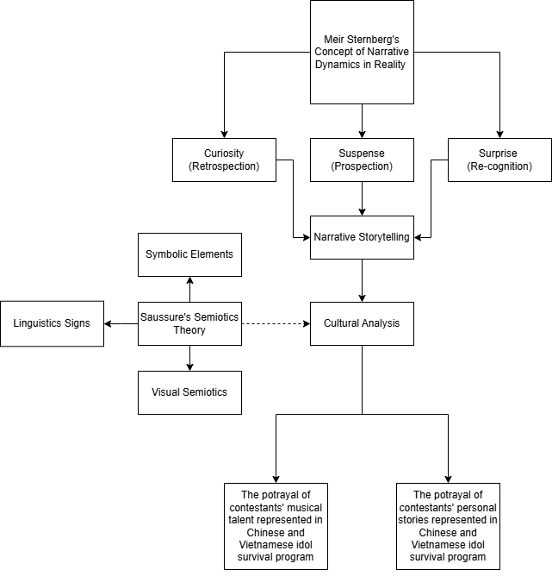

As shown in Figure 2.7, the theoretical framework provided involves two key concepts: Stenberg's concept of Narrative Dynamics in Reality Television and Saussure’s semiotics theory.
Along with the concept of Reality TV genre focuses on narrative dynamics within reality television, highlighting the elements of prospection, retrospection, and recognition in portraying contestants' personal stories and musical talents. This framework guides the analysis of how Chinese and Vietnamese idol survival programs utilize narrative storytelling to portray contestants' journey and talent.
Saussure’s semiotics theory works alongside Sternberg’s narrative functions by examining the symbolic and cultural signs used in shows to create meaning. Visual elements like colors, costumes, and set designs are analyzed to see how they align with cultural themes and enhance storytelling. Linguistic aspects, such as dialogues and slogans, reflect local values of community and collectivism while incorporating global ideas of self-expression and individuality. Symbolic gestures and rituals, such as bowing or specific actions, reinforce cultural ideologies and add authenticity to the programs. Additionally, semiotic analysis helps explore how these shows blend global entertainment trends with local cultural aesthetics, creating a balance between international appeal and cultural identity.
By combining these two theories into one framework, the analysis aims to compare Chinese and Vietnamese idol survival programs in terms of narrative. It examines how each program constructs narratives around contestants' personal stories and music talent within the cultural and social contexts of China and Vietnam. This comparison sheds light on the effectiveness of narrative strategies in shaping the success and appeal of these reality television programs in their respective markets.

Methodology

In this chapter, the researcher explained the methods used for the study. To prepare for the research, this chapter covers five sections: research design, choosing the population and sample, research tools, how the data is collected, and how the data is analyzed. It discusses why textual analysis was selected as the best methods for this research and describes how both of these methods were used. Additionally, the chapter provides details about the research methods, such as how the data was gathered and how the population and sample were chosen.

Research Design
This study employs a qualitative approach with the objective of comprehending the narrative structures found in idol survival programs.
A significant benefit of qualitative research methods is that they typically do not aim to make broad statements about a whole group of people. Instead, they focus on deeply understanding specific sub-groups and the core processes, values, dilemmas, emotions, conflicts, and relationships that lead to certain outcomes (Drury, Homewood, & Randall, 2011). This approach aligns with the idea that fandom communities are a type of subculture. Specifically, this paper focuses on the fandom of idol survival programs as an example of such a subculture (Pacis, 2012). In academic research, using qualitative methods is crucial when studying the detailed storytelling in idol survival programs. Qualitative methods are considered ideographic research, focusing on individual cases or events (Kelin & Myers, 1999 cited in Skinner, Tagg, & Holloway, 2000, p.104). This approach possesses the capability to comprehend diverse perspectives, meanings, and occurrences of various individuals. In this methodology, knowledge originates from the meanings associated with different events (Richardson, 2012 cited in Skinner, Tagg, & Holloway, 2000, p.104). The mentioned benefits are why a qualitative approach is conducted in this research project. The research method is a subset of this approach, and once the approach is decided, we need to choose a suitable research method (Omar, 2013 cited in Lekngam, 2019, p.94).
Idol survival shows known for intense competition and emotional stories (Zhang, 2019), require media text analysis that quantitative methods might miss. Textual analysis provides researchers with the tools to explore the underlying dimensions of these narrative patterns, delving into the emotions, motivations, symbols, and interpretations embedded within them. This approach also uncovers subjective aspects such as empathy, personal perspectives, and the complex dynamics of individual and group development, offering a holistic understanding of how these narratives influence and reflect the natural growth of participants and their interactions. These elements may represent behavioral patterns, experiences, and various factors influencing typical behaviors or natural environments. They often require an individual's unique perspectives and subjective understandings (Lune & Berg, 2016).
Content analysis is explained as the examination of content, considering the meanings, contexts, and intentions present in messages (Prasad, 2008). Analyzing content is helpful for studying patterns in documents and offers a factual foundation for tracking changes in public opinion (Stemler, 2000). Despite it being a quantitative method of analyzing media content, the “content analysis can be effective in qualitative analysis – that counts of textual elements merely provide a means for identifying, organizing, indexing, and retrieving data” (Berg, 2009 as cited in Lekngam, 2019, p.98). The application of less statistic restrict-content analysis to qualitative analysis of media text in this sense has therefore been called by qualitative researcher as “qualitative content analysis” (Lekngam, 2019, p.98)
For this study, before conducting a textual analysis that deeply explores the embedded meanings of narrative techniques in idol survival programs, the analysis of TV texts started with a qualitative content analysis to categorize and count the topics of contestants' personal stories and their musical talent presented in the competition's content.
The key aspects of qualitative content analysis can be seen as it assists in trimming down the material, it is very organized, and it is adaptable, especially when compared to the quantitative version (Schreier, 2014 cited in Lekngam, 2019, p.98). The contestants in an idol survival show can come from many different countries. This makes idol survival shows a rich source for understanding how diverse cultures interact and influence each other. Therefore, this paper chooses to apply textual analysis since it is interested in how contestants express their cultural identities, share their perspectives, and shape the overall message of the show. This method will help uncover the deeper meanings behind their interactions and how these shows contribute to cross-cultural communication.
In the idol survival programs context, it is the choreography, staging, and visual storytelling. In simple terms, textual analysis here means looking at both words and actions. It involves understanding how a contestant shows off their stage presence, the way challenges are presented, and where emotional moments are strategically placed. In conclusion, the analysis of narrative patterns and the depiction of contestants' personal experiences and musical talents in idol survival shows employed qualitative content analysis and textual analysis.

Population and Sample Selection
During broadcasting time, CHUANG 2021 aired 10 main episodes, 4 parallel segments, in which totally have 134 episodes, and focus fancam for each contestant in their performances, as well as behind the scenes videos throughout the competition on an application called WeTV and Youtube . Then, Vote For Five, also aired 10 main episodes, highlight cut for each episodes and behind the scenes videos on Youtube, Facebook and TikTok. Therefore, it is impossible to examine all of the episodes of two shows.
The sample size in qualitative research should be big enough to fully address the research question (Marshall, 1996). This means the size can vary depending on the specific question, and whether the sample is large or small is determined by the sampling strategy. In this study, the researcher chose to use a judgment sampling, also known as a purposive sampling. This is a common sampling method where the researcher selects the most useful samples that fit the criteria.
Since the research question’s purpose is examining the narrative techniques that portray contestants’ personal story and music talent. Therefore, in addition to the 10 main episodes of CHUANG 2021 and Vote For Five this research will focus on the “Behind The Scence” series for personal story aspect, and “Performance Stage” series for music talent aspect. For “Performance Stage” series, researcher picked out top 3 most-vỉewed performance videos on each show’s Youtube channel, including Lover Boys 88 (5,7M views), You Better Not Think About Me (4,9M views), Push No.5 for Cute in Input Method (15M views) from CHUANG 2021, and Thà Rằng Như Thế (1,5M views), Như Là Mơ (1,2M views), Trái Đất Này Là Của Chúng Mình (1,5M views) from Vote For Five. On the other hand, in order to explore the personal story aspect from “Behind The Scence” series, researcher choose one behind the scene clip from each program, where contestants are given the chance to make a call to their family in CHUANG 2021 or a chance to confide in themself Vote For Five. Despite not having an exactly same content, these two videos have the same value in exploring private life and personal stories of competitors.

Research Instrument
This research consists of three main steps. First, videos with similar content from CHUANG 2021 and Vote For Five are selected to create the research sample. Next, a text analysis is done on these samples to identify the narrative elements that showcase the contestants' personal stories and musical talents in both China and Vietnam's shows. This step is the core part of the research. Finally, the study compares idol survival shows from both countries, using Meir Sternberg's idea of narrative dynamics in reality TV.
The researcher starts by filtering videos on YouTube, focusing on performance stages and behind-the-scenes clips from CHUANG 2021 and Vote For Five. Based on similar content from behind-the-scenes footage and a view-ranking method for performances, the research samples are chosen. Since the semiotics (symbols and meanings) in variety shows are complex, the study defines specific semiotic elements to focus on and classifies them accordingly (Luckanavanich, 2021). The study is coded in two categories: visual/audible elements and scene/character interactions.

Data Collection Procedure and Data Analysis
By summarizing the selected videos, the narrative elements that highlight the contestants' personal stories and musical abilities are organized and coded into two main categories. These categories are listed in the Coding Sheet below (Table 3.1)
 | Scene | Character
Visual | Environment  - Lightning  - Props  - On-site atmosphere | Costume  - Uniform / Themed clothes  - Casual clothes / Free-style clothes
Visual | Location  - Indoor  - Outdoor | Interaction  - With people  - With themselves
Visual | Event  - Festival
Audio | Music / Lyrics  - Chinese music  - Vietnamese music  - Foreign music | Language  - Dialogue among contestants, hosts, commentator, and guests
Table 3. 1: The Coding Sheet: Catalogue of narrative elements

This research used the above method to analyze the narrative elements in idol survival shows from China and Vietnam, aiming to find their similarities and differences. The steps for the analysis were as follows:
1) Closely watch each of the selected sample and take note of the key narrative elements.
2) Organize the symbols and signs from the shows based on specific codes.
3) Understand the meaning behind these symbols.
4) Compare the similarities and differences in narrative elements between Chinese and Vietnamese idol survival shows, focusing on their symbols.

Reliability and Validity of the Study
In this study, the researcher gathered data by closely observing the samples, then organized and labeled the content based on semiotics codes. Afterward, these contents were compared and analyzed to get the research results. The study ensures reliability. To keep the research valid and avoid personal bias, the researcher does not base judgments on YouTube comments or twist facts. This approach ensures that the analysis of narrative elements in idol survival shows is objective and grounded in semiotics.

Findings

This chapter provides a detailed analysis of selected videos from CHUANG 2021 and Vote For Five to gather specific insights. Meir Sternberg's idea of narrative dynamics in reality TV is applied to explore the similarities and differences in storytelling techniques used in Chinese and Vietnamese idol survival shows. Additionally, the audience's views and satisfaction with the storytelling in these shows are examined through Saussure’s Semiotics Theory.

Textual analysis in Chinese and Vietnamese Idol Survival Show
4.1.1 Textual analysis in Lover Boy 88 performance stage
The analysis of two selected Chinese and Vietnamese idol survival shows was conducted. Tables 4.1 to 4.3 show the results of the semiotic elements from performance stages in CHUANG 2021, that influence the narrative dynamics of the show, such as "prospection - suspense," "retrospection - curiosity," and "re-cognition - surprise." The performances are in order: Lover Boys 88, You Better Not Think About Me, and Push No.5 for Cute in Input Method. Similarly, Tables 4.4 to 4.6 present the semiotic elements from the performance stages in Vote For Five, that affect these narrative dynamics. The performances are listed in the following order: Thà Rằng Như Thế, Như Là Mơ, and Cùng Đi Khắp Tinh Cầu. Table 4.7 shows the semiotic elements from behind-the-scenes videos in CHUANG 2021, and Table 4.8 presents the same for Vote For Five, both impacting the same narrative dynamics.

Table 4.1 1: The Coding Sheet: Semiotic elements in Lover Boys 88 performance stage
 | Scene | Character
Visual | Environment  - Stage effect  - Disco lights simulation  - Low Fog Machine  - Cold spark machines  - No props  - Vibrant and lively atmosphere | Costume  - Denim theme clothes
Visual | Location  - In-door studio | Interaction  - Competitors on stage with on-site audience
Visual | Event  - First live public evaluation stage with on-site audience voting
Audio | Music / Lyrics  - Re-arrange the original song  - Re-write song’s lyrics | Language  - Chinese  - English

Lover Boy 88 is a nostalgic and melodically rich track by Thai singer-songwriter Phum Viphurit. The song gained popularity for its captivating rhythm and retro aesthetic, evoking a vintage yet uplifting atmosphere. Its lyrics explore themes of youthful love and longing, delivering a whimsical and romantic tone that appeals to a global audience.
Environment
In order to enhance the song's mood and theme, the stage design integrates disco lights, low fog machines, and cold spark effects. These elements are carefully arranged to create an engaging and lively atmosphere that immerses the audience. The colorful disco lights complement the song’s retro vibe, while the low fog adds a dreamy, romantic touch, reflecting themes of love and longing. Meanwhile, the cold spark effects bring bursts of energy, emphasizing the celebratory and uplifting tone of the track. Together, these design elements contribute to what Meir Sternberg describes as "re-cognition," or the element of surprise, by crafting a visually striking performance that leaves a lasting impression. This visual storytelling deepens the audience’s emotional connection, ensuring the performance is both impactful in the moment and memorable long after it ends. In the comment section, audience, the audience continuously gave compliments to Lover Boy 88. This performance made them watch it over and over again, or even listen to it again after many years. Some audiences even said that this was the best performance at CHUANG 2021.
Figure 4. 1: Comments in Lover Boy 88’s video (WeTV, 2024)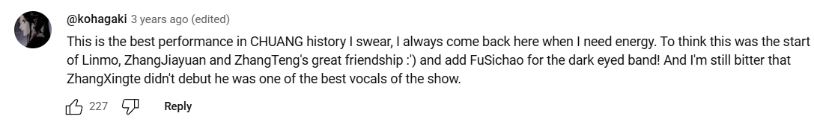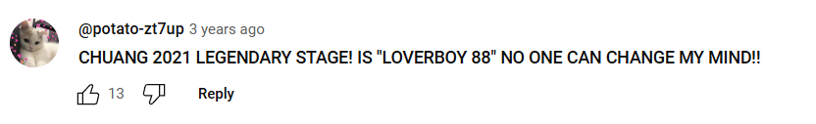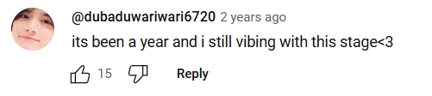

Figure 4. 2 Stage effect in Lover Boy 88 stage performance (WeTV, 2024)
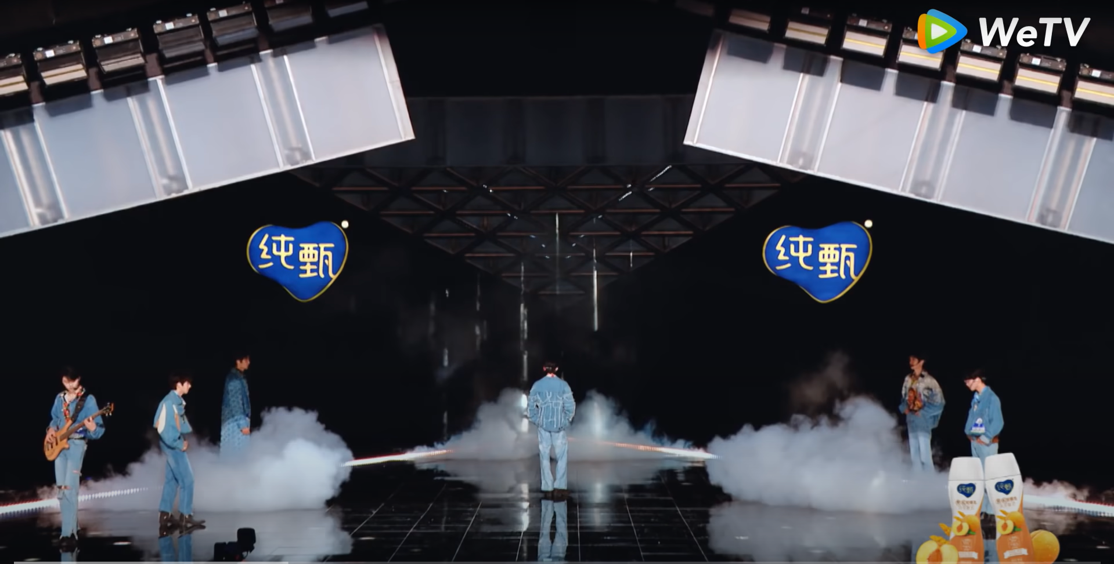
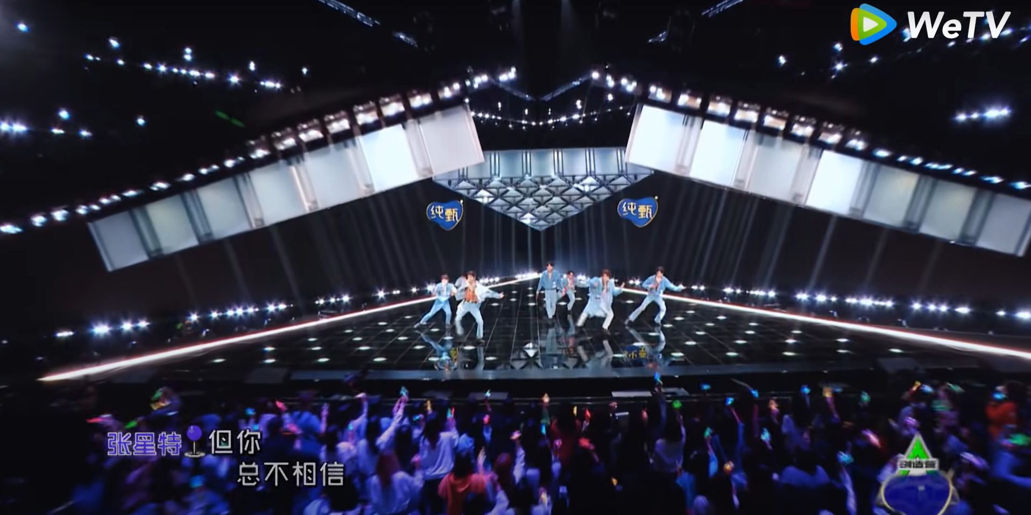

Location
During three live performance rounds of CHUANG 2021, the production utilized an indoor studio in Hainan, China, as the central venue, where each performance was crafted with different stage design that aligned with the song's mood, theme, and style. These customized settings incorporated diverse backdrops, intricate lighting effects, props, and dynamic stage layouts, enhancing both the visual and emotional impact of each performance while allowing the competitors to fully express their artistic vision. This approach not only showcased the performers' creativity and versatility but also contributed to the show's narrative dynamics, reflecting Meir Sternberg's concepts of "retrospection - curiosity," and "re-cognition - surprise." By aligning the stage design with the thematic essence of each song, the production team encouraged audiences to reflect on the artistic choices made by the performers, fostering a deeper understanding of the connections between the song's message, the visual storytelling, and the performers’ expressions. Additionally, the detailed stage environments created moments of recognition, where viewers could identify recurring emotional motifs or symbolic elements that enriched the storytelling. This immersive design strategy engaged the audience on a deeper level, inviting them to actively interpret and piece together the creative layers of the performances, thus reinforcing the emotional and narrative depth of the show.
Event
The performance of Lover Boy 88 took place during the first live public evaluation stage, where audience voting played a pivotal role. The live studio audience was composed of "lucky" individuals selected through a registration process that required fans to actively engage with the show’s platforms and stay updated on announcements. This audience selection process incorporated narrative elements described by Meir Sternberg: the suspense of being chosen ("prospection"), reflection on the efforts made to secure a spot ("retrospection"), and the surprise of either being selected or witnessing the final outcome ("re-cognition"). Adding to this dynamic, the live voting process by individual fans or fan groups introduced another layer of competition and strategy, as attendees cast their votes to support their preferred contestant. This heightened the suspense ("prospection") surrounding the results, which were conducted via secret ballot and kept hidden until the episode aired. The delayed revelation of scores not only sustained curiosity ("retrospection") but also created a moment of surprise ("re-cognition") for both the studio audience and viewers watching from home, amplifying the engagement and emotional investment in the performance.
Costume
The competitors wear denim-themed outfits that have a dominant blue tone to visually highlight the retro aesthetic and thematic essence of Lover Boy 88 which perfectly complemented the disco vibe of the song. The denim not only aligned with the track's youthful and free-spirited energy but also added a casual yet stylish flair that resonated with the retro aesthetic. The coordinated denim attire created a strong sense of visual harmony among the team members, ensuring a cohesive and unified presence on stage. This choice of wardrobe enhanced the performance by tying together the nostalgic and uplifting atmosphere of the song with the carefree and vibrant essence of the performers, leaving a lasting impression on the audience.
Figure 4. 3 Costume in Lover Boy 88 stage performance (WeTV, 2024)
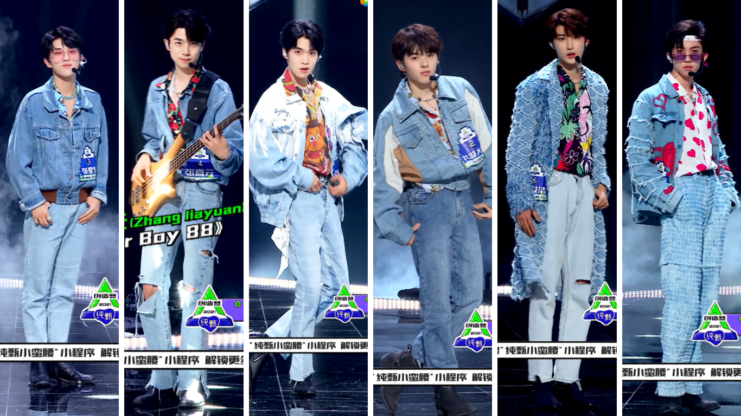

Music / Lyrics
The version of Lover Boy 88 performed in CHUANG 2021 was creatively remixed to enhance its disco and retro vibe, showcasing the contestants' ability to reimagine and personalize an existing track. A notable change was the adaptation of the lyrics, where all English singing from the original was removed, leaving only Chinese lyrics with a few English words, making the song more relatable to a Chinese-speaking audience. Additionally, the contestants replaced the original track’s references to specific hometowns with names of their own home countries and those of their co-performers, adding a personal touch while celebrating their diverse cultural backgrounds and international unity. This thoughtful adaptation not only honored the song's original intent but also demonstrated the contestants' creativity, musical talent, and innovation in making the performance their own. The changes introduced a sense of surprise and novelty for audiences familiar with the original song, offering a fresh and memorable experience. Whether watched live or through digital platforms, this reimagined version left a lasting impression, highlighting the contestants’ ingenuity and their ability to connect deeply with the audience through music. In the video comments section, many fans expressed their excitement for the new remix of the song Lover Boy 88. Some viewers even said that the remix at CHUANG 2021 was better than the original.
Figure 4. 4: Comments in Lover Boy 88 video (2) (WeTV, 2024)


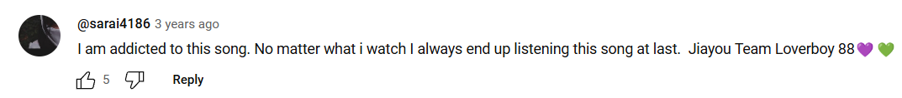

4.1.2 Textual analysis in You Better Not Think About Me performance stage
Table 4.1 2: The Coding Sheet: Semiotic elements in You Better Not Think About Me performance stage
 | Scene | Character
Visual | Environment  - Stage effect  - Starry night sky simulation  - Low Fog Machine  - Artificial pond  - Boat models  - Sad and emotional atmosphere | Costume  - Light blue color vest
Visual | Location  - In-door studio | Interaction  - Among team members on stage
Visual | Event  - Second live public evaluation stage with on-site audience voting
Audio | Music / Lyrics  - Chinese song with a re-arranging | Language  - Chinese

You Better Not Think About Me is a heartfelt ballad performed by Hebe Tien, a renowned Taiwanese singer and former member of the girl group S.H.E. Released in 2013 as part of her album Insignificance (渺小), the song showcases Hebe's emotive vocals and lyrical storytelling. The track explores the pain of letting go after a breakup, urging an ex-lover not to dwell on the past while subtly revealing the lingering emotions of heartbreak.
Environment
The stage design incorporates symbolic elements such as a simulated starry night sky, an artificial pond, low fog effects, and boat models to amplify the melancholic and reflective themes of the song, creating a vivid and emotional landscape. The starry sky evokes loneliness and heartbreak, while the pond symbolizes hidden emotional turbulence beneath a calm surface. Low fog adds a dreamlike quality, blurring reality and memory, and the boats metaphorically represent transition and moving forward. Together, these elements evoke "re-cognition," as described by Meir Sternberg, surprising and deeply engaging the audience, ensuring the performance leaves a lasting impression.
Figure 4. 5 Stage effect in You Better Not Think About Me stage performance (WeTV, 2024)
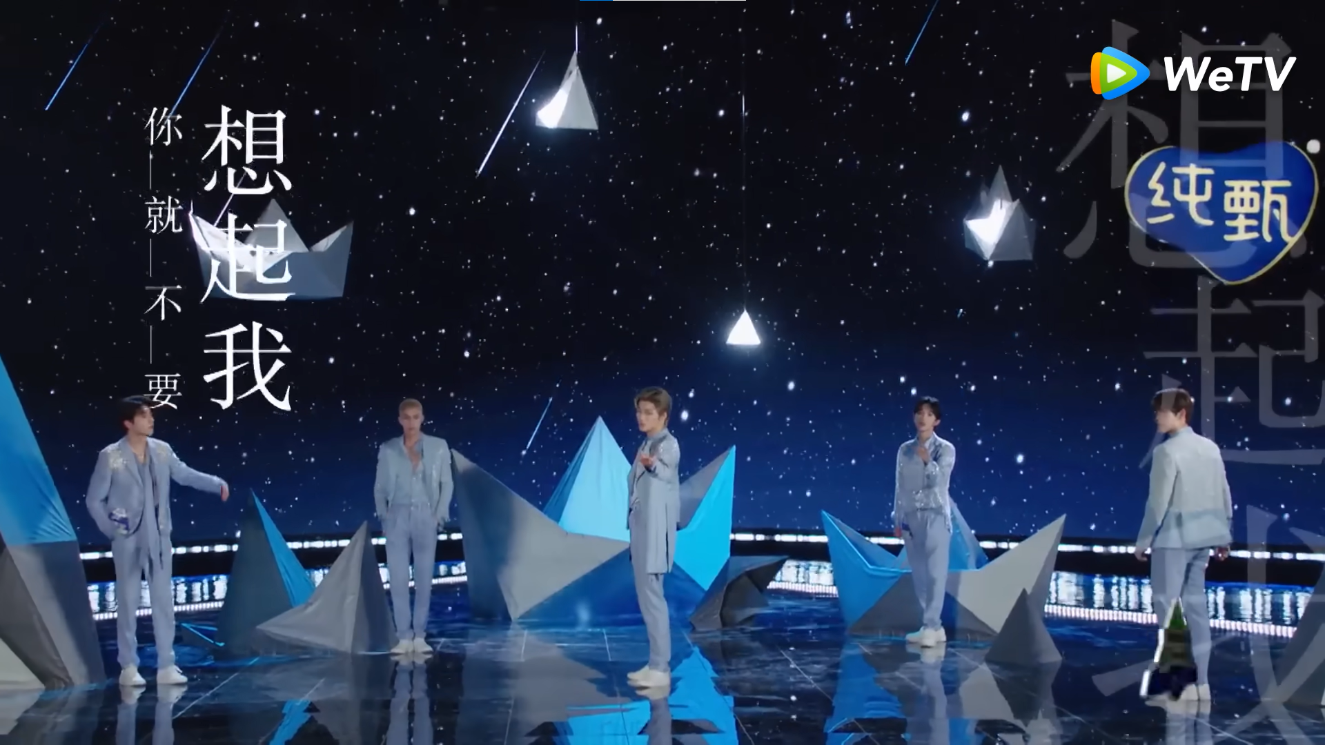
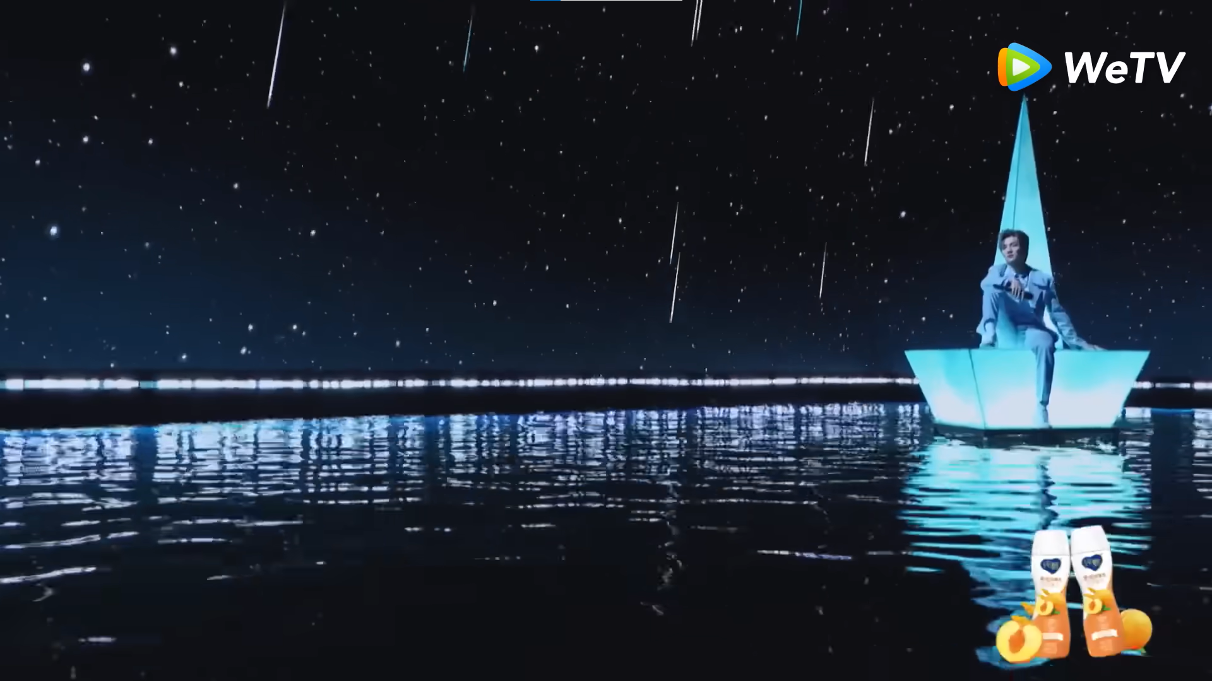

In the comments, viewers consistently praised You Better Not Think About Me. This performance captivated them to the point where they replayed it multiple times or revisited it after many years. Some viewers even expressed that it was the standout performance at CHUANG 2021.
Figure 4. 6: Comments in You Better Not Think About Me video (WeTV, 2024)
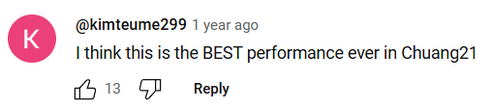



Event
The performance of You Better Not Think About Me occurred during the second live public evaluation stage, where the results were determined by on-site audience voting, adding an extra layer of engagement and suspense. The live audience consisted of "lucky" fans who were randomly selected through a registration process requiring them to fill out forms and stay actively connected with the show's updates on social media. This audience selection process mirrors the narrative dynamics outlined by Meir Sternberg, encompassing "prospection," as fans anxiously awaited the selection results; "retrospection," as they reflected on their efforts to secure a seat; and "re-cognition," as they experienced surprise upon being chosen or witnessing the event unfold. During the performance, the fans’ ability to directly influence the outcome through live voting introduced an element of strategy and competition, further heightening the suspense ("prospection") as they deliberated over their votes. The use of secret ballots kept the final scores undisclosed until the episode aired, intensifying curiosity ("retrospection") as fans speculated on the results. This delayed reveal amplified the sense of surprise ("re-cognition") for both the live audience and viewers at home, transforming the entire event into a dynamic and emotionally engaging experience that blended participation, anticipation, and reflection.
Costume
In the You Better Not Think About Me stage performance, the competitors chose to wear vests in a cohesive light blue or pastel blue color palette. This costume choice complemented the song’s sad yet mature vibe, visually amplifying the emotional depth of the performance. The blue color also associated with depression, coldness, and detachment (Stone et al., 2008), which exactly what the song conveys. The pastel palette seamlessly blended with the stage's setting, which featured a night-sky-inspired backdrop and a reflective pond, creating a serene and melancholic atmosphere. Additionally, the matching color palette brought a sense of visual harmony among the team members, making their group presence more unified and aesthetically pleasing. This cohesive styling not only enhanced the overall mood of the performance but also left a lasting impression on the audience.
Figure 4. 7 Costume in You Better Not Think About Me stage performance (WeTV, 2024)
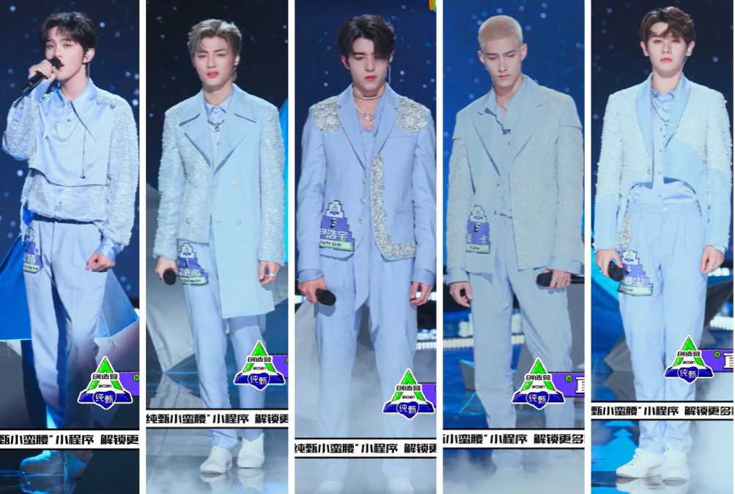

Music / Lyrics
The re-arranged version of You Better Not Think About Me performed by the male contestants creatively reinterprets the original ballad, aligning with Meir Sternberg’s narrative elements of "retrospection - curiosity" and "re-cognition - surprise." By speeding up the tempo and altering the arrangement, the song was transformed into a dynamic and energetic performance that not only highlighted the contestants' vocal range but also added a new layer of emotional depth. The remix introduced stronger beats and instrumental support while still preserving the original sentiments of heartbreak and emotional vulnerability. This fresh take on the song piqued the audience’s curiosity by offering a different perspective on a familiar track, inviting them to reflect on the original version. The faster tempo and bold re-arrangement provided a surprising twist, shifting the emotional tone and creating a sense of unexpected contrast, yet still keeping the core message intact. This reimagined version allowed the contestants to showcase their vocal and creative abilities, giving them the chance to reinterpret a classic in a way that was both personal and surprising for the audience. In the comments section of the video, numerous fans shared their enthusiasm for the new remix of You Better Not Think About Me. Viewers get emotional everytime listen to CHUANG 2021's version.
Figure 4. 8: Comments in You Better Not Think About Me video (2) (WeTV, 2024)


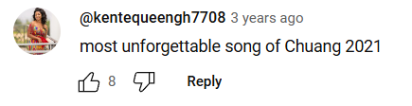



4.1.3 Textual Analysis in Push No.5 for Cute in Input Method performance stage
Table 4.1 3: The Coding Sheet: Semiotic elements in Push No.5 for Cute in Input Method performance stage
 | Scene | Character
Visual | Environment  - Stage effect  - Sunset lights stimulation  - Night sky stimulation  - Artificial pond  - Low fog machine  - Staircase model  - Relaxing and romantic atmosphere | Costume  - Beige color vest
Visual | Location  - In-door studio | Interaction  - Competitors on stage with actress Ju Jingyi as co-singer
Visual | Event  - Third live public evaluation stage with on-site audience voting
Audio | Music / Lyrics  - Chinese song written exclusively for CHUANG 2021 | Language  - Chinese  - English

Push No.5 for Cute in Input Method is a exclusive song written for CHUANG 2021 and was performed during the third live performance round of the show. The song centers around a man's heartfelt confession of love to his partner. Despite having been together for a long time, he expresses that he still feels the same deep affection for her as he did when they first met, and he hopes their love will last for a lifetime. The title’s reference to the number "5" is significant in Chinese, as its pronunciation resembles the word for "I" (我), adding a dual meaning to the song. On one hand, it symbolizes the man's readiness to always be there for the girl whenever she needs him. On the other, it serves as a playful compliment, expressing how cute he finds her. The song blends romantic sentiments with a lighthearted touch, reinforcing the emotional depth and affection between the couple.

Environment
The stage design of Push No.5 for Cute in Input Method visually amplifies the song's playful and romantic themes by incorporating elements such as sunset lighting, a night sky effect, an artificial pond, low fog machines, and a staircase model. These features combine to craft a dreamy and relaxing atmosphere that complements the mood of the performance. The sunset lights evoke a sense of warmth and nostalgia, while symbolizing the fading beauty of the day, which complements the song’s lighthearted yet tender mood. The night sky effect deepens the romantic ambiance, offering a vast, tranquil backdrop that encourages the audience to feel a sense of calm and connection. The artificial pond serves as a tranquil visual metaphor for the calm yet hidden emotions beneath the surface, symbolizing peace amidst the complexity of love. Low fog machines further enhance this serene atmosphere, creating a soft, ethereal quality that blurs the distinction between fantasy and reality, much like the whimsical nature of the song. The scene also reminds viewer about Mika, as known as the main actor for this stage’s hometown, which is Hawaii. Hawaii famous for its beaches lined with coconut trees. Therefore, it can be seen as a way to mention about Mika’s homeland. The staircase model adds an element of progression and elevation, subtly hinting at personal growth and the ascent towards a romantic ideal. These stage elements collectively work to create a captivating environment that resonates with the song’s playful and romantic undertones, ensuring an immersive and memorable performance. In line with Meir Sternberg’s idea of "re-cognition," the combination of these stage effects introduces an unexpected yet meaningful layer to the performance, engaging the audience and leaving a lasting impression long after the performance concludes.

Figure 4. 9 Stage effect in Push No.5 for Cute in Input Method stage performance (WeTV, 2024)
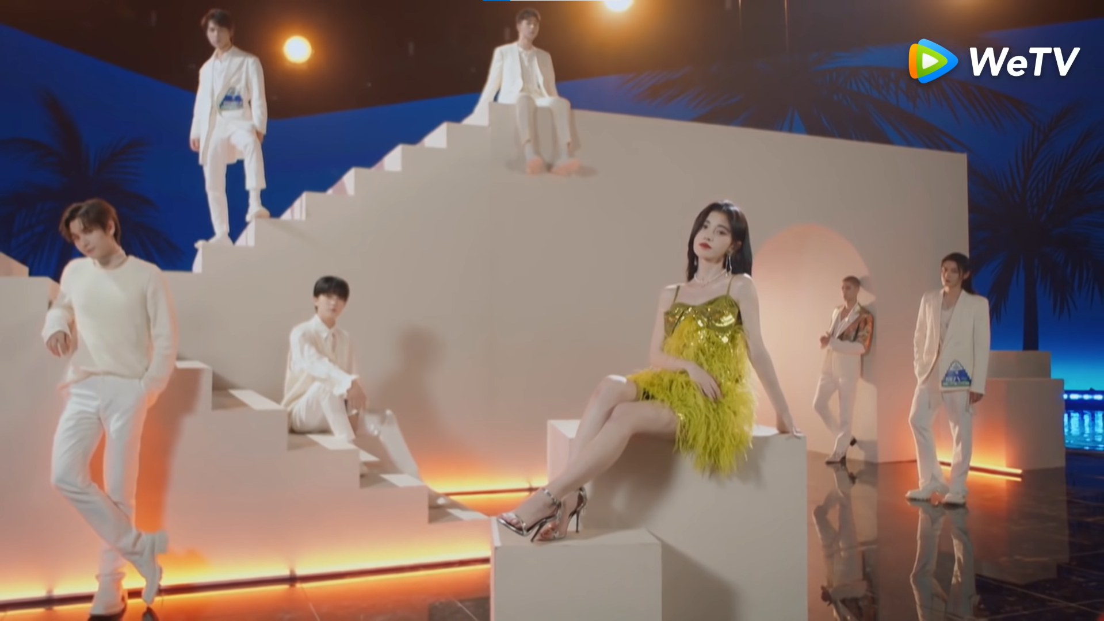
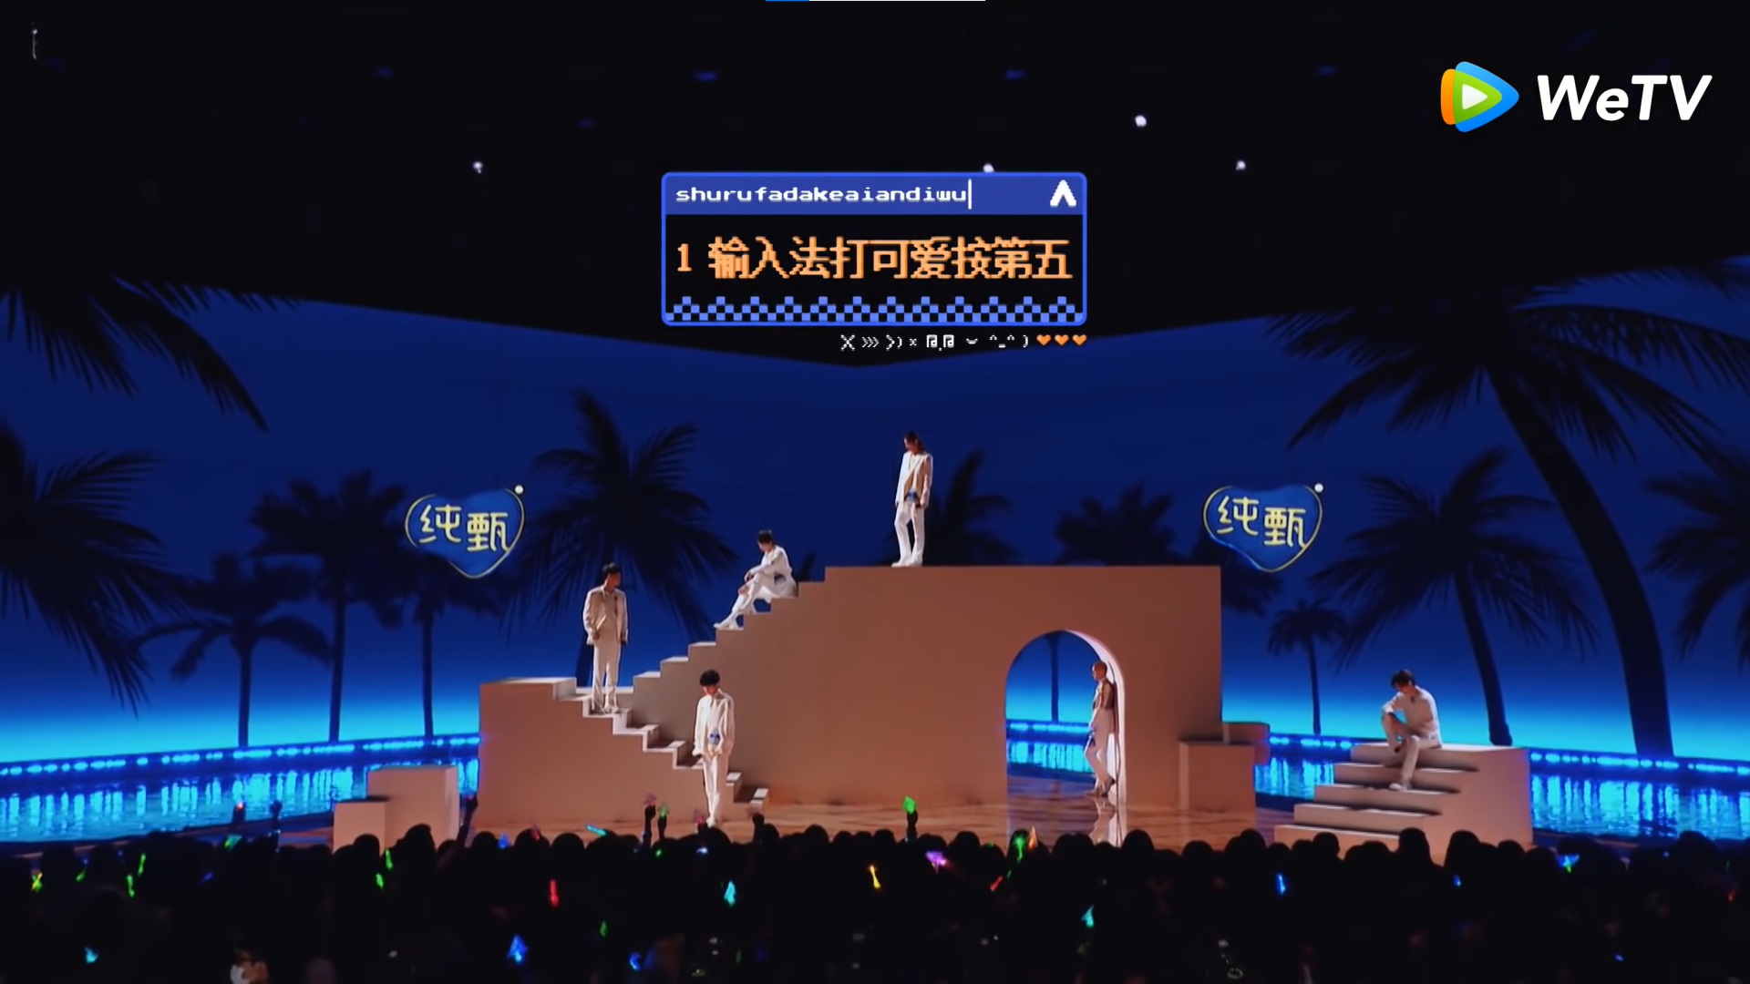

In the comments, audiences frequently commended You Better Not Think About Me. This performance enthralled them so much that they watched it repeatedly or returned to it after several years. Some commenters even stated that it was the highlight of CHUANG 2021.

Figure 4. 10: Comments in Push No.5 for Cute in Input Method video (WeTV, 2024)
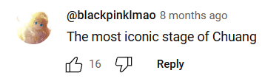

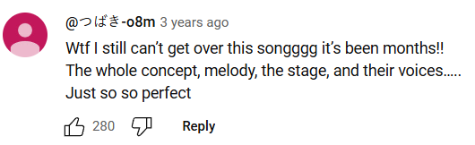

Event
The performance of Push No.5 for Cute in Input Method took place during the third live performance stage, where the excitement was heightened by real-time audience interaction and the competitive atmosphere. The live audience for this event was composed of devoted fans, many of whom had earned their spots through a selection process involving social media engagement and active participation in the show's online community. This process ties into the narrative concepts of "prospection," as fans eagerly anticipated the results of the live voting, "retrospection," as they reflected on their efforts to be part of the live audience, and "re-cognition," as they experienced the thrill of being in the presence of their favorite competitors. The addition of live voting, where the audience could directly influence the outcome of the performance, introduced a layer of strategy and excitement, enhancing the fans’ involvement ("prospection") as they carefully considered their choices. The suspense surrounding the final scores, kept hidden until the episode aired, fueled curiosity ("retrospection") and speculation about the results, while the eventual reveal brought an element of surprise ("re-cognition"), creating a truly interactive and immersive experience for both the live audience and viewers at home. This blend of engagement, suspense, and anticipation transformed the performance into a compelling event, where fans became integral to the narrative unfolding on stage.
Costume
In the Push No.5 for Cute in Input Method stage, the contestants wore vests in a soft beige color, perfectly complementing the sunset-themed setting. The warm, neutral tone of the vests harmonized with the romantic and pure love atmosphere conveyed by the song, enhancing the overall emotional impact of the performance. The beige color not only mirrored the soft, golden hues of a sunset but also symbolized wedding, softness and simplicity in positive meaning (Stone et al., 2008), aligning with the whimsical and sweet essence of the track. Additionally, the choice of matching vests created a sense of visual unity among the team members, fostering a cohesive and synchronized stage presence. This careful attention to wardrobe design contributed to a smooth, aesthetically pleasing performance, allowing the contestants to shine individually while remaining connected as a group.
Figure 4. 11 Costume in Push No.5 for Cute in Input Method stage performance (WeTV, 2024)
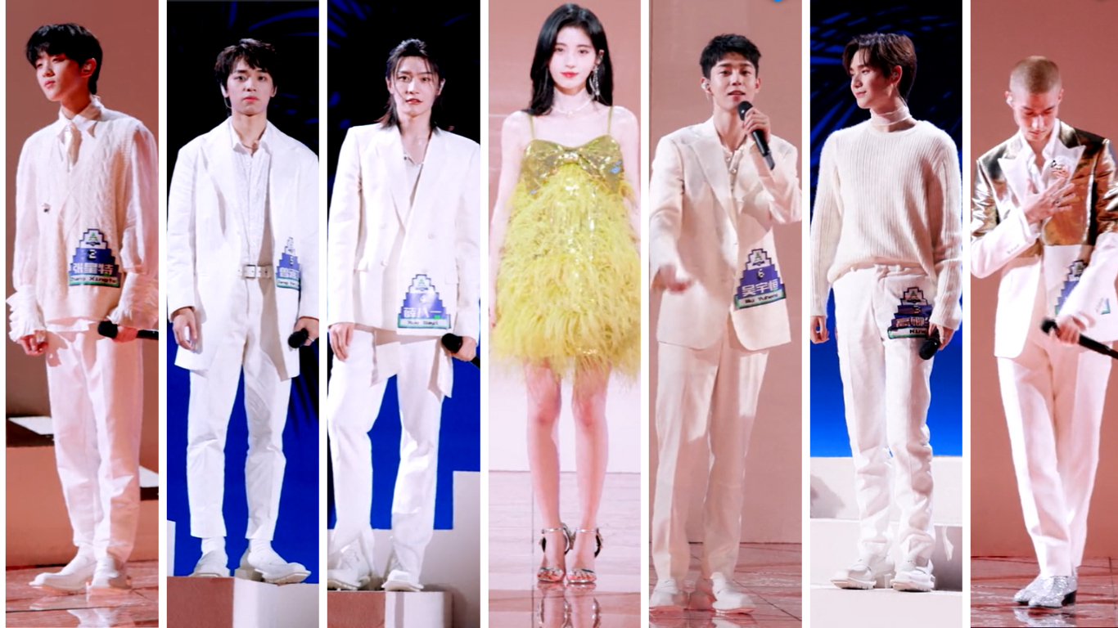

Music / Lyrics
The debut performance of Push No.5 for Cute in Input Method introduced a unique song specifically written for this competition round, which added a fresh dynamic to the stage. The upbeat and catchy rhythm of the track was tailored to the contestants' vocal strengths, allowing them to showcase both their vocal agility and stage presence. The song’s tempo, designed to create a calm and romantic atmosphere, encouraged the contestants to interact with the lead actress, while also highlighting their ability to capture the whimsical and playful spirit of the song. By giving contestants the chance to creatively interpret the song and inject their own personal styles, the performance engaged the audience and made the track feel uniquely theirs. Moreover, the exclusive composition generated Sternberg’s idea of re-cognition, creating moments of surprise as the contestants brought their individual flair to the performance, enhancing the song's lighthearted and engaging nature. In the comment section, viewers kept showering praise on Push No.5 for Cute in Input Method. This performance captivated them so much that they found themselves watching it repeatedly or listening to it even after several years. Some fans even claimed that this was the highlight of CHUANG 2021, and is still the best version of the song compared to the seasons of the following years.
Figure 4. 12: Comments in Push No.5 for Cute in Input Method video (2) (WeTV, 2024)



Interaction
In the performance stage Push No.5 for Cute in Input Method from CHUANG 2021, the interaction between the male contestants and actress Ju Jingyi illustrates Meir Sternberg’s concept of “re-cognition – surprise.” Sternberg’s theory suggests that audiences experience a moment of re-cognition when they encounter something familiar, followed by surprise when the familiarity is altered or reframed in a new context. In this performance, the male contestants' interactions with Ju Jingyi create a blend of these two elements. Initially, the male contestants engage with Ju in a conventional manner, as expected in typical idol performance formats, which leads to a sense of recognition for the audience. However, as the performance progresses, the contestants begin to act in unexpected ways—either through exaggerated gestures, playful challenges, or surprising expressions—breaking away from traditional norms of idol behavior. This sudden shift creates a surprise for the viewers, who are presented with a fresh and playful dynamic between the contestants and the actress. The playful banter, humorous exchanges, and light-hearted moments between them further deepen this surprise element, as it contrasts with the audience's prior expectations of a more typical or formal performance interaction. By integrating the familiar with the unexpected, this interaction exemplifies Sternberg’s idea of re-cognition – surprise, keeping the audience engaged and invested in the evolving dynamics of the performance. This strategy not only enhances the entertainment value but also elevates the emotional connection between the contestants, Ju Jingyi, and the viewers.

Figure 4. 13 Interaction in Push No.5 for Cute in Input Method stage performance (WeTV, 2024)
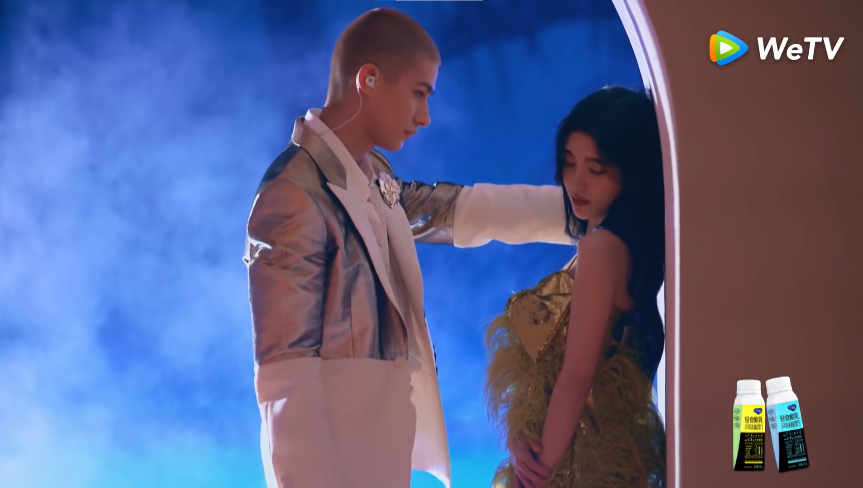
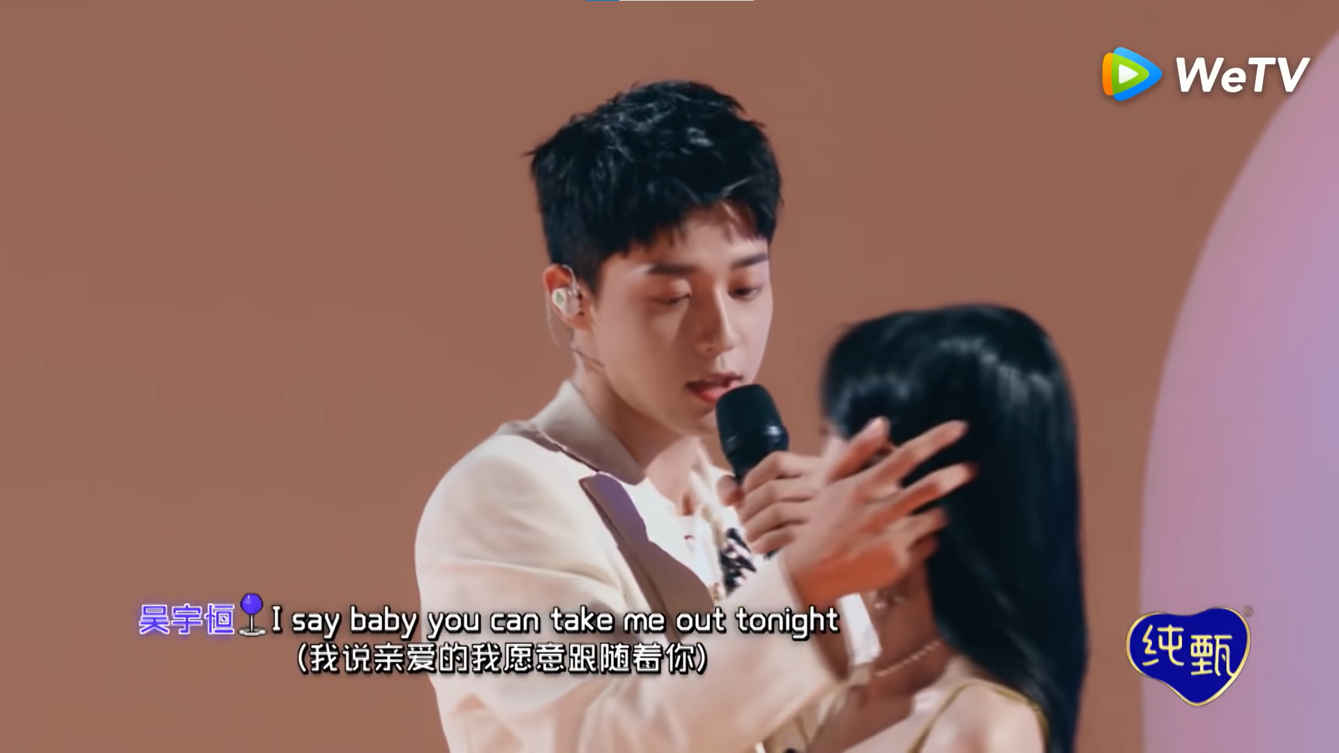
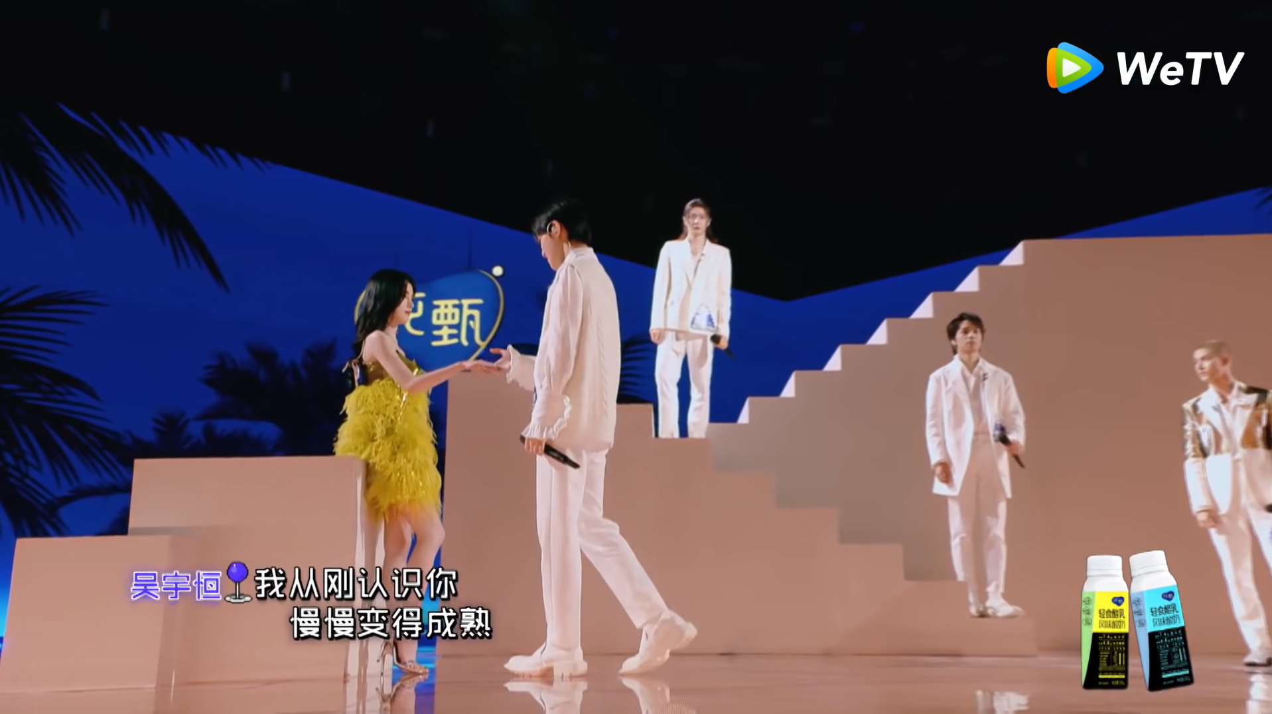

In the video's comments section, fans did not hesitate to express their love for the interaction between the contestants and the female lead actress. Some of them even compared this performance to a Korean movie script.

Figure 4. 14: Comments in Push No.5 for Cute in Input Method video (3) (WeTV, 2024)




4.1.4 Textual analysis in Thà Rằng Như Thế stage performance
Table 4.1 4: The Coding Sheet: Semiotic elements in Thà Rằng Như Thế performance stage
 | Scene | Character
Visual | Environment  - Stage effect  + Stage lighting  + LED screen  - No props  - Vibrant atmosphere | Costume  - Hip-hop theme clothes
Visual | Location  - In-door studio | Interaction  - No interaction
Visual | Event  - First live public evaluation stage with on-site audience voting
Audio | Music / Lyrics  - Vietnamese song with an re-arrange | Language  - Vietnamese

Thà Rằng Như Thế is a Vietnamese pop ballad performed by a Vietnamese male soloist singer, named Ưng Hoàng Phúc in the early 2000s. The song tells the story of a love that can no longer be salvaged, urging both sides to let go instead of holding onto painful memories. Its relatable theme, combined with its nostalgic sound, has made Thà Rằng Như Thế a timeless anthem for Vietnamese youth who has experienced the bittersweet pain of parting ways in love.
Environment
The stage performance of Thà Rằng Như Thế relies on stage effects, including random images displayed on LED screens and white and yellow stage lighting. While these elements create a visually stimulating backdrop, they fail to establish any narrative dynamics as defined by Meir Sternberg's theory, which emphasizes the progression and interplay of narrative elements such as "prospection - suspense," "retrospection - curiosity," and "re-cognition - surprise.". The random nature of the images and the static lighting design lack cohesion and do not contribute to the storytelling or emotional development of the performance. As a result, the stage effects serve more as decorative elements rather than tools to enhance the narrative structure or engage the audience on a deeper level.

Figure 4. 15 Stage effect in Thà Rằng Như Thế stage performance (VOTE FOR FIVE OFFICIAL, 2024)
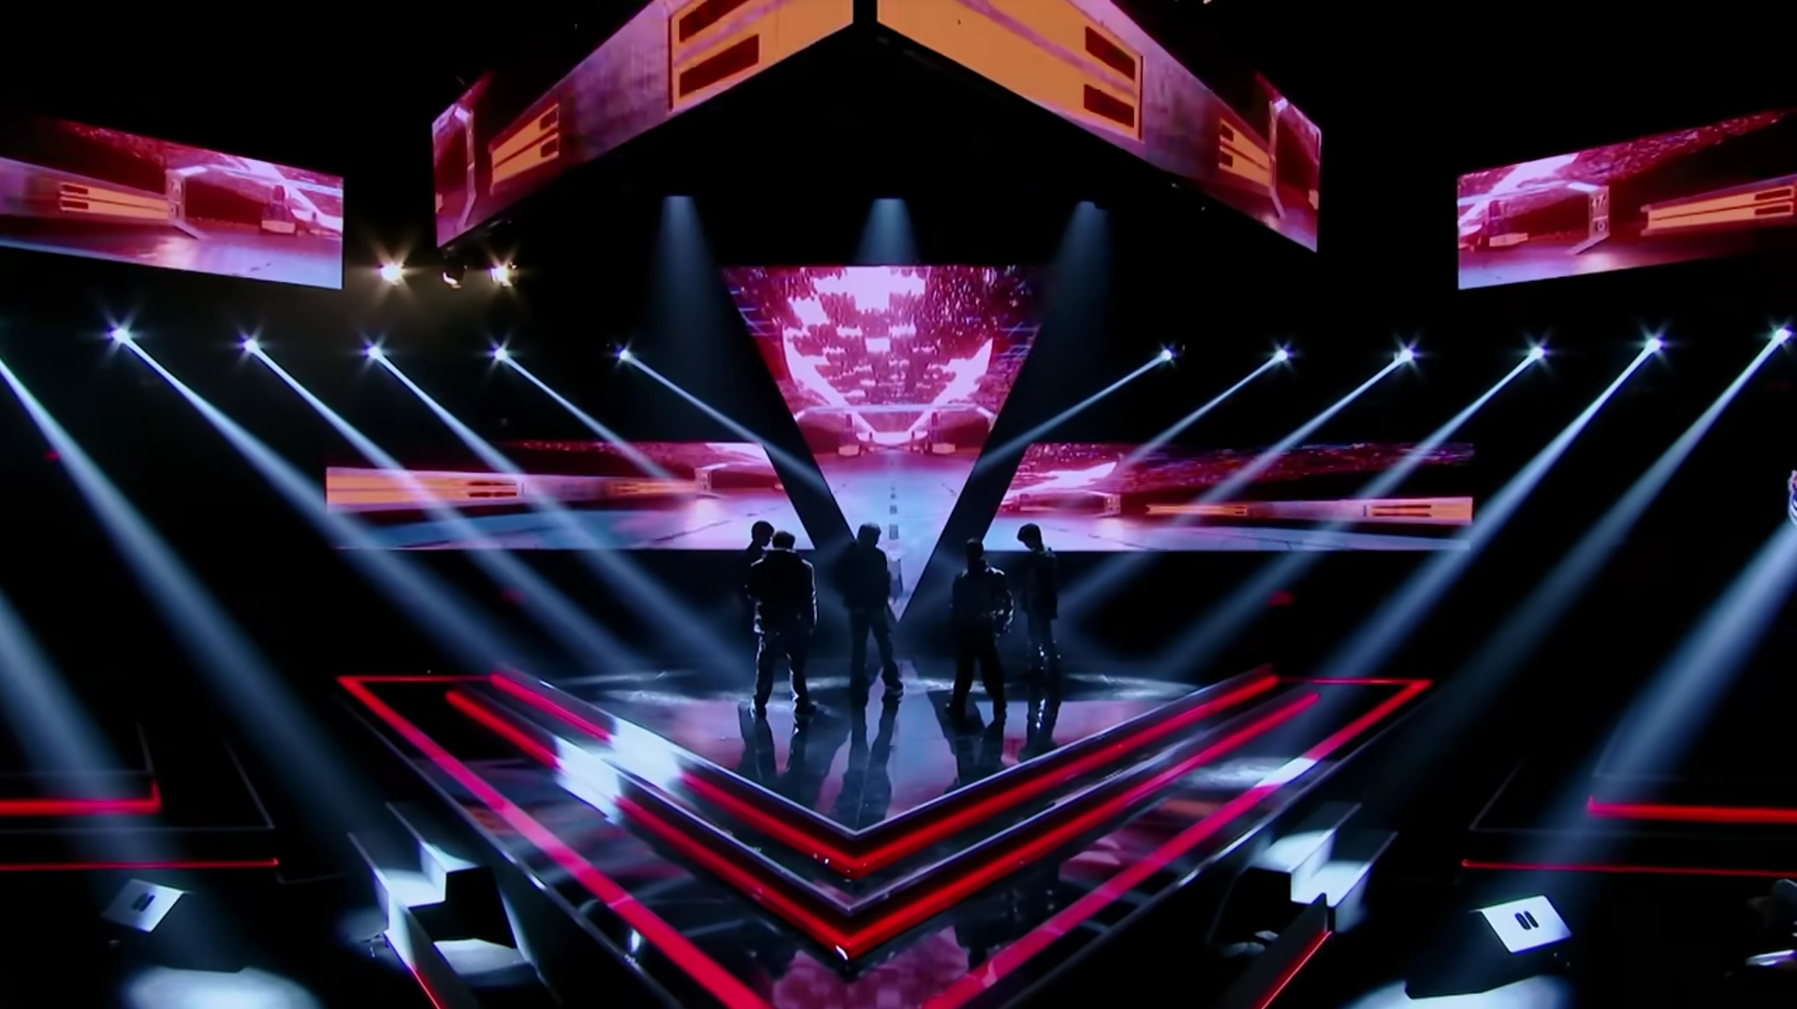
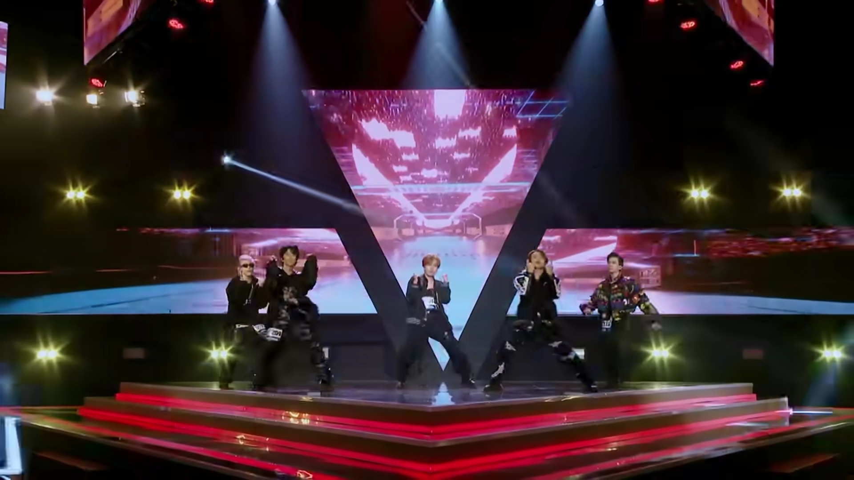

Location
During the performance rounds of Vote For Five, the production utilized an indoor studio in Vietnam as the primary venue for its stages. The show adopted a minimalist approach, with limited stage settings and basic lighting effects. The lack of diverse backdrops, intricate props, or dynamic layouts meant that the performances did not create narrative depth or thematic connections between the music and visual elements. Consequently, this approach did not engage with Meir Sternberg’s concepts of "retrospection-curiosity" and "re-cognition-surprise," as the stage design did little to foster a sense of narrative progression or emotional reflection. Without symbolic elements or layered storytelling in the visual presentation, the audience's engagement was limited to the performers' vocal and dance skills rather than a holistic artistic experience. While this simplicity may have kept the focus on the contestants' raw talent, it missed the opportunity to deepen audience immersion or create meaningful connections between the song's message and its visual representation.
Event
The performance of Thà Rằng Như Thế took place during the first live public evaluation stage. The on-site audience voting for this stage was composed of individuals hired specifically for recording purposes, rather than active followers of the program or contestants' fandoms. While the live studio audience fulfilled the practical need for recording, their lack of personal connection to the show and voting process diminished the emotional engagement typically associated with audience participation. Nevertheless, for viewers watching from home, Meir Sternberg's narrative elements—suspense ("prospection"), curiosity ("retrospection"), and surprise ("re-cognition")—remained present. The hidden results of the voting process maintained some level of intrigue and anticipation for viewers awaiting the episode's airing. However, the emotional investment was less impactful compared to scenarios where the voting audience consists of the program's followers or contestants' fans, whose personal stakes and efforts in the process add a deeper sense of connection and engagement. As a result, while Thà Rằng Như Thế retained some elements of narrative tension, the voting process lacked the full intensity and relatability typically seen in performances with a fan-driven audience.
Costume
The stage performance of Thà Rằng Như Thế creates a visually cohesive experience through the contestants' choice of black hip-hop-themed clothing. The coordinated outfits not only reflect the edgy and powerful vibe (Stone et al., 2008) of the song but also establish a strong sense of unity among the performers. Moreover, in the sense of negative meanings, black color relates to mourning, heaviness, and emptiness, which also aligns with the song’s meaning. The dark tones of the costumes contrast effectively with the stage lighting, enhancing the overall visual appeal and directing focus to the contestants' movements and expressions. This deliberate styling choice emphasizes the contemporary and rhythmic essence of the performance while maintaining a harmonious and professional aesthetic that resonates with the energy of the track.
Figure 4. 16 Costume in Thà Rằng Như Thế stage performance (VOTE FOR FIVE OFFICIAL, 2024)
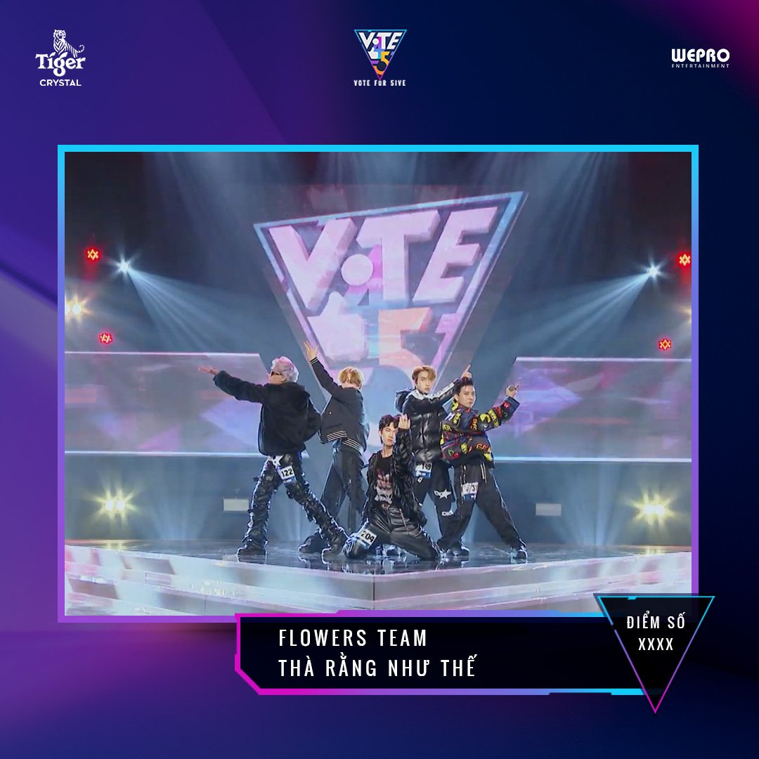

Music / Lyric
The version of Thà Rằng Như Thế performed in Vote For Five was creatively reimagined to infuse a faster tempo and a distinct hip-hop vibe, showcasing the contestants' ability to modernize and personalize a beloved track. A standout addition was the incorporation of a rap segment, which brought a fresh dynamic to the song and allowed the performers to display their versatility and lyrical creativity. This remix not only brought a fresh, contemporary twist to the track but also introduced an element of surprise for the audience, particularly those familiar with the original version. According to Meir Sternberg’s theory of "re-cognition," this unexpected change in style prompted viewers to reassess their prior understanding of the song, creating a "re-cognition" effect. The contrast between the original and remixed versions engaged the audience in a way that made them perceive the song anew, evoking a sense of novelty and excitement. A number of viewers commented that they were very excited about the modern arrangement of one of the songs representing the early period of Vietnamese pop music.
Figure 4. 17: Comments in Thà Rằng Như Thế video (VOTE FOR FIVE OFFICIAL, 2024)

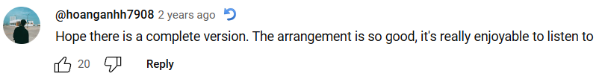

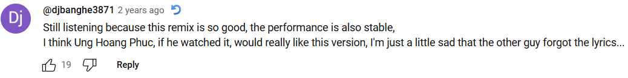


4.1.5 Textual analysis in Như Là Mơ performance stage
Table 4.1 5: The Coding Sheet: Semiotic elements in Như Là Mơ performance stage
 | Scene | Character
Visual | Environment  - Live band  - Light bulbs string  - Mic stand  - Wooden stage  - Cozy and lively atmosphere | Costume  - Winter clothes with pastel palette color
Visual | Location  - Outdoor stage in Da Lat city | Interaction  - Competitors on stage with on-site audience  - Among team members on stage
Visual | Event  - Third live public evaluation stage with on-site audience voting
Audio | Music / Lyrics  - Vietnamese song with an re-arrange | Language  - Vietnamese

Như Là Mơ is a Vietnamese pop song performed by two Vietnamese soloists named Hà Okio and Trang Pháp. This track is an original sound track of a Vietnamese comedy film called Long Ruồi. The movie follows the story of Tèo, a simple countryside man who unexpectedly takes the place of a notorious gangster named Long Ruồi, leading to a series of humorous and chaotic situations. Its official soundtrack, Như Là Mơ, plays a significant role in reflecting the emotional layers of the film. The song, with its dreamy melody and heartfelt lyrics, captures the contrast between Tèo’s naive aspirations and the challenges he faces in a world far from his own.
Environment
The performance of Như Là Mơ on stage utilized a combination of selected stage effects, including a live band, string light bulbs, vintage-style microphones, and a wooden stage, to craft a cozy yet vibrant atmosphere. These elements worked together to evoke a sense of intimacy and nostalgia, while simultaneously energizing the performance with a lively and dynamic ambiance. The use of a live band added an organic, authentic touch to the music, while the warm glow of the string light bulbs created a visually inviting setting that felt personal and engaging. This harmonious blend of stage design and performance aesthetics contributed significantly to what Meir Sternberg describes as "re-cognition" in narrative dynamics—the surprise factor that prompts the audience to perceive a familiar piece in a new and unexpected way.
Figure 4. 18 Stage effect in Như Là Mơ stage performance (VOTE FOR FIVE OFFICIAL, 2024)
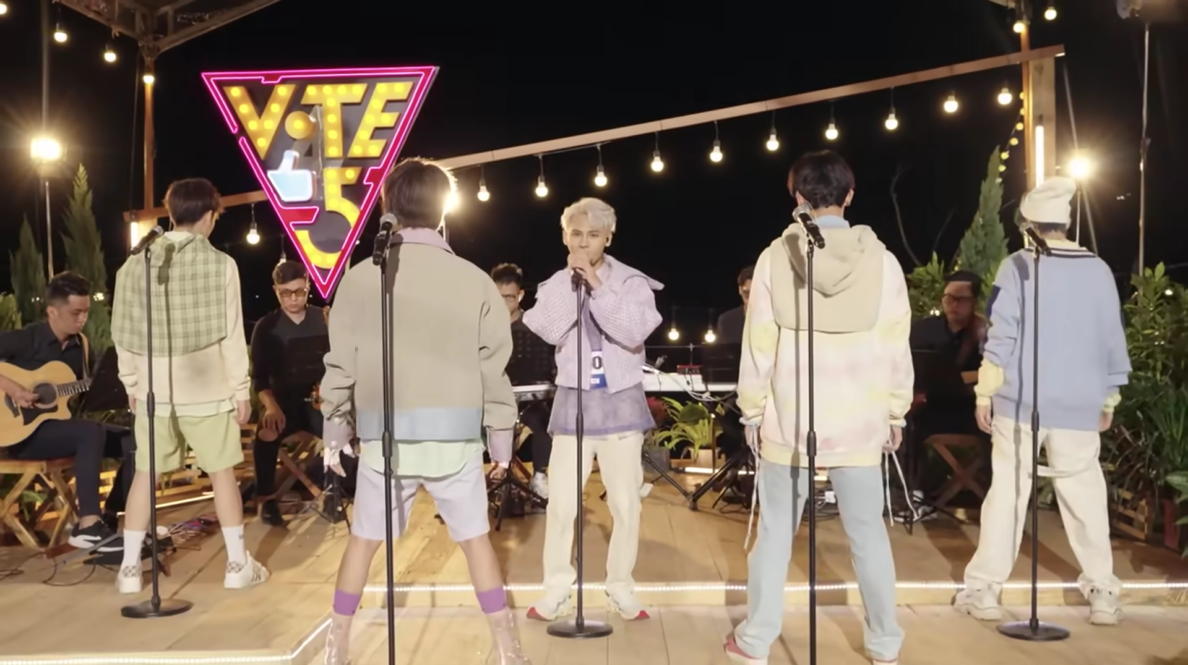

Location
During the live band theme round of Vote For Five, the production team utilized an outdoor stage in Da Lat, Vietnam, as the central performance venue. This choice of location leveraged the city's scenic natural beauty and fresh atmosphere, creating a unique backdrop that enhanced the performances' emotional and visual appeal. The choice of location and stage design encouraged the "retrospection - curiosity" and "re-cognition - surprise" elements of Meir Sternberg’s narrative theory, inviting viewers to reflect on the performers' creative choices while also creating moments of surprise and recognition. The connection between the performers' music, the natural environment, and the visual elements of the stage helped deepen the audience's engagement, prompting them to actively interpret the layered meanings and emotional messages conveyed through the performances.

Event
The performance of Như Là Mơ during the third live public evaluation stage was marked by on-site audience voting, where the audience was composed of both hired individuals and some active followers of the show. Unlike the first stage, this audience included viewers who were more familiar with the program and its contestants, which likely contributed to a stronger emotional connection and greater engagement during the voting process. The presence of dedicated fans added intensity to the voting, as their personal stakes and support for the contestants created a more relatable and invested atmosphere. Despite this, Meir Sternberg’s narrative elements, such as suspense, curiosity, and surprise, continued to play a role for the at-home viewers. The results of the voting, still hidden until the airing of the episode, helped maintain a level of anticipation and intrigue. Although the emotional investment from the studio audience was stronger compared to the first stage, it still did not fully match the heightened connection typically seen when the audience is primarily made up of passionate supporters and fans, whose involvement often deepens the narrative experience.

Costume
The stage performance of Như Là Mơ creates a visually harmonious experience through the contestants’ choice of winter clothing in a soft pastel color palette. The light and soothing tones of the outfits complement the gentle, dream-like atmosphere of the song, adding to the overall sense of calm and serenity. The pastel colors contrast subtly with the stage lighting, enhancing the delicate and soft mood of the performance while drawing attention to the contestants’ movements and expressions. This thoughtful styling choice highlights the ethereal and tranquil nature of the track, maintaining a polished and unified aesthetic that aligns with the song's gentle, romantic tone.
Figure 4. 19 Costume in Như Là Mơ stage performance (VOTE FOR FIVE OFFICIAL, 2024)


Music / Lyric
The version of Như Là Mơ performed in Vote For Five was reimagined as an acoustic rendition, featuring a striking a cappella arrangement that highlighted the vocal abilities of the contestants. This reinterpretation brought a fresh, intimate quality to the song, focusing on raw, unaccompanied voices rather than the original, more produced sound. By stripping down the instrumentation, the performers were able to showcase their vocal range and emotional expression, adding a new depth to the track. This acoustic remix introduced a surprising element for the audience, especially for those familiar with the original version. Drawing on Meir Sternberg’s theory of "re-cognition," the shift in style encouraged viewers to reconsider their initial perception of the song, providing a sense of novelty and emotional impact. The contrast between the original and the remixed versions enhanced the audience's engagement, offering a fresh perspective on the song. Viewers flooded the comment section with praise for Như Là Mơ, expressing how deeply captivated they were by the performance. Many shared that they repeatedly watched it or continued listening to it even years later. Some fans went as far as to declare it the standout moment of Vote For Five and maintained that it remains the best rendition of the song compared to subsequent seasons.
Figure 4. 20: Comments in Như Là Mơ video (VOTE FOR FIVE OFFICIAL, 2024)
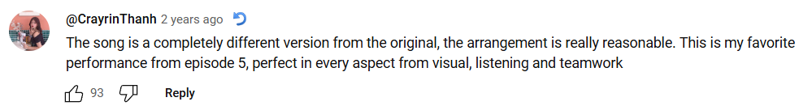
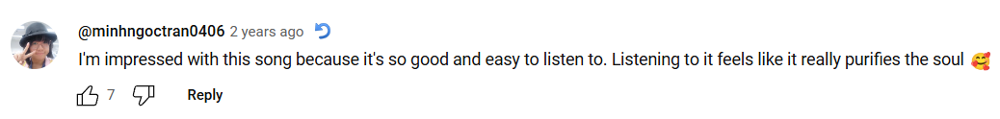




4.1.6 Textual analysis in Cùng Đi Khắp Tinh Cầu stage performance
Table 4.1 6: The Coding Sheet: Semiotic elements in Cùng Đi Khắp Tinh Cầu performance stage
 | Scene | Character
Visual | Environment  - Stage lighting  - LED screen  - Cold spark machines  - No props  - Vibrant and lively atmosphere | Costume  - Denim theme clothes  - Luxury theme clothes
Visual | Location  - In-door studio | Interaction  - No interaction among team members or on-site audience
Visual | Event  - Fifth live public evaluation stage with on-site audience voting
Audio | Music / Lyrics  - Vietnamese song written exclusively for <Vote For Five> | Language  - Vietnamese

Cùng Đi Khắp Tinh Cầu is a song specifically composed for the Vote For Five show, performed during on its final stages. The song expresses a man's heartfelt confession of love to his partner. In the lyrics, he declares his desire to take her to a place where it’s just the two of them, away from the world, ensuring that nothing and no one can come between them. The song blends deep affection with a sense of longing, conveying both the emotional intensity and the determination to protect their bond.
Environment
The stage performance of Cùng Đi Khắp Tinh Cầu utilizes various stage effects, including multi-color stage lighting, random images displayed on LED screens, and cold spark machines, but lacks the presence of any props. While these elements create a visually vibrant atmosphere, they fail to establish a cohesive connection between the stage effects and the song's themes. According to Meir Sternberg's theory, effective narrative dynamics rely on the interplay of "prospection - suspense," "retrospection - curiosity," and "re-cognition - surprise." However, the disjointed use of visuals and static design prevents the performance from fostering any narrative progression or emotional depth. Consequently, the stage effects function as ornamental features rather than tools to enhance storytelling or deepen the audience's engagement with the song.
Figure 4. 21 Stage effect in Cùng Đi Khắp Tinh Cầu stage performance (VOTE FOR FIVE OFFICIAL, 2024)
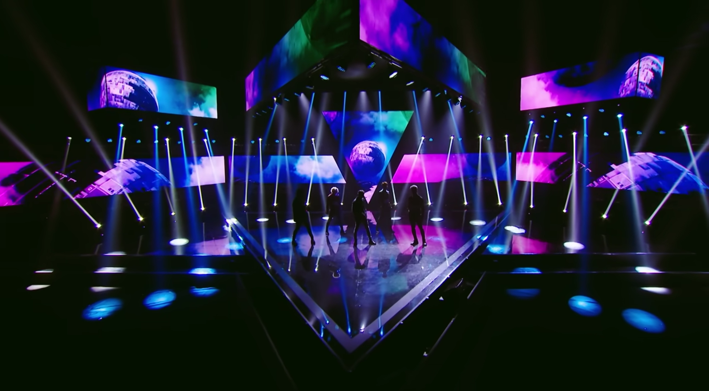
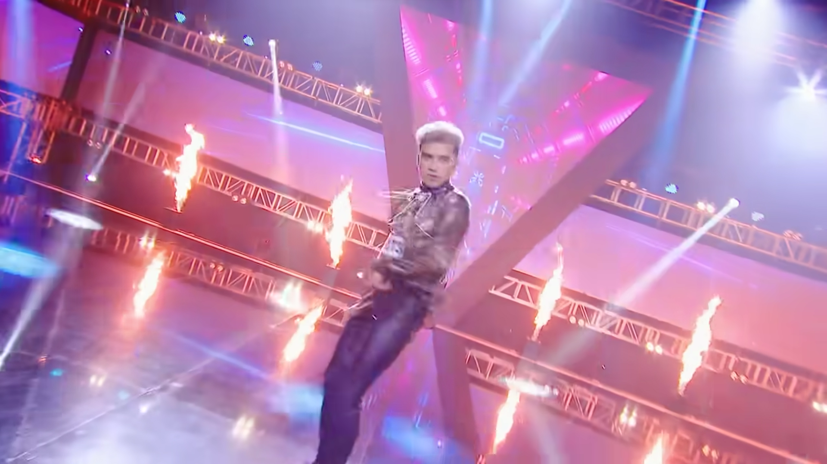

Event
The performance of Cùng Đi Khắp Tinh Cầu occurred during the final stage of Vote For Five. Similar to earlier rounds, the on-site audience was composed of individuals hired specifically for recording purposes, rather than dedicated fans of the program or contestants. While their presence served the practical purpose of creating a live studio atmosphere, the lack of personal connection to the contestants or voting process reduced the emotional engagement typically associated with audience participation in such events. For viewers watching the broadcast from home, Meir Sternberg’s narrative elements of suspense ("prospection"), curiosity ("retrospection"), and surprise ("re-cognition") were still present, as the final results remained hidden until the airing of the episode. However, without a fan-driven voting audience, the emotional intensity and relatability of the performance were diminished. Unlike scenarios where active fans contribute their personal stakes and efforts, the hired audience lacked the passion and investment necessary to fully enhance the narrative tension and emotional depth of the show. While Cùng Đi Khắp Tinh Cầu maintained some elements of intrigue, the absence of a genuine fan-based audience lessened the overall impact of the stage.
Costume
In the performance of Cùng Đi Khắp Tinh Cầu, two groups of contestants, each consisting of five members, compete against each other while performing the same song. To distinguish the teams, one group adopts a denim-themed wardrobe, while the other group embraces a luxury-themed style. While this contrast in clothing successfully highlights the individuality of each group, it creates a visual imbalance on stage. The contrasting fashion choices, although effective in separating the teams, disrupt the overall cohesion of the performance, making the visual presentation appear inconsistent and lacking harmony. This imbalance detracts from the audience's ability to fully immerse themselves in the performance as a unified artistic experience.

Figure 4. 22 Costume in Cùng Đi Khắp Tinh Cầu stage performance (VOTE FOR FIVE OFFICIAL, 2024)
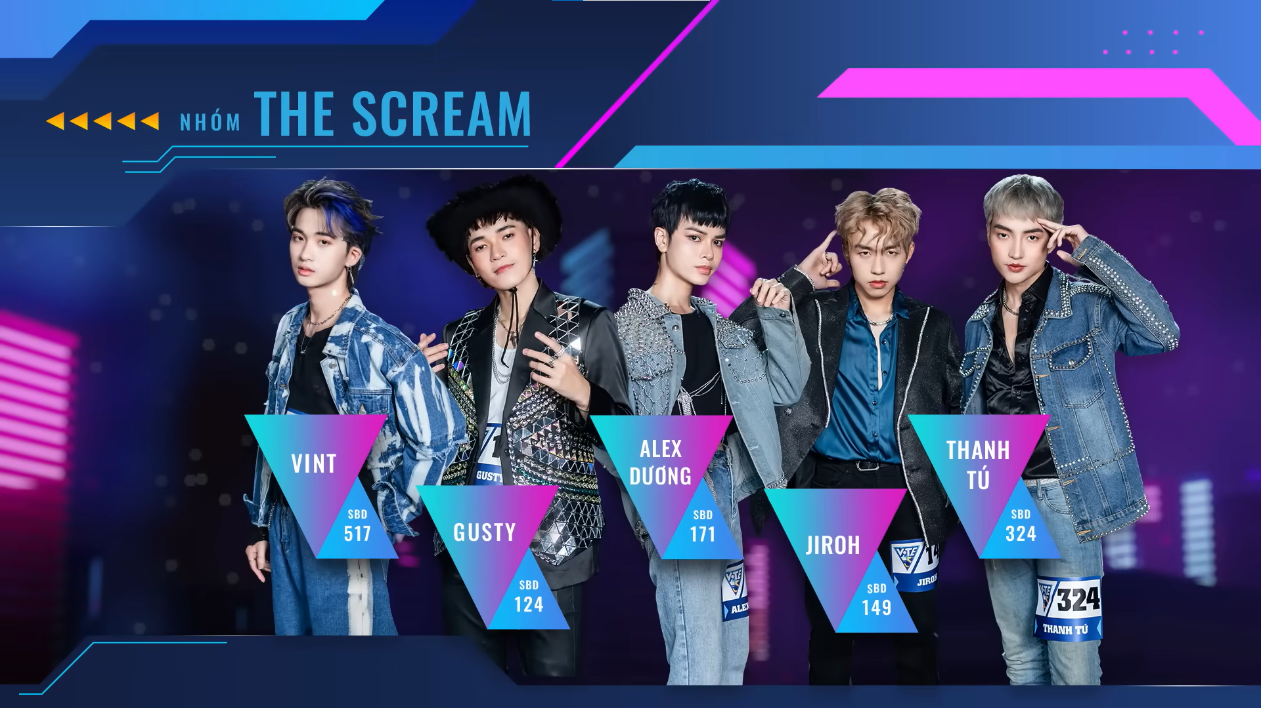
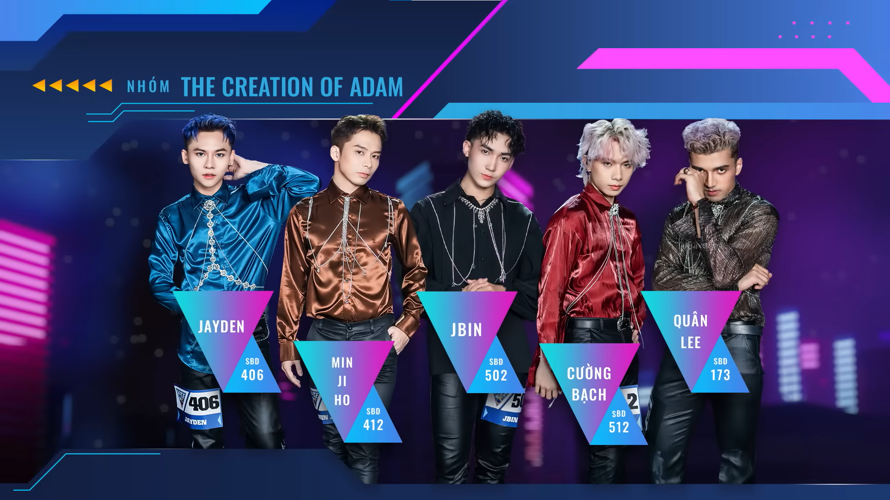

Music / Lyric
The performance of Cùng Đi Khắp Tinh Cầu marked its debut as a song crafted specifically for this competition round, bringing a fresh and dynamic element to the stage. Unlike slower, more introspective tracks, this song featured a fast tempo and an energetic rhythm, creating an exciting and lively atmosphere. A standout feature of the song was its dance break, which provided contestants with a platform to showcase not only their vocal abilities but also their dance skills. This dual challenge allowed contestants to display versatility, captivating the audience through both their physical agility and stage charisma. Cùng Đi Khắp Tinh Cầu performance stage is aligning with Sternberg’s concept of re-cognition by creating moments of surprise and engagement. In the comments section, viewers consistently praised Cùng Đi Khắp Tinh Cầu. The performance left such a strong impression that many admitted to rewatching it. Some fans even declared it the standout moment of Vote For Five’s final episode.
Figure 4. 23: Comments in Cùng Đi Khắp Tinh Cầu video (VOTE FOR FIVE OFFICIAL, 2024)






4.1.7 Textual analysis in CHUANG 2021 - A Nice Evening! Trainees Make a Call to Their Families behind the scenes clip
Table 4.1 7: The Coding Sheet: Semiotic elements in CHUANG 2021 - A Nice Evening! Trainees Make a Call to Their Families behind the scenes clip
 | Scene | Character
Visual | Environment  - Lunar New Year theme decoration | Costume  - CHUANG 2021’s practice uniform
Visual | Location  - Trainees’ dorm | Interaction  - Competitors with their and others’ family members  - Among competitors
Visual | Event  - Tradition Chinese Spring Festival Eve  - Competitors making phone calls to their families
Audio | Music / Lyrics  - No music  - Background noise | Language  - Chinese  - Japanese  - Russian  - German  - Thai

In CHUANG 2021, contestants were required to live in dormitories throughout the competition, with limited contact with the outside world until their elimination. Under these strict rules, they could not use their phones or receive visits from their families, even during important cultural events. However, during the Lunar New Year, a festival deeply rooted in Chinese culture as a time for family reunions and togetherness, the contestants were given a special opportunity to make a brief phone call to their families. In Chinese tradition, being with loved ones during the Lunar New Year symbolizes harmony, renewal, and the continuation of familial bonds, making this small gesture of connection particularly meaningful. For the contestants, this moment offered emotional support and a sense of warmth, reminding them of the values of family even as they pursued their dreams far from home.
Environment
The behind-the-scenes clip A Nice Evening! Trainees Make a Call to Their Families from CHUANG 2021 features a Lunar New Year-themed decoration, creating a festive and culturally meaningful atmosphere that resonates deeply with the show’s primarily Asian audience. The setting, filled with traditional elements like red lanterns and festive ornaments, aligns perfectly with the New Year season, making viewers feel connected to both the holiday spirit and the trainees' emotional moments. This design not only enhances relatability but also evokes Meir Sternberg's narrative dynamics of "retrospection - curiosity" and "re-cognition - surprise." Viewers reflect on their own familial connections while feeling curious about the trainees' stories, and the heartfelt moments of reunion or conversation deliver emotional surprises, keeping the audience engaged and further rooting the show in shared cultural values.
Figure 4. 24 Setting CHUANG 2021 - A Nice Evening! Trainees Make a Call to Their Families behind the scenes clip (WeTV, 2024)
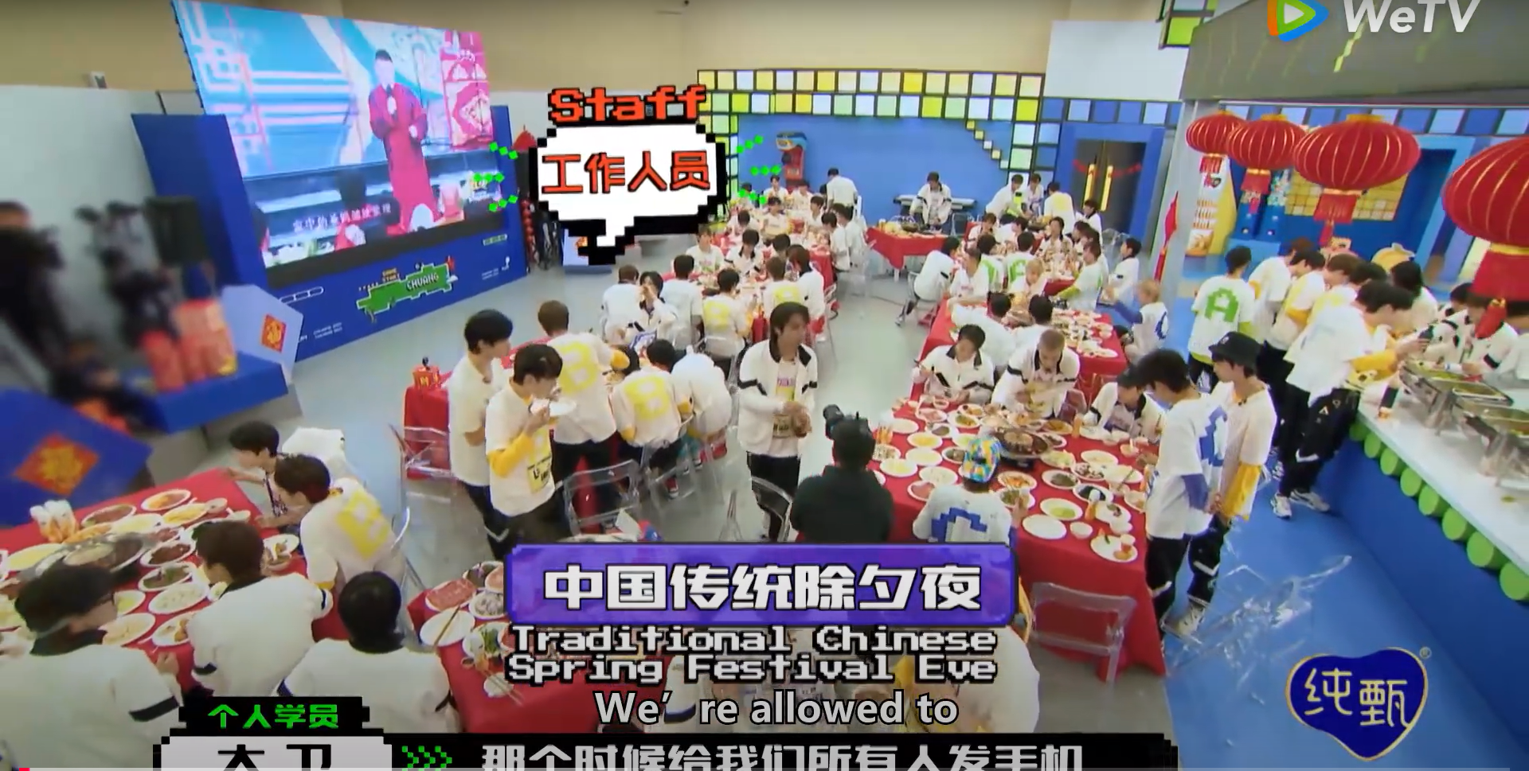

Location
In CHUANG 2021, the dorm served as the primary setting for off-camera moments, offering a glimpse into the contestants' daily lives beyond the stage. Almost all behind-the-scenes clips were filmed in this space, creating a sense of intimacy and authenticity that engaged the audience on a deeper level. This focus on dorm life embodies Meir Sternberg’s idea of narrative dynamics, particularly "retrospection-curiosity" and "re-cognition-surprise." Viewers were drawn to reflect on previous performances while growing curious about how contestants prepared, bonded, and handled challenges in their personal time. Additionally, unexpected and heartfelt moments, such as spontaneous interactions or emotional breakthroughs, brought elements of surprise, re-framing the contestants' stories in new and engaging ways. By making the dorm a central narrative space, the show effectively blended personal storytelling with competition, keeping the audience emotionally invested.
Costume
In the behind-the-scenes clips of CHUANG 2021, contestants are shown wearing designated uniforms in their daily practice routines. The practice uniform consists of a short-sleeve white T-shirt with a level mark on the back, paired with a long-sleeve shirt underneath in the same color as the level mark. This design not only creates a visual signature for the show but also ensures visual harmony among contestants. By standardizing the outfits, the show reinforces a sense of unity while making the contestants' individual progress and rankings easily identifiable to the audience. This cohesive visual strategy enhances the show’s branding and organization.
Interaction
The behind-the-scenes clip of CHUANG 2021's A Nice Evening! Trainees Make a Call to Their Families offers a heartfelt glimpse into the contestants' interactions with their families, creating a deeper emotional connection between the audience and the trainees. The clip not only shows the contestants' personalities when they are with their families, how much they are missing their hometown, but also reveals unexpected moments of humor and warmth as their families interact with other contestants. This interplay aligns with Meir Sternberg's concept of narrative dynamics, particularly "retrospection-curiosity," as the audience is intrigued to learn what the contestants are like in a family setting, and "re-cognition-surprise," as viewers are delightfully surprised by the funny and spontaneous connections formed between the families and other contestants. These moments add layers of authenticity and relatability, enriching the overall narrative of the show.
Figure 4. 25 Interaction between the contestants and their families (WeTV, 2024)
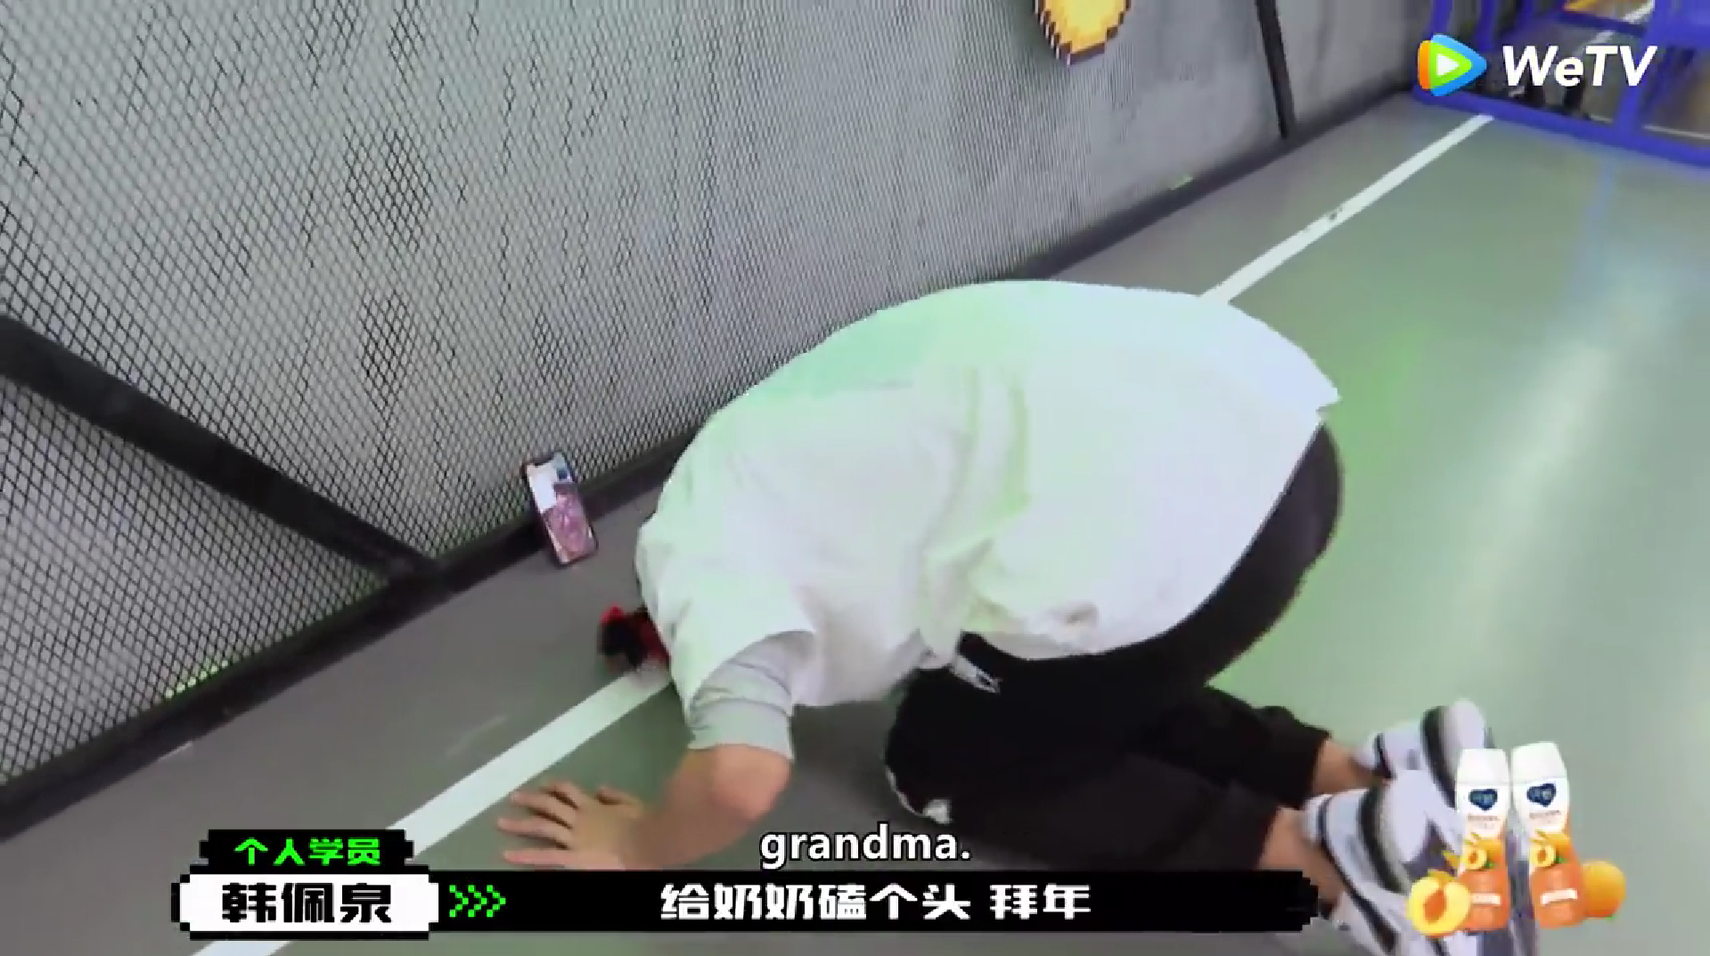
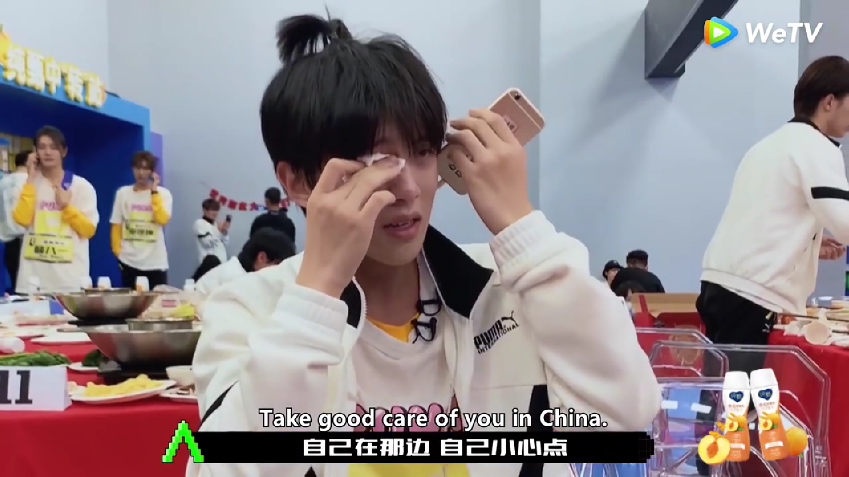

Some fans in the comments section also had memories of studying, working and living far away from their relatives, so they sympathized with the international contestants and had a high level of sympathy for this type of content from the CHUANG 2021 program.
Figure 4. 26: Comments in CHUANG 2021 behind the scene video (WeTV, 2024)





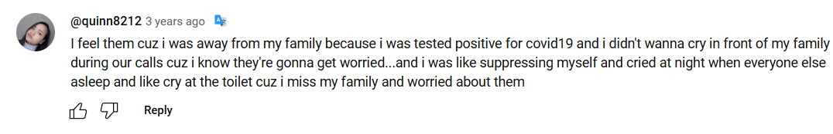

Figure 4. 27 Interaction between contestants and other families (WeTV, 2024)
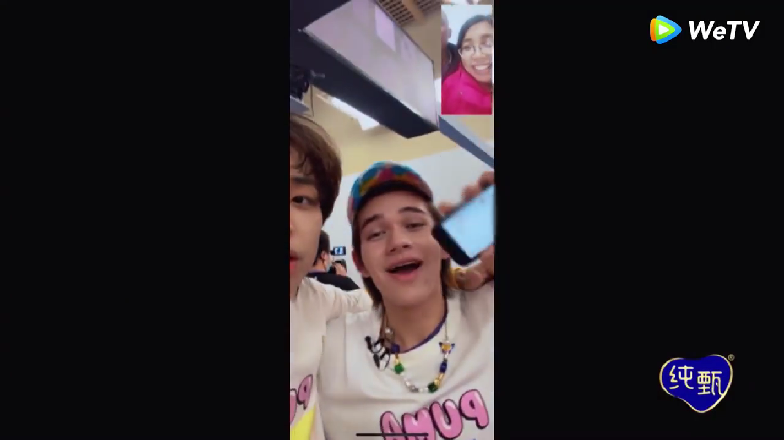
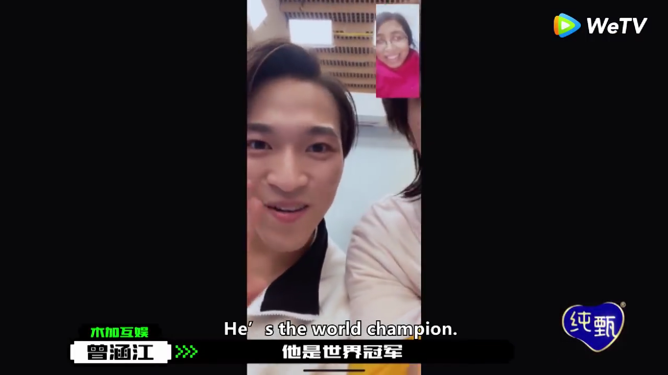
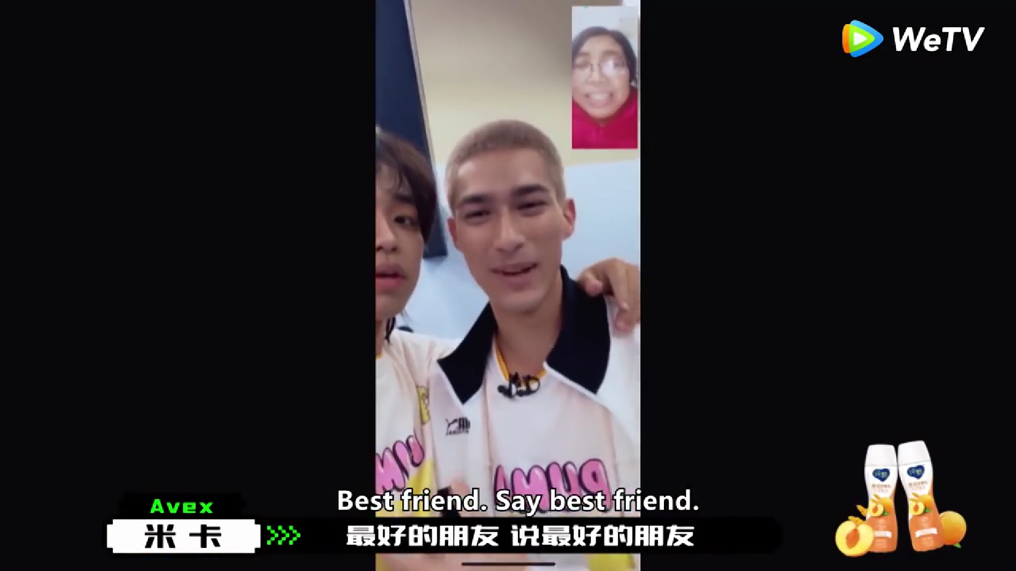

Language
The behind-the-scenes clip A Nice Evening! Trainees Make a Call to Their Families from CHUANG 2021 offers a heartfelt glimpse into the contestants’ personal lives as they speak with their families in their native languages, such as Japanese, Russian, German, and Thai. This moment contrasts with the main language of the show, Chinese, creating a layered narrative dynamic as described by Meir Sternberg. The element of “retrospection-curiosity” arises as the audience wonders what kind of conversations the trainees will have in the intimate setting of a family call, while “re-cognition-surprise” emerges when viewers hear contestants express themselves fluently in languages outside the program’s primary language. These interactions not only deepen the emotional connection between the contestants and the audience but also highlight the cultural diversity within the competition, making the scene both relatable and unexpected.

4.1.8 Textual analysis in Vote For Five - Gửi người đặc biệt và duy nhất.. behind the scene clip
Table 4.1 8: The Coding Sheet: Semiotic elements in Vote For Five - Gửi người đặc biệt và duy nhất.. behind the scenes clip
 | Scene | Character
Visual | Environment  - Black curtain  - A full-body length mirror  - An emotional atmosphere | Costume  - Free style casual clothes
Visual | Location  - In-door studio | Interaction  - Competitors with themself
Visual | Event  - No event
Audio | Music / Lyrics  - Sad & emotional instrumental | Language  - Vietnamese

The Vote For Five behind-the-scenes clip titled Gửi người đặc biệt và duy nhất.. offers a heartfelt glimpse into the contestants' emotional journey during the competition. In this clip, the participants engage in a reflective moment, speaking to themselves in the mirror as a way to offer reassurance and encouragement. This intimate interaction not only highlights their vulnerability and determination but also serves as a form of self-motivation to overcome challenges. By showcasing this personal and emotional side, the clip captures the contestants' resilience and growth, providing a deeper connection between the audience and the individuals striving to achieve their dreams on stage.
Environment
The behind-the-scenes clip for Vote For Five - Gửi Người Đặc Biệt Và Duy Nhất uses minimalistic setting elements to create an emotional atmosphere. The use of a black curtain as a backdrop evokes a sense of intimacy and focus, drawing attention to the performers and their emotions. The full-body-length mirror serves as a reflective device, both literally and metaphorically, symbolizing self-reflection and personal growth. This setting emphasizes the vulnerability and sincerity of the contestants, creating a raw and emotional connection with the audience. Through these simple yet meaningful elements, the clip enhances the sentimental tone of the performance while aligning with the show's focus on personal expression and emotional storytelling.
Figure 4. 28: Setting in VOTE FOR FIVE behind the scene video (VOTE FOR FIVE OFFICIAL, 2024)
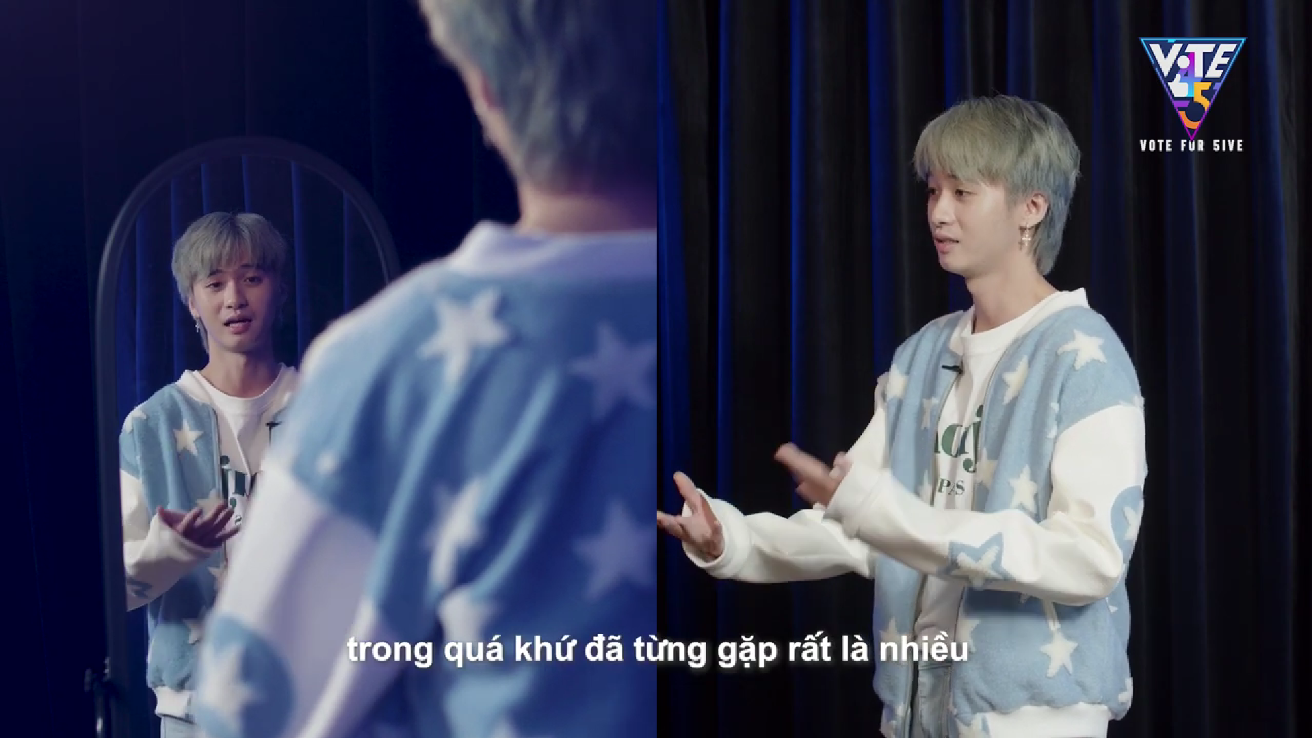

Some viewers in the comments section were also touched by the contestants' heartfelt sharing about their dreams. They also gave words of encouragement to the boys.
Figure 4. 29: Comments in VOTE FOR FIVE behind the scene video (VOTE FOR FIVE OFFICIAL, 2024)
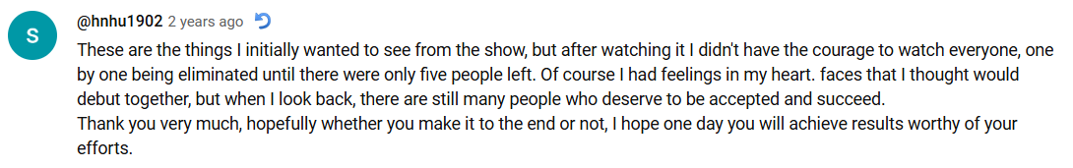


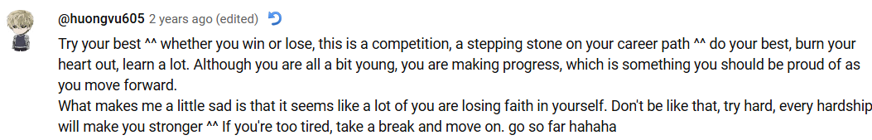

Costume
The behind-the-scenes clip of Vote For Five - Gửi Người Đặc Biệt Và Duy Nhất captures the contestants in freestyle casual clothing, allowing them to express their individual styles and personalities. Each outfit reflects the uniqueness of the contestants, offering insight into their personal tastes and character. However, this diversity in clothing choices results in a lack of visual harmony, as the outfits do not follow a coordinated theme or color scheme. While this approach highlights individuality, it also creates a contrast that may affect the overall cohesion of the group’s image in the clip.
Figure 4. 30: Costume in Vote For Five behind the scene video (VOTE FOR FIVE OFFICIAL, 2024)
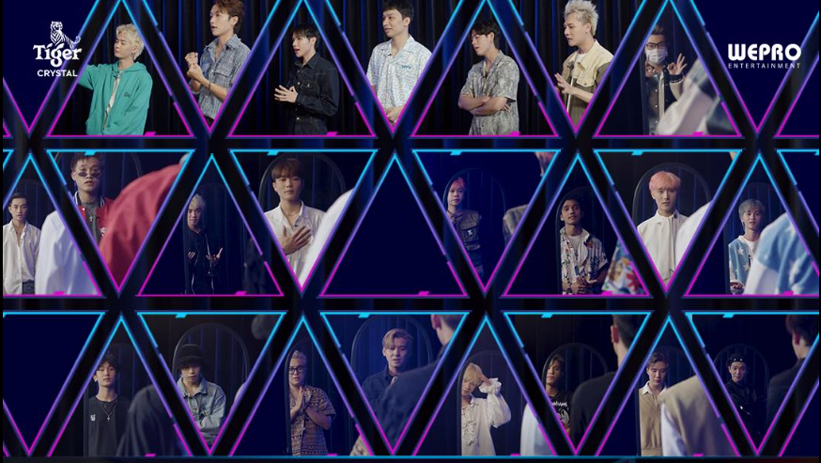

Music / Lyric
The behind-the-scenes clip for Vote For Five - Gửi Người Đặc Biệt Và Duy Nhất uses emotional and sad instrumental background music to evoke a heartfelt connection with the audience. This choice of music complements the emotional tone of the video, highlighting the contestants' dedication, struggles, and personal growth throughout the competition. The reflective atmosphere created by the music amplifies the vulnerability and sincerity captured in the moments shared between the contestants and their supporters. By pairing these raw, behind-the-scenes visuals with such evocative music, the clip strengthens the emotional bond between the audience and the performers, allowing viewers to empathize with the challenges and aspirations of the contestants while reinforcing the sentimental theme of the show.

Conclusions
Table 4.1 9: Table 3. 1: The Coding Sheet: Catalouge of narrative elements in Vietnam and China idol survival show
Vietnam idol survival show |  | Scene | Character
Vietnam idol survival show | Visual | Environment  - Using different stage effects, but not really has any meanings.  - No props on stage | Costume  - Visual harmony, in term of performance costume, is not stable throughout all the stages in show
Vietnam idol survival show | Visual | Location  - In-door & out-door studio | Interaction  - The audience rarely sees interactions between contestants both on stage and backstage
Vietnam idol survival show | Visual | Event  - Live public evaluation stage with on-site audience voting  - Fans can not join the recording day
Vietnam idol survival show | Audio | Music / Lyrics  - Remix version of existing Vietnamese songs  - Vietnamese song exclusively written for the show | Language  - Vietnamese and English for songs  - Vietnamese for daily communication.
China idol survival show |  | Scene | Character
China idol survival show | Visual | Environment  - Using different stage effects with meanings  - Each stage has their own props | Costume  - Visual harmony, in term of performance costume, is stable throughout all the stages in show.
China idol survival show | Visual | Scene | Character
China idol survival show | Visual | Location  - In-door studio | Interaction  - The audience gets to see the contestants interact with each other both on stage and backstage.
China idol survival show | Visual | Event  - Live public evaluation stage with on-site audience voting  - Fans can join the recording day.
China idol survival show | Audio | Music / Lyrics  - Re-mixed version of existing Chinese songs  - Chinese song exclusively written for the show | Language  - Chinese and English for songs  - Chinese, English, Thai, German, Russian, Japanese for daily communication

Chinese idol survival shows focus on maintaining visual consistency in both stage performances and behind-the-scenes content. Filmed in indoor studios and dormitories, live performances feature an audience selected via a lottery system, who can vote for their favorite contestants. The shows often remix popular Chinese songs and showcase the contestants’ daily lives, highlighting their interactions and relationships. While Chinese is the primary language, contestants’ diverse backgrounds introduce a mix of other languages, including English, Japanese, Thai, German, and Russian.
In contrast, Vietnamese idol survival shows struggle with consistent visual presentation in costumes and show uniforms. These shows are also filmed in indoor studios, with a hired audience voting on performances. Remix versions of Vietnamese songs are typically used, but contestant interactions—both on stage and behind the scenes—are rarely revealed. Vietnamese is the main language used throughout the show, with minimal linguistic diversity compared to Chinese programs.

Discussion

The discussion section of this paper provides a comprehensive analysis of the key findings from the research, offering a deeper understanding of how Chinese and Vietnamese idol survival programs portray contestants' personal stories and musical talents. It will examine the extent to which these findings align with the initial research expectations, highlighting the contrasts and similarities between the two countries’ approaches to idol competitions. In addition, the discussion will address the implications of these findings, exploring how the portrayal of contestants’ personal lives and musical abilities influences audience engagement and the overall success of the programs. Finally, based on the insights gained, this section will provide recommendations for further application, suggesting potential areas for improvement in both the content and format of future idol survival shows, with a particular focus on how these shows can evolve to better cater to audience preferences and enhance viewer connection.

Summary of Findings
This research examines Chinese and Vietnamese idol survival shows through the lenses of semiotics and narrative dynamics. It conducts a textual analysis of six performance stage clips and two behind-the-scenes clips, comparing the similarities and differences in semiotic elements within the shows. The analysis focuses on visual and auditory aspects, as well as scenes and characters, to highlight the distinctions and commonalities between the two formats.
Research Question # 1: How do the Chinese and Vietnamese idol survival programs portray the contestants’ personal stories?
Chinese idol survival shows go beyond showcasing the contestants' musical talents by emphasizing their personalities through various spin-off segments, such as games, practice routines, and dorm life. These additional episodes provide a deeper look into the contestants' interactions outside of the main competition, allowing viewers to see their true selves. Since contestants live together in dorms throughout the competition, the shows often highlight their friendships, camaraderie, bromance, and teamwork, especially among male contestants. This dynamic not only adds a layer of emotional depth to the narrative but also offers a more relatable and engaging portrayal of their off-camera lives, providing viewers with a multifaceted perspective on the contestants beyond their performances.
Vietnamese idol survival shows tend to focus more on the contestants' performances and musical abilities, with less emphasis on their personalities and off-camera lives. There are fewer spin-off segments that showcase their interactions outside the main episodes, such as games or dorm life. The shows rarely provide a deeper insight into the contestants' personal relationships, friendships, or teamwork, and instead focus primarily on their public image and stage presence. As a result, the emotional depth and behind-the-scenes dynamics of the contestants are often underexplored, leaving viewers with a more one-dimensional view of the competitors. While the emphasis is placed on their talents, the lack of attention to their personal interactions makes it harder for audiences to connect with the contestants on a more personal level.
Research Question # 2: How do the Chinese and Vietnamese idol survival programs portray the contestants’ musical talents?
Chinese idol survival shows prioritize maintaining visual consistency in both stage setups and performance costumes. The show carefully aligns each element on stage with the song's mood and message, creating a cohesive atmosphere that enhances both the emotional impact of the song and the audience's connection to it. This approach effectively elevates the contestants' musical talent and performance. Additionally, the shows often remix popular Chinese songs in innovative ways, differing from the original versions. These remixes are thoughtfully arranged, taking into account the vocal abilities of the contestants, which further highlights and refines their musical skills.
The Vietnamese idol survival show doesn't focus heavily on maintaining visual consistency, particularly in terms of stage design and costumes. While the show makes an effort to align the stage elements with the vibe and meaning of the song, this effort falls short of creating a fully cohesive experience. This doesn't undermine the emotion conveyed in the song or the audience's connection, but it limits the added satisfaction viewers might feel from the performances. The show often remixes popular Vietnamese songs in creative ways, differing from the original versions. The song arrangements are carefully crafted, taking into account the contestants' vocal abilities and the theme of each round, effectively showcasing the musical talent of the participants.

Discussions
The discussion section of this paper aims to critically analyze and interpret the findings in relation to the research questions, providing a deeper understanding of the comparisons between Chinese and Vietnamese idol survival shows. This section will examine how these shows portray contestants' personal stories and musical talents, addressing both the similarities and differences observed across the two cultural contexts. The discussion will also consider the implications of these findings in terms of audience engagement, emotional connection, and the broader entertainment industry trends in both countries. By contextualizing the results within existing literature and theoretical frameworks, this section will explore the impact of these idol survival shows on contestants’ public personas, the production processes, and the ways in which cultural nuances shape viewer perceptions and preferences. Ultimately, the discussion will provide a comprehensive analysis of how these two entertainment formats influence and reflect the cultural and media landscapes of China and Vietnam.

Discussions based on past research findings
The findings from this study reveal key differences between Chinese and Vietnamese idol survival programs in how they portray contestants' personal stories and musical talents. Chinese idol survival shows excel in showcasing contestants’ personalities by incorporating spin-off segments such as games, practice routines, and dorm life. These segments allow the audience to connect with contestants on a deeper, more personal level, highlighting their friendships, teamwork, and emotional depth. In contrast, Vietnamese idol survival shows focus primarily on contestants' performances and musical abilities, with little attention given to their off-camera lives or personal stories. This limited portrayal of personal interactions reduces the emotional connection viewers can form with the contestants, presenting a more one-dimensional image of the participants.
In terms of musical talent, Chinese idol survival shows prioritize maintaining visual consistency, creating cohesive performances that enhance both the contestants’ vocal abilities and the overall impact of the performance. The use of remixed Chinese songs, carefully tailored to suit the contestants' vocal skills, further refines their musical talent. Vietnamese idol survival shows, while also focusing on contestants’ musical abilities, fall short in creating a cohesive visual experience. While they remix popular Vietnamese songs creatively, the stage design and costumes lack the same level of consistency, which can undermine the emotional resonance of the performances.
These findings align with previous research on the influence of the Korean wave (Hallyu) and the challenges faced by Vietnamese entertainment as it adopts Korean-style formats. The study highlights the gaps in production skills and the lack of comprehensive research on Vietnamese idol survival programs. It also underscores the need for further academic inquiry into how Vietnamese idol survival shows can adapt Korean models while considering local cultural contexts and audience dynamics. The failure to fully engage with the unique cultural and personal aspects of contestants' lives and the underutilization of the dedicated Vietnamese fanbase suggests a need for more research on fandom behavior and audience engagement strategies. To succeed in the global entertainment landscape, it is crucial for the Vietnamese entertainment industry to address these gaps and develop a deeper understanding of production processes and audience expectations. This paper aims to contribute to this understanding by examining storytelling techniques and audience perceptions of Vietnamese idol survival programs.

Discussions based on relevant concepts and theories
In examining the portrayal of contestants’ personal stories in Chinese and Vietnamese idol survival programs, both Saussure’s Semiotics Theory and Meir Sternberg’s concept of narrative dynamics offer insightful frameworks for understanding how these shows construct meaning and engage audiences.
Saussure's Semiotics Theory asserts that meaning is generated through signs, where each element within a system (such as the contestants' actions, interactions, and portrayals) conveys a certain meaning based on its relationship with other signs. In the case of Chinese idol survival shows, the integration of spin-off segments, such as dorm life, games, and practice routines, provides a complex system of signs that portray contestants not just as performers, but as multi-dimensional individuals. The way these contestants are framed in friendship, teamwork, and camaraderie signals a narrative of personal growth, emotional depth, and relational dynamics. These signs, when viewed together, create a holistic picture of the contestant that goes beyond their musical talent, offering the audience an immersive and multifaceted view. The relationship dynamics, such as bromance or friendship, function as important signs that invite audiences to interpret these contestants not only as performers but also as relatable individuals navigating the journey of fame and competition.
In contrast, Vietnamese idol survival shows rely heavily on performance as the central signifier of identity, which limits the variety of signs available for signification. By focusing more on vocal talent and public image, the shows lack the additional layers of personal interactions and relational signs that could deepen audience engagement. Without the additional spin-off segments, the contestants are largely reduced to their public personas, leading to a more one-dimensional understanding of their characters. This limited use of signs does not offer viewers the opportunity to decode the contestants' personalities in relation to one another, making it more difficult for the audience to form emotional connections or interpretations based on personal stories.
Meir Sternberg’s Concept of Narrative Dynamics provides a complementary perspective by exploring how stories evolve and surprise the audience. Sternberg’s idea of “re-cognition – surprise” involves moments where the audience's expectations are challenged or reshaped, often creating a more engaging and dynamic narrative. Chinese idol survival shows, through the portrayal of friendships, teamwork, and interactions beyond the stage, allow for unexpected shifts in the narrative that surprise the audience. For example, the camaraderie between male contestants or the emotional vulnerability displayed in dorm life can alter the audience’s perception of a contestant, adding an element of surprise as they are invited to re-interpret the contestants’ journey beyond what was initially expected from a performance-focused show. These moments of emotional revelation create narrative dynamics that keep the audience engaged and invested in the contestants' personal growth.
Vietnamese idol survival shows, however, focus primarily on the musical performance itself, which limits opportunities for narrative surprises. Since the contestants' personal stories and interactions are less explored, there is less room for the audience to re-cognize or reinterpret the contestants' journey. The competition remains centered on their vocal talents, and without deeper personal narratives, the audience’s expectations are rarely challenged or reshaped, making the narrative more predictable and static. This lack of complexity in the contestants’ portrayal means there is less scope for the narrative to surprise or evolve in ways that keep viewers emotionally invested beyond the performance.
In conclusion, the Chinese idol survival shows, through their incorporation of various spin-off segments and their emphasis on contestant relationships, create a rich and dynamic narrative that aligns with Saussure’s theory of sign systems and Sternberg’s concept of narrative dynamics. By presenting a holistic portrayal of the contestants, these shows engage the audience on multiple levels. In contrast, Vietnamese idol survival shows, with their focus on musical performance and minimal exploration of personal stories, offer a more straightforward and predictable narrative, limiting the opportunity for emotional connection and surprise.

Discussions based on your expectations
This study examined how contestants' personal stories and musical talents are portrayed in Chinese and Vietnamese idol survival programs. The findings largely align with initial expectations, though some nuances emerged. Chinese shows, as anticipated, prioritize a well-rounded narrative, showcasing contestants' musical abilities alongside their personal lives through spin-off segments like games, practice routines, and dorm interactions. These behind-the-scenes glimpses foster emotional connections by highlighting camaraderie, friendships, and teamwork, particularly among male contestants. This multifaceted approach deepens audience engagement and reinforces the importance of personal dynamics in shaping contestants' public images.
Conversely, Vietnamese idol survival programs focus more on musical talent, offering fewer insights into contestants’ personal lives. While some off-camera moments are shown, the lack of consistent spin-off content limits the depth of personal storytelling. This aligns with expectations that Vietnamese programs emphasize performance over personal dynamics, but it also presents an opportunity for future shows to incorporate richer personal narratives to enhance emotional engagement.
In terms of musical talent, Chinese programs excel in creating visually cohesive performances. Stage design, costumes, and song arrangements are carefully aligned to amplify the emotional tone and showcase contestants’ vocal abilities. The use of remixed songs further highlights their skills while keeping performances innovative and engaging. In contrast, Vietnamese programs, while also using remixes, lack the same level of visual and thematic cohesion. This inconsistency diminishes the emotional impact of performances and suggests an area for improvement in stage production.
This study has limitations that should be acknowledged. First, the analysis is based on a limited number of episodes and social media interactions, which may not fully capture the breadth of audience perceptions. Second, cultural nuances and language barriers might have influenced the interpretation of certain narrative elements. Lastly, the study focuses on only two programs, limiting its generalizability to other idol survival shows or regions. Future research could expand the scope by including additional programs or conducting audience interviews to provide a more comprehensive understanding of these dynamics.
In conclusion, while Chinese programs excel in balancing musical performance with personal storytelling, Vietnamese programs lean more heavily on musical talent, offering a less multifaceted portrayal of contestants. These differences highlight unique cultural approaches to idol survival programs, underscoring the potential for both formats to learn from each other to create more engaging and emotionally resonant shows.

Recommendation for Further Application
This section of this research aims to provide practical suggestions based on the findings and analysis of the research. This part focuses on how the insights gained from the study can be applied in the context of the idol survival show industry, both in Vietnam and China. By examining the strengths and weaknesses identified in the portrayal of contestants' musical talents and personal stories, this section offers recommendations for improving future productions. These recommendations are intended to enhance the audience's engagement, deepen emotional connections with contestants, and refine the overall quality of idol survival shows. Additionally, the section explores how these findings can inform broader industry trends and contribute to the development of idol shows that better cater to viewer expectations and preferences, while also considering the cultural contexts in which these shows are produced.

Application for communication scholars/researchers
Based on the findings regarding how Chinese and Vietnamese idol survival programs portray contestants' personal stories and musical talents, communication scholars and researchers can explore several avenues to further understand the impact of these media portrayals on audiences and the performers themselves.

- Further Exploration of Personal Story Portrayals in Idol Shows: The contrast between the personal story portrayals in Chinese and Vietnamese idol survival shows offers scholars an opportunity to study how different media formats shape public perceptions of contestants. Researchers can investigate how the portrayal of personal stories, such as through spin-off segments like games, practice routines, and dorm life in Chinese shows, influences audience engagement, loyalty, and emotional attachment to contestants. Conversely, they can explore the implications of the more performance-focused, less personal approach in Vietnamese shows, examining how this lack of emotional depth may affect the audience’s connection to the contestants. By comparing these two approaches, scholars can gain insights into the effectiveness of personality-driven narratives in idol programs and how they align with cultural preferences for intimacy and public persona in different countries. This could also lead to a deeper understanding of how these formats impact the contestants' public images and fan following.

- Investigation of Musical Talent Portrayals and Stage Design Consistency: The differences in how Chinese and Vietnamese idol survival programs approach the portrayal of contestants' musical talents, particularly in terms of visual consistency and stage design, present another area for research. Scholars can study the impact of carefully crafted stage setups, consistent costumes, and remixed songs in Chinese programs, evaluating how these elements contribute to the audience's perception of the contestants' musical abilities and emotional resonance. In contrast, the less visually cohesive stage designs in Vietnamese programs could be analyzed to understand how such discrepancies may influence audience satisfaction and emotional connection with the performance. Further research could explore how stage design, music remixes, and costume choices play a role in the perceived quality of performances, and how these elements enhance or detract from the musical talent displayed on stage.

- Cultural Context and Audience Reception: The differences in these idol survival formats reflect broader cultural contexts that influence production choices. Researchers can delve into how cultural expectations in China and Vietnam shape media portrayals of talent and personality. For example, in Chinese idol survival shows, the greater emphasis on emotional depth, teamwork, and personality may resonate with the audience’s preference for community and emotional connection, while the more talent-centric approach in Vietnam may align with local values of professionalism and performance. By examining how these cultural nuances affect audience reception and engagement, communication scholars can contribute to the growing body of knowledge on how regional cultural contexts influence the production and consumption of media content.

- The Role of Format in Shaping Fandom Dynamics: Finally, both findings suggest significant implications for the development of fan culture and fandom dynamics. The Chinese shows, with their greater focus on personal stories, likely foster deeper fan interactions and more engaged online communities. In contrast, the Vietnamese shows may generate a different kind of fandom based more on the contestants' vocal abilities and public image. Researchers could investigate how these different portrayals of talent and personality influence the formation of fandoms, particularly in terms of fan loyalty, content creation, and audience interactions with the idols.

In conclusion, these findings offer valuable insights into the portrayal of idol contestants in Chinese and Vietnamese survival programs and provide a basis for future research in media studies, communication, and cultural analysis. Through studying the impact of personal stories, stage design, and performance presentation, scholars can contribute to understanding how idol programs shape both public perceptions and fandom dynamics in different cultural context.

Application for governmental offices/policy makers
To apply these findings to governmental offices or policymakers, it is crucial to recognize the importance of promoting a more holistic and multifaceted portrayal of contestants in idol survival shows. The findings suggest that Chinese idol survival shows successfully emphasize both the musical talents and the personal stories of contestants, offering a more relatable and engaging experience for viewers. This approach encourages emotional connection and social empathy by showcasing contestants' personalities, friendships, and behind-the-scenes dynamics. Policymakers could look at this as a model for fostering a deeper connection between audiences and performers, which could positively impact national cultural products and the entertainment industry.
For Vietnamese idol survival shows, where there is less emphasis on contestants' personal stories and behind-the-scenes interactions, policymakers could consider encouraging more comprehensive and inclusive formats. By integrating elements like dorm life, social interactions, and the personal challenges contestants face, shows could increase viewer engagement and foster stronger emotional bonds between the public and contestants. Such changes could also contribute to a more balanced representation of contestants, ensuring that both their talents and personalities are highlighted, enriching the overall narrative.
Additionally, the findings point to the importance of visual and emotional consistency in stage setups, as seen in Chinese idol shows, which align stage elements with the mood and theme of each song. Policymakers could advocate for better production standards within the Vietnamese entertainment industry to ensure that performances are presented cohesively, which would enhance the viewer experience and elevate the overall quality of the shows. This could involve supporting training programs for production teams or incentivizing investment in creative and professional stage designs, ensuring that the visual elements complement the musical performances.
By taking these insights into account, governmental offices and policymakers can help improve the entertainment landscape, encouraging more engaging, dynamic, and inclusive formats that resonate with both local and international audiences. Furthermore, such policies could enhance the global competitiveness of the Vietnamese entertainment industry, fostering not only talent development but also deeper cultural engagement.

Application for communication practitioners
Based on the findings of the research, communication practitioners in the entertainment industry, particularly those working with idol survival shows, can draw several key insights to improve audience engagement and deepen their connection with contestants.
For Chinese Idol Survival Shows: The emphasis on contestants' personalities through spin-off segments, such as games, practice routines, and dorm life, has proven to be an effective strategy for building audience loyalty. By offering a more holistic view of contestants beyond their musical performances, these shows create emotional depth, which resonates with viewers on a personal level. Communication practitioners should consider implementing similar approaches by incorporating behind-the-scenes content that highlights contestants' personal stories, friendships, and teamwork. This can foster a stronger emotional bond with the audience, making them more invested in the contestants’ journeys. Additionally, the focus on visual consistency and carefully curated stage setups enhances the overall viewer experience. Communication teams should prioritize creating cohesive and visually appealing stage environments that complement the contestants' performances and elevate their musical abilities. This consistent and thoughtful alignment of visuals with music can create a more immersive experience for viewers.
For Vietnamese Idol Survival Shows: While the focus on contestants' musical talents is important, the lack of emphasis on their personal stories and off-camera lives may limit audience engagement. Communication practitioners can apply the findings by integrating more content that delves into the contestants' relationships and personal growth throughout the competition. By incorporating additional segments that showcase dorm life, friendships, and candid moments, the show could provide a more well-rounded portrayal of the contestants, making it easier for the audience to relate to them. Furthermore, while the emphasis on stage design and costumes is not as strong in Vietnamese idol shows, practitioners can consider giving more attention to creating visually cohesive environments that align with the mood and message of each performance. This could not only enhance the emotional impact of the performances but also offer a more satisfying viewing experience for audiences, who may appreciate the added layers of detail in the production. Finally, remixes of popular songs should be used strategically, ensuring that they complement the contestants' vocal abilities while providing a fresh take on familiar tracks to captivate the audience.
In both contexts, communication practitioners should strive to create a balance between showcasing contestants' musical talent and their personalities. Doing so will provide a more engaging and dynamic viewing experience, allowing the audience to form a deeper connection with the contestants and the narrative of the show. By learning from both the strengths and gaps identified in these shows, communication professionals can create more impactful and memorable idol survival programs.

Recommendation for Further Research
Based on the findings regarding the portrayal of contestants' personal stories and musical talents in Chinese and Vietnamese idol survival shows, several areas warrant further investigation to gain a deeper understanding of the dynamics within these programs.
- Exploring the Impact of Personal Storytelling on Viewer Engagement: Further research could examine the psychological effects of personal storytelling on audience engagement in Chinese and Vietnamese idol survival shows. While Chinese shows incorporate in-depth personal narratives, friendships, and emotional dynamics, Vietnamese shows focus more on performances. It would be valuable to study how these different approaches affect viewer attachment to contestants and their emotional investment in the show. Additionally, research could explore the role of personal stories in shaping audience perceptions of contestants' authenticity and relatability, especially in the context of varying cultural expectations.
- Comparative Analysis of Cultural Differences in Contestant Portrayals: Given the contrasting portrayals of contestants’ personalities and relationships, a cross-cultural comparison of Chinese and Vietnamese idol survival shows could provide insight into how national culture influences the way contestants are depicted. This could include examining how societal norms, expectations of masculinity and femininity, and media representations of emotions and relationships shape the narrative choices in these shows. Research could further investigate how these portrayals align with or diverge from audience expectations in both countries.
- The Role of Visual Consistency in Musical Performance: As Chinese idol survival shows are noted for their attention to visual consistency, further research could focus on how the cohesive stage setups, costume design, and remixes of songs impact the audience's perception of contestants’ musical talent. A study could examine whether visual coherence amplifies or detracts from the audience's experience of the performances, especially in terms of enhancing the emotional delivery of the songs. In contrast, the less consistent visual presentation in Vietnamese shows raises questions about how this affects the overall viewer experience and the extent to which it influences the perceived quality of the musical performance.
- Audience Reception of Remix Culture in Idol Shows: Both Chinese and Vietnamese shows remix popular songs, but the effectiveness of these remixes in showcasing contestants' musical talents could be further explored. Research could investigate how different arrangements impact the audience's enjoyment and appreciation of the contestants' abilities, and whether the approach to remixing influences how viewers perceive the authenticity or originality of the performances. Understanding the role of remix culture in idol survival shows could offer insights into how the music industry is evolving in these countries, particularly in terms of genre blending and innovation.
- Impact of Non-Musical Elements on Talent Assessment: Future research could explore the intersection of non-musical elements (e.g., personal stories, teamwork, and on-screen relationships) with the evaluation of contestants' musical talents. For instance, it could investigate whether audiences rate contestants higher when their personalities are shown in a relatable and engaging way, or if the focus remains on their vocal and performance skills. This could reveal whether personal narratives influence how talent is perceived, which could have implications for how future idol survival shows structure their content to maximize both entertainment value and talent recognition.
By addressing these areas, future research could provide a more comprehensive understanding of the various factors that contribute to the success and cultural significance of idol survival shows in China and Vietnam, and how these programs can be tailored to appeal to both domestic and international audiences.

Bibliography
Anh, T. (2022, July 21). Show tìm kiếm boygroup đầu tiên tại Việt Nam. Ho Chi Minh City, Vietnam: Báo Thanh Niên. Retrieved November 28, 2023, from https://thanhnien.vn/show-tim-kiem-boygroup-dau-tien-tai-viet-nam-1851480429.htm#:~:text=Vote%20For%20Five%20l%C3%A0%20ch%C6%B0%C6%A1ng,th%E1%BA%A7n%20t%C6%B0%E1%BB%A3ng%20nam%20(boygroup).
Apuke, O.D. (2017) ‘Social and traditional mainstream media of communication: Synergy and variance perspective’, Online Journal of Communication and Media Technologies, 7(4), pp. 83–86. doi:10.29333/ojcmt/2614.
Aristotle. (2008). The Poetics of Aristotle. (S. H. Butcher, Trans.) Illinois: Project Gutenberg.
Barthes, R. (1993). Mythologies. Random House.
Branston, G. and Stafford, R. The media student’s book. 3rd edn. London: Routledge. 2003.
Broersma, M. (2019). Audience engagement. The international encyclopedia of journalism studies, 1-6.
Caijing. (2018, July 1). Produce 101 Begins a Wave of Interest in Chinese Idol Groups. Beijing, China: Pandaily. Retrieved November 14, 2023, from https://pandaily.com/produce-101-begins-a-wave-of-interest-in-chinese-idol-groups/
Chandler, D. (2004). Semiotics: The Basics. Psychology Press.
Chandler, D. and Munday, R. (2011). A dictionary of media and communication. Oxford: Oxford University Press.
Chen, X. (2021). Consumption Oriented Idol Worship in China. 2021 4th International Conference on Humanities Education and Social Sciences (ICHESS 2021), 1012-1016.
Choi, J., & Maliangkay, R. (2014). Kpop - The international rise of the Korean music industry. London: Routledge. doi:https://doi.org/10.4324/9781315773568
De Saussure, F. (2011). Course in General Linguistics. Columbia University Press.
Dao. (2021, April 29). Brands snap up contestants from viral Chinese talent show ‘Produce Camp 2021’. Dao Insights. Retrieved February 18, 2024, from https://daoinsights.com/news/brands-snap-up-contestants-from-viral-chinese-talent-show-produce-camp-2021/
Ding, Y., & Zhuang, X. (2021). Why Chasing Kpop? Is Fandom Truely Crazy? -- The Motivations and Behaviors of Kpop Fans. International Conference on Educational Reform, Management Science and Sociology (ERMSS 2021), 51-57.
Duong, N. H. P. (2016). Korean Wave as Cultural Imperialism: A study of K-pop Reception in Vietnam. Unpublished master’s thesis, Leiden University, Leiden, Netherlands.
Dương, N. (2024, January 18). Sơn Tùng "bắt tay" nhà băng ra mắt thẻ fandom đầu tiên của nghệ sĩ tại Việt Nam. Ho Chi Minh City, Vietnam: Báo Người Lao Động. Retrieved February 28, 2024, from https://nld.com.vn/son-tung-bat-tay-nha-bang-ra-mat-the-fandom-dau-tien-cua-nghe-si-tai-viet-nam-196240118224717804.htm#:~:text=Be%20The%20Sky%20l%C3%A0%20th%E1%BA%BB,s%C4%A9%20trong%20nh%E1%BB%AFng%20d%E1%BB%8Bp%20%C4%91%E1%BA%B7c
Erikson, E. H. (1970). Autobiographic Notes on the Identity Crisis. Daedalus, 99(4), 730-759.
Fischer, D., Selm, H., Sundermann, A., & Storksdieck, M. (2020). Storytelling for Sustainability in Higher Education: An Educator's Handbook. (P. Molthan-Hill, H. Luna, T. Wall, H. Puntha, & D. Baden, Eds.) London: Routledge. Retrieved November 14, 2023, from https://www.researchgate.net/profile/Daniel-Fischer-7/publication/340277691_Storytelling_for_Sustainability_A_Definition_and_Its_Implications_for_Education_and_Communication/links/5e89dbcca6fdcca789f5deb2/Storytelling-for-Sustainability-A-Definition-and-I
Garber-Barron, M., & Si, M. (2021, June 30). Towards interest and engagement, a framework for adaptive storytelling. Proceedings of the AAAI Conference on Artificial Intelligence and Interactive Digital Entertainment, 8(2), 63-68. doi:https://doi.org/10.1609/aiide.v8i2.12536
Herman, T. (2017, December 11). K-Pop Audition Shows Produce Big Results, But Cause Concerns Over Industry’s Future. New York, America: Billboard. Retrieved November 14, 2023, from https://www.billboard.com/music/music-news/k-pop-audition-shows-produce-big-results-south-korea-music-industry-8031250/
Hill, A. (2014). Reality TV. London: Routledge. doi:https://doi.org/10.4324/9780203082195
Huyền, C. (2023, August 2023). Kpop và giải trí Hàn đang "tấn công" thị trường Việt Nam như thế nào? Ho Chi Minh City, Vietnam: Báo Lao Động. Retrieved November 29, 2023, from https://laodong.vn/giai-tri/kpop-va-giai-tri-han-dang-tan-cong-thi-truong-viet-nam-nhu-the-nao-1228276.ldo
Istad, F., Gibson, J., & Curran, N. M. (2022, December). More or less a foreigner: Domestic reception of multinational K-pop groups. Asian Journal of Social Science, 50(4). doi:https://doi.org/10.1016/j.ajss.2022.05.006
Jin, D. Y., & Yoon, K. (2014). The social mediascape of transnational Korean pop culture: Hallyu 2.0 as spreadable media practice. New Media & Society, 18(7), 1277-1292.
Jin, Y. D., & Lee, J. H. (2019). K-Pop Idols: Popular Culture and the Emergence of the Korean Music Industry. London: Lexington Books.
Keating, P. (2013). Narrative dynamics in the competitive reality show. Storyworlds: A Journal of Narrative Studies, 55-75.
Khachaturyan, S. V. (2021). Hallyu (the” Korean Wave”) in Vietnam. he Russian Journal of Vietnamese Studies, 109-128.
King, G. (2005). The spectacle of the real: From Hollywood to “reality” TV and Beyond. Intellect Books.
Kim, B.-r. (2015, October). Past, present and future of Hallyu (Korean Wave). American International Journal of Contemporary Research, 5(5), 154-160. doi:10.30845/aijcr
Kress, G. R., & Van Leeuwen, T. (2006). Reading images: The Grammar of Visual Design. Psychology Press.
Kweon, G. (2018). School of K-pop: Teaching a Nation Through Idol Survival Programs. University of North Carolina at Chapel Hill, Department of Music. doi:https://doi.org/10.17615/vhah-9f32
Lekngam, S. (2019). The discursive construction of nostalgic Thai identity through Thai television programmes (Doctoral dissertation, Newcastle University).
Linh, N. (2023) ‘Nhóm nam Vote For Five chưa được debut’, Kenh14.vn, 24 May. Available at: https://kenh14.vn/nhom-nhac-nam-chien-thang-show-thuc-te-nhung-cho-hon-nua-nam-van-chua-duoc-ra-mat-20230524170315263.chn (Accessed: 22 April 2024).
Luckanavanich, S. (2021). The cultural elements in slow variety shows: A comparative study between South Korean and Chinese shows. http://dspace.bu.ac.th/jspui/handle/123456789/5072
Lune, H., & Berg, B. L. (2016). Qualitative research methods for the Social Sciences. Pearson.
MALLOY, K. (2022) Art of theatrical design: Elements of visual composition, methods, and Practice, Taylor & Francis Group. S.l., New York: ROUTLEDGE. Available at: https://www.taylorfrancis.com/books/mono/10.4324/9781003023142/art-theatrical-design-kaoi%E1%B9%81e-malloy (Accessed: 23 April 2024).
Malur, D. P. G., Lakshmikantha, N., & Prashanth, V. (2014). Reeling the Reality: a study on contemporary reality shows and their influence on other entertainment program genres. https://papers.ssrn.com/sol3/papers.cfm?abstract_id=3339519
Marshall, M. N. (1996). Sampling for qualitative research. Family Practice, 13(6), 522–526. https://doi.org/10.1093/fampra/13.6.522
MB Bank. (2024). [official] be the sky – Sơn Tùng M-TP x MB X JCB. Ngân hàng Thương mại Cổ phần Quân đội. https://bethesky.vn/
McAdams, D. P. (2019). “First we invented stories, then they changed us”: The Evolution of Narrative Identity. Evolutionary Studies in Imaginative Culture, 3(1), 01-18. doi:https://doi.org/10.26613/esic.3.1.110
Newman, M. Z. (2006). From beats to arcs: Toward a poetics of television narrative. The velvet light trap, 16-28.
Nguyên, A. (2022, August 1). Show thực tế “Vote for five” của Việt Nam liệu có bùng nổ như Produce? Ho Chi Minh City, Vietnam: Báo Lao Động. Retrieved November 14, 2023, from https://laodong.vn/giai-tri/show-thuc-te-vote-for-five-cua-viet-nam-lieu-co-bung-no-nhu-produce-1075447.ldo
Nguyen, D. T., & Inada, K. (2023, June 1). “Unveil Vietnamese Fandom”: Hakuhodo Vietnam Group reveals its latest research. (Hakuhodo, Interviewer)
Nguyen, H. L., & Nguyen, P. H. (2020). Generation Z in Vietnam: The Quest. In E. Gentina, The New Generation Z in Asia: Dynamics, Differences, Digitalization (pp. 135-148). Leeds: Emerald Publishing Limited.
Nguyễn, Q. C., Võ, T. X., & Nguyễn, A. P. (2021). The Impacts of Brand Ambassador on Purchase Intention among Customers in Ho Chi Minh City. Tạp chí Khoa học và Công nghệ.
Nld.com.vn (2023) Hạng Mục: Mai Vàng: Báo người lao động online, NLD.COM.VN. Available at: https://maivang.nld.com.vn/guong-mat-ung-vien.htm (Accessed: 22 April 2024).
Obaya, A. (2022). 23. Korean Beauty Standards Weight on Society: Movie Analysis. In M. Y. Li, A. Santiago, & K. M. Carter, CHIN/WCL 3342: Tales of East Asian (pp. 116-123). Houston: University of Houston.
Olley, W. O., Chiadika, J., & Iwegbue, G. U. (n.d.). EXAMINING VIEWERS’ EMOTIONAL CONNECTIONS TO CONTESTANTS AND THEIR EXPERIENCES TO REALITY TELEVISION PROGRAMMES. Nigerian Journal of Communication Review, 2(1).
Oxford University, P. (2023). Oxford Learner's Dictionaries. Retrieved November 14, 2023, from https://www.oxfordlearnersdictionaries.com/definition/english/hallyu?q=hallyu
Pacis, J. J. (2012). Popping the K-pop Bubble: A Study on the World of K-pop Fandom as a Subculture. University of the Philippines Diliman, Department of Broadcast communication. Quezon City: University of the Philippines Diliman.
Papacharissi, Z., & Mendelson, A. L. (2007). An exploratory study of reality appeal: Uses and gratifications of reality TV shows. Journal of Broadcasting & Electronic Media, 51(2), 355-370.
Peirce, C. S. (1931). Collected Papers of Charles Sanders Peirce. Harvard University Press.
Pham, B. (2022). Public reception of young K-pop fans in Vietnam, 2011–19. Transformative Works and Culture, 38.
Prasad, B. D. (2008). Content analysis. Research methods for social work, 5, 20.
Rd, A. P. M. (2019, August 15). Korean weight loss diet review: Does the K-Pop diet work? Healthline. https://www.healthline.com/nutrition/korean-kpop-diet#downsides
Sam. (2022, August 3). Nếu lấp đầy những lỗ hổng này, "Vote For Five" hẳn đã không bị chỉ trích nhiều đến vậy. Báo Điện Tử Tiền Phong. Retrieved June 19, 2024, from https://hoahoctro.tienphong.vn/neu-lap-day-nhung-lo-hong-nay-vote-for-five-han-da-khong-bi-chi-trich-nhieu-den-vay-post1458215.tpo
SGGP, S.G.G.P. (2024) ‘2023 Mai Vang Awards’ winners revealed’, Sài Gòn Giải Phóng News, 19 January. Available at: https://en.sggp.org.vn/2023-mai-vang-awards-winners-revealed-post107727.html (Accessed: 22 April 2024).
Skinner, D., Tagg, C., & Holloway, J. (2000). Managers and research. Management Learning, 31(2), 163–179. https://doi.org/10.1177/1350507600312002
Stemler, S. (2000). An overview of content analysis. Practical assessment, research, and evaluation, 7(1).
Stenberg, M. (2010). Narrativity: from objectivist to functional paradigm. Poetics Today, 507-659.
Sternberg, M. (1992). Telling in time (II): Chronology, teleology, narrativity. Poetics today, 463-541.
Stone, T. L., Adams, S., & Morioka, N. (2008). Color Design Workbook: A Real World Guide to Using Color in Graphic Design. Rockport Pub.
Trần T. (2018, August 10). "Mượn" hình ảnh G-Dragon vào MV mới, ZERO 9 nhận ý kiến trái chiều. Báo Điện Tử Tiền Phong. Retrieved June 19, 2024, from https://hoahoctro.tienphong.vn/muon-hinh-anh-g-dragon-vao-mv-moi-zero-9-nhan-y-kien-trai-chieu-post1195231.tpo
Trần, T. (2022) ‘“Vote for Five” hay là “Fake Produce 101"?’, Viez.vn, 28 July. Available at: https://viez.vn/vote-for-five-hay-la-fake-produce-101-THLtYa0ZqpJI.html (Accessed: 22 April 2024).
VOV, T. V. of V. (2023, December 13). Vietnamese reality show nominated at asian television awards 2023. Vovworld.Vn. Retrieved April 22, 2024, from https://vovworld.vn/en-US/news/vietnamese-reality-show-nominated-at-asian-television-awards-2023-1255559.vov.
Vũ, N. H. (2023, September 12). Analyze biti’s marketing strategy in the most detail malu design - branding agency. Malu Design - Branding Agency. https://maludesign.vn/en/news/analyze-bitis-marketing-strategy-in-the-most-detail/
Yoon, S. Y. (2019, July 18). Has the power of ‘Produce 101’ finally run out?: As K-pop fans grow tired of audition shows, networks seem to be slow to change. Korea JoongAng Daily. Retrieved February 18, 2024, from https://koreajoongangdaily.joins.com/2019/07/18/etc/Has-
Zhang, H. (2019). From "Overnight Fame" to "Being Worth Teaching" "Idol Cultivation": a New Narrative Mode of Talent Show. 4th International Conference on Contemporary Education, Social Sciences and Humanities (ICCESSH 2019), 1164-1167.
Zhang, H. (2021). Analysis of gratifications about talent-type reality network variety show “Produce 101” among Chinese audience. Bangkok University, Communication Arts in Global Communication. Retrieved November 14, 2023, from http://dspace.bu.ac.th/jspui/handle/123456789/5071

Appendix
One Chinese idol survival show
CHUANG 2021 (2021)
Producer by: Tencent Video and Have Fun Media
Program content: CHUANG 2021 is a Chinese idol survival program where 90 male trainees from diverse backgrounds compete for a spot in an international boy group. The show features high-stakes performances, intense mentorship from industry professionals, and rigorous evaluations by celebrity coaches and the audience. Through aspirational storytelling, CHUANG 2021 highlights contestants' personal growth, cultural diversity, and teamwork, blending entertainment with emotional narratives to engage viewers.
One Vietnamese idol survival show
Vote For Five (2022)
Producer by: Wepro Entertainment
Program content: The Vote For Five project, a groundbreaking music competition in Vietnam, was officially launched on July 25. This innovative talent search aims to identify and nurture five exceptional music talents, aged between 18 and 28, to form the country’s very first male idol group, also known as a boy group. Designed to follow the globally popular idol survival show format, Vote For Five seeks to revolutionize Vietnam’s music and entertainment industry by creating a group that can compete on both a national and international scale.
Three Chinese performance stage
  - Lover Boy 88
  - You Better Not Think About Me
  - Push No.5 for Cute in Input Method
Three Vietnamese performance stage
- Thà Rằng Như Thế
- Như Là Mơ
- Cùng Đi Khắp Tinh Cầu
One Chinese behind the scene video: CHUANG 2021 - A Nice Evening! Trainees Make a Call to Their Families
One Vietnamese behind the scene video: Vote For Five - Gửi người đặc biệt và duy nhất..

Biodata
Name-Surname: Le Ho My Uyen
Email: lehomy.uyen@bumail.net
Address: Lumpini township rangsit Khlong 1, 52 ซอย รังสิตนครนายก28/1 Prachathipat, Thanyaburi District, Pathum Thani 12130
Educational Background: 2023-2024: Master of Communication Arts, Major in Global Communication (International Program), Bangkok University

